Class.Net – Help Document

Quick Reports - Host Family List
How to produce a list of Host Families?

This can be achieved by using the Quick Reports.

The example below explains how to produce a list of all active families.
It also shows how the criteria can be used to give a further breakdown.

From the main menu select: Reporting / Quick Reports
Alternatively, use the shortcut picture

Report Type – select ‘Accomm’

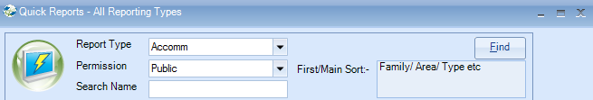

Click ADD to create a new report.

Report owned by – this will show your Class login and is linked to the Permission.
Permission:
- Public – other users can amend the criteria and run this report.
- Public Read Only – other users can run this report but not amend the criteria.
- Private – only the ‘owner’ can amend and run the report.

Name: Give your report a name
Code: a suggestion is to enter your initials

Date Filter – this is not applicable for ‘Accomm’ type reports.

Now you can add the required fields to the report.

Select Add Item

Open Accommodation / Accommodation
Highlight the fields to be included in the report.

Example:
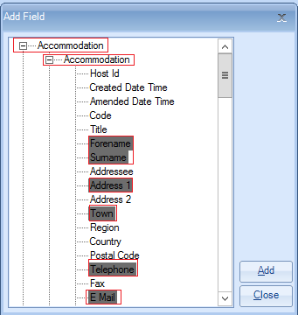

Select ADD to place the fields in to the report.

Open Rooms / Rooms
Highlight the fields to be included in the report.

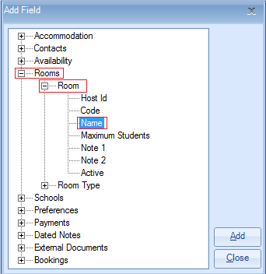

Select ADD to place the fields in to the report.

Once all the required fields have been added to the report select Close.

The report must contain at least one sort field
Select Add Sort -
Open Accommodation / Accommodation
Highlight ‘Surname’
Select Add
Select Close

Example of report:

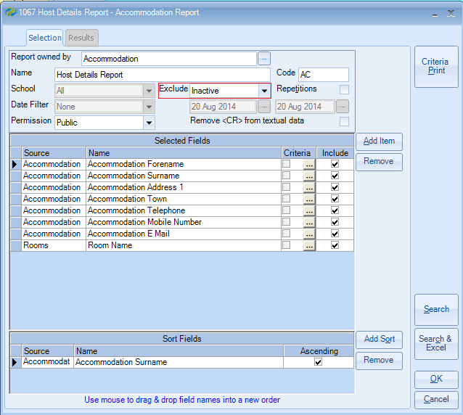

Exclude: ‘Inactive’
Within an accommodation record there are up to four available status options:
Active, Prospective, Inactive, Suspended

If your report is set to ‘exclude inactive’ it will include only accommodation that is active, prospective and suspended.

Therefore, if you wish the report to show only ‘active’ accommodation and/or ‘prospective’ accommodation you must add an additional field to the report with criteria as follows:

Select Add Item

Open ‘Accommodation / Accommodation Status’
Highlight ‘Name’
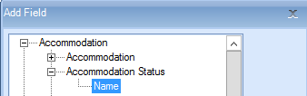

Select ADD to place the field in to the report.
Close

Untick the Include box so that the status does not appear in the results.
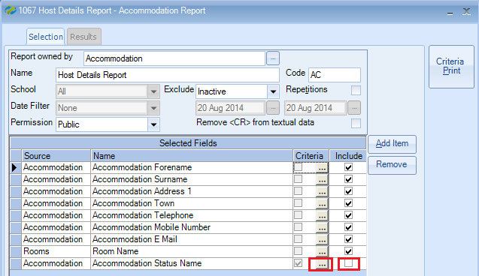

To add the criteria, select the box with three dots.
Criteria:
For Active only accommodation, highlight Active
Select Set
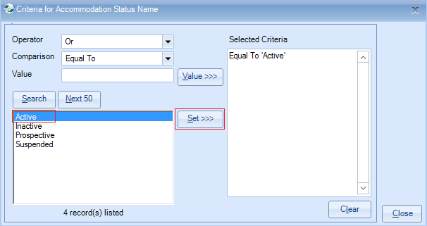
Select Close

Alternatively for both Active and Prospective accommodation, highlight both items
Select Set

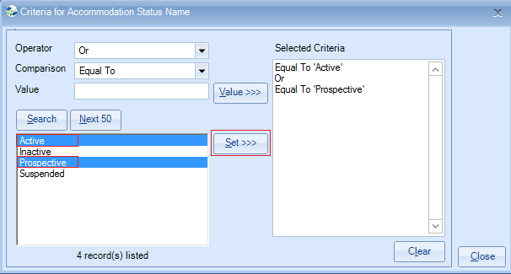
Select Close

Within the accommodation database each item is set up with the type of accommodation. For example this is often set to: Host Family, Residence, Hotel.

You may wish to produce a list for Host Families only and therefore you will need to add the specific field and criteria as follows:

To do this select Add Item

Select Accommodation / Accommodation Type – Name
Add
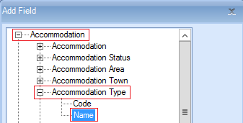

Untick the ‘include’ box

Add criteria to include the required accommodation type.

Select Host Family
Select SET

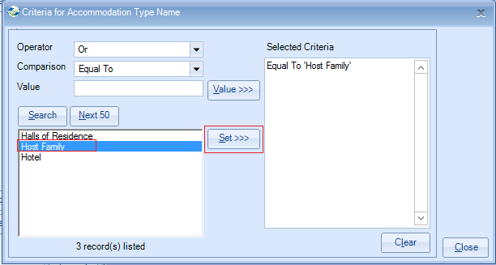

Once happy with your selection select Search.

This will display the list of host families that match your selection criteria.
The number of records found is listed at the top of the screen.

Select Search & Excel to produce the list in an Excel Spreadsheet

Example:

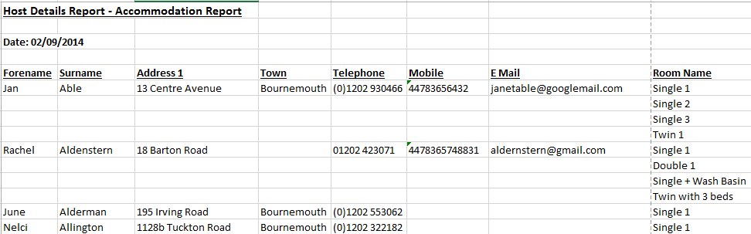

TIPS:
Within an ‘Accomm’ quick report you can also use the criteria to be selective by a number of other fields. Some examples are:
Town, Area, Grade, School, Preferences, Analysis Fields.

