Class.Net – Help Document

Quick Reports – Arrivals/Departure List

How to produce an Arrivals List?

This can be achieved by using the Quick Reports.

The example below explains how to produce a list of all students arriving on a particular date or within a date range.

From the main menu select: Reporting / Quick Reports
Alternatively, use the shortcut picture

Report Type – select “Enrolment-General”
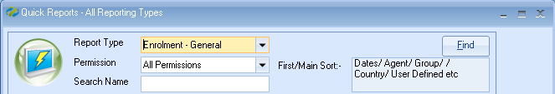

Click ADD to create a new report.

Report owned by – this will show your Class login and is linked to the Permission.
Permission:
- Public – other users can amend the criteria and run this report.
- Public Read Only – other users can run this report but not amend the criteria.
- Private – only the ‘owner’ can amend and run the report.

Name: Give your report a name
Code: a suggestion is to enter your initials
School: if you have multiple schools you may wish to select just one from the list.

Date Filter – For an Arrivals report set to Starting
For a Departures report set to Finishing

Add the date range you wish to report on.
As the report is Enrolment-General type the dates are based on the arrival/departure dates of the student’s enrolment and therefore, you must ensure the date range includes the Saturday and Sunday dates.

Note: other Date Filters available are:
Present – to list all students present within the date range.
Created – to list all students whose enrolment was added within the date range.
Now you can add the required fields to the report.
Select Add Item and choose the required fields.

Open Enrolment
Scroll down to Student
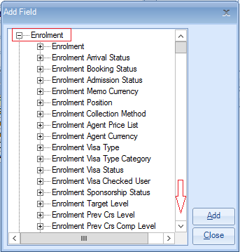
Highlight the required fields
.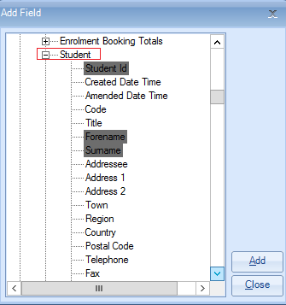
Select ADD

Add all the required fields.

Example:

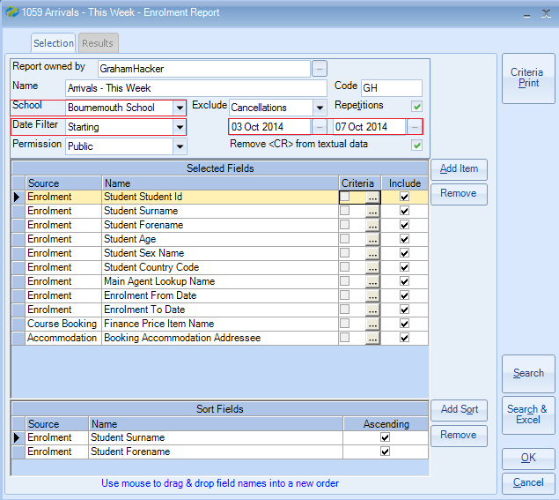

The report must contain at least one sort field
Select Add Sort and choose the required sort field(s) from the list.

Exclude: ‘Cancellations’
This will exclude any cancelled enrolments that would have arrived in the selected date range.

Once happy with your selection select Search

This will display the list of student arrivals that match your selection criteria.
The number of records found is listed at the top of the screen.

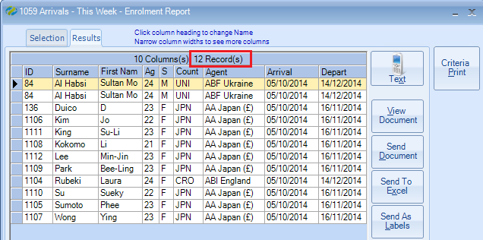

Select Search & Excel to produce the list in an Excel Spreadsheet

DEPARTURES LIST
This report can be used as a Departures report by simply changing the ‘Date Filter’ to Finishing and inputting the requested departure dates

OR

You can make a copy of the arrivals report by closing the arrival report and at the list of reports, highlight the report you wish to copy and select COPY.
Then edit the new report and amend the report name and date filters.

Example:

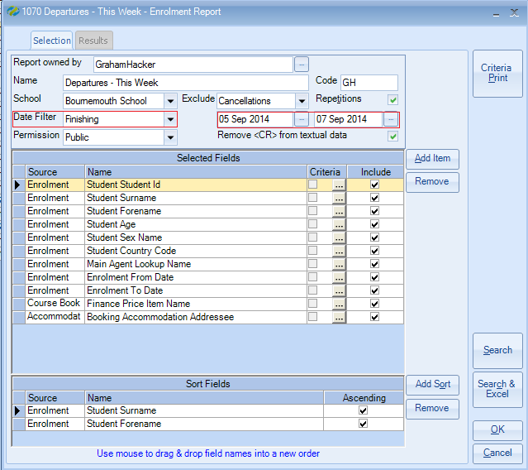

Search and Excel to produce the Departures List.

