Class.Net – Help Document

Quick Reports – List of Current Students

How to produce a list of Current Students

This can be achieved by using the Quick Reports.

The example below explains how to produce a list of all students currently in the school.

From the main menu select: Reporting / Quick Reports
Alternatively, use the shortcut picture

Report Type – select “Enrolment-General”

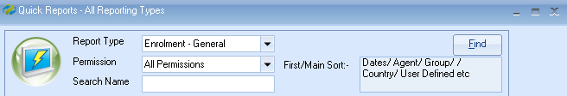

Click ADD to create a new report.

Report owned by – this will show your Class login and is linked to the Permission.
Permission:
- Public – other users can amend the criteria and run this report.
- Public Read Only – other users can run this report but not amend the criteria.
- Private – only the ‘owner’ can amend and run the report.

Name: Give your report a name
Code: a suggestion is to enter your initials

Date Filter – this would be set as “Present” and then add the dates you want to report on.

Now you can add the required fields to the report
Select Add Item
Open Enrolment
Scroll down to Student
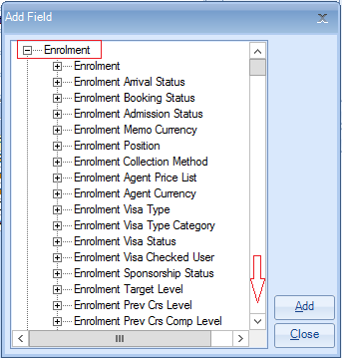
Highlight the required fields.
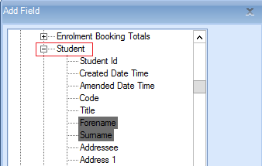
Select ADD
Once all the fields have been added select Close
Example of Report

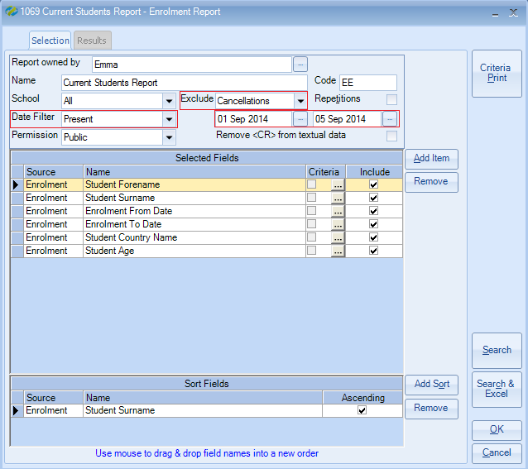

The report must contain at least one sort field
Select Add Sort -
Open Enrolment / Student
Highlight Surname
Select Add
Select Close

Exclude: ‘Cancellations’
A student’s enrolment has three booking status options:
Booked, Provisional, Cancelled

If your report is set to ‘exclude inactive’ it will include only enrolments that are Booked and Provisional.
Therefore, if you wish to report on only ‘Booked’ enrolments you must add an additional field to the report with criteria as follows:

Select Add Item

Open Enrolment / Enrolment Booking Status
Highlight ‘Name’

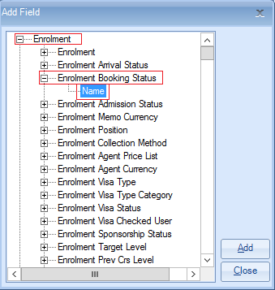

Select ADD to place the field in to the report.
Close

Untick the Include box so that the status does not appear in the results.

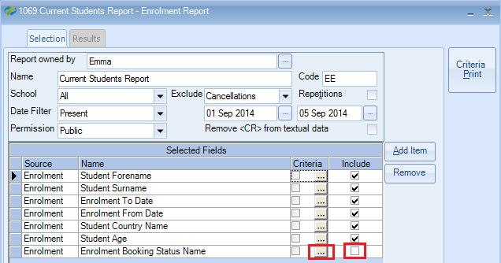
To add the criteria, select the box with three dots.
Criteria:
For Booked enrolment only, highlight Booked
Select Set
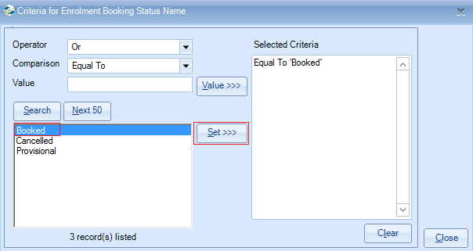
Select Close

Once happy with your selection select Search.

This will display the list of student enrolments that match your selection criteria.
The number of records found is listed at the top of the screen.

Select Search & Excel to produce the list in an Excel Spreadsheet

