Class.Net – Help Document

Enrolment Statistics -
Student numbers by Country & Agent

This document explains how to produce a report showing the number of enrolments (student count) within a specific date range by country and broken down by agent.

NOTE: Enrolment Statistics reports only give the student count/numbers.
If you wish to report on statistical weeks or financial values you will need to use the Invoicing Statistics reports.

To produce this information go to: Reporting / Reporting Module
Select Enrolment Statistics:

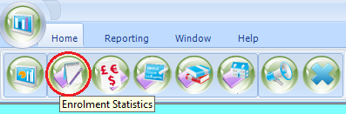

ADD to create a new report

The criteria of this report is split between two tabs: General and Sorting.

General screen:

Give the report a name.
The code could be your initials.

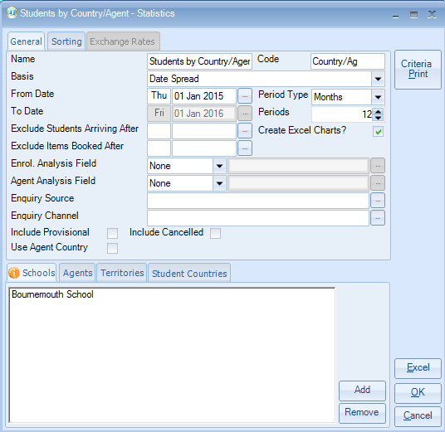

Basis -
Booking Based - based on the date the booking item was entered into the system.
This refers to the course/accommodation/etc, and not the date that the student’s enrolment was entered in to Class.
Production Based - based on spreading the enrolment element (e.g. Tuition) over the duration of the study/stay (dates attended).

Date Arrival – based on the students arrival date from the enrolment general screen

From Date - Enter the start date for your report

Period Type - Days, Weeks, Months or Years

Periods - Select the number of periods for the above selection
example: Days = 7, Weeks = 6, Months = 12, Years = 2

Exclude Students Arriving After – you may have set your selected date range for 1 year from 01/Jan/15 to 31/Dec/15, but exclude students arriving after 05/Dec/15.

Exclude Students Booked After – see above, but this excludes any booking items added after a certain date. For example if a long term student is starting a new course in Dec 15 you may wish to exclude this within the results.

Use Agent Country - The default for running this report is by student country, but this can be changed to report by agent country

Sorting Screen:

Select Add – choose Country Name & Agent Name from the list.

Subtotal by Country Name – tick the box.
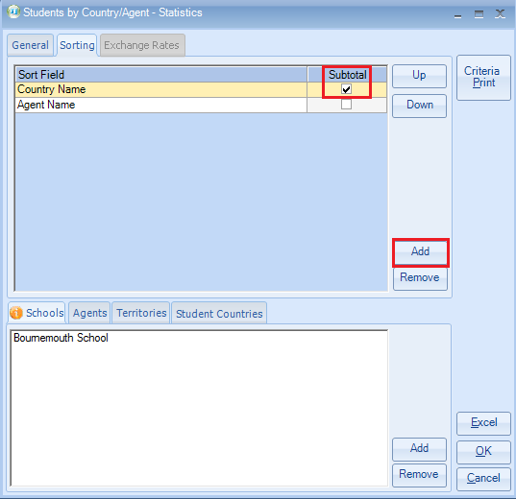

Nearer the bottom of the selection screens you will see tab –
Schools / Agents / Territories / Student Countries
If required highlight the tab and then select ADD to include extra criteria.
Example:
Schools = if you have multiple schools you can select just one to report on.
Agents = be selective by certain agents.
Territories = be selective by one or two Territories.
Student Countries = select specific countries to report on.

Once the criteria is set up to your requirements select EXCEL to produce the results.

