Class.Net – Help Document

Statistics – Invoicing Stats

How reporting by ‘date spread’ works with statistical weeks.
When running an invoicing statistics report based on ‘date spread’ for courses the statistical weeks are not always rounded as 1 for one statistical week. Instead we see results such as 0.77 and 1.08.
This document explains how Class deals with the course stats weeks.
Courses generally run from Monday to Friday 5 days
The invoicing statistics are always based on 7 days
The examples in this document are based on Invoicing Statistics reports. However, the same principal applies to all statistics.

The results you see within your invoicing statistics reports for each course are based on how the price item is set up within: Maintenance/Settings > Maintenance.

See below:

EXAMPLE 1

Maintenance/Settings > Maintenance

Price Item: GE15 – General English 15 Lessons

This course has been set up to charge Mon to Fri, therefore 5 days
Statistical Factor = 1

So, 1 stats week for GE15 course is 5 days

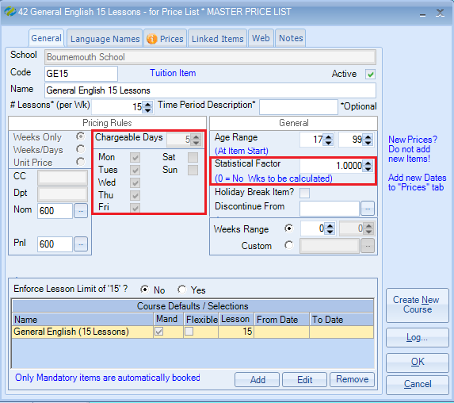

Student Enrolment

Based on the tuition price item above, a student is booked on General English 15 Lessons from 04/04/16 to 29/04/16 (4 weeks) = 4 statistical weeks.
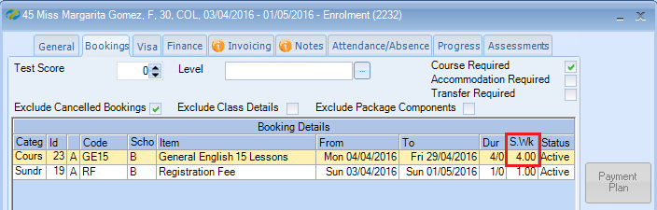

Invoicing Statistics Report criteria

Basis = Date Spread
From Date = Sat 02 Apr 2016 (Note: The report is set to start Saturday)
Period Type = Weeks
Periods = 4
Price Items = General English 15 Lessons

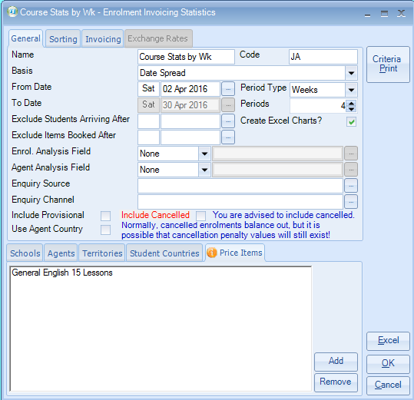

The report is based on Tuition + Statistical Weeks.
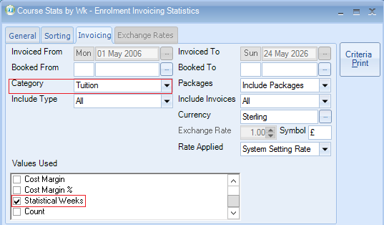

Report Results -

Gomez is booked for 4 statistical weeks and this is shown in the far right column below.

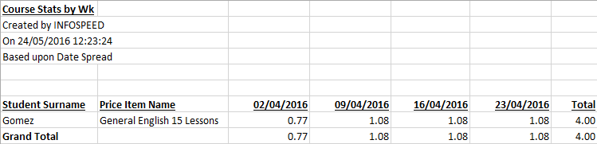

The breakdown of the calculation for this is:
Student starts their course on Monday 4th April and finishes on Friday 29th April.
The number of days between these dates is 26, which includes the Saturdays and Sundays.

The calculation for the first week is from the course start date Mon 4th April for 5 days so, 4 weeks divided by 26 days, = 0.1538 etc multiplied by 5 = 0.7692 ( this figure is rounded up to 0.77), the remaining weeks are then multiplied by 7, as these will include the Saturdays and Sundays.
4 weeks divided by 26 = 0.15238 etc, multiplied by 7 = 1.0769 (this figure is also rounded up to 1.08.)
The calculation will always start on the course start date and end on the course finish date.
The end result (the total) equals the 4 weeks.
EXAMPLE 2

Maintenance/Settings > Maintenance

Price Item: English + Activities Course

This course has been set up to charge Mon to Sun, therefore 7 days
Statistical Factor = 1

So, 1 stats week for ENG+Act course is 7 days

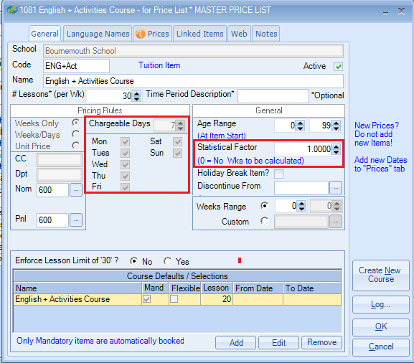

Student Enrolment

Based on the tuition price item above, a student is booked on English + Activities Course from 09/05/16 to 05/06/16 (4 weeks) = 4 statistical weeks.
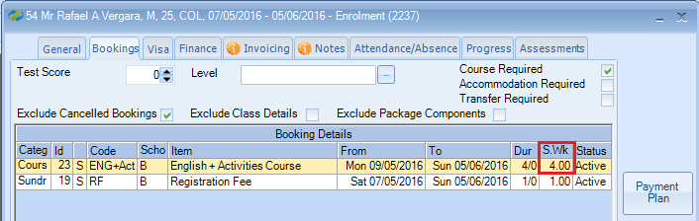

Invoicing Statistics Report criteria

Basis = Date Spread
From Date = Sat 07 May 2016 (Note: The report is set to start Saturday)
Period Type = Weeks
Periods = 4
Price Items = English + Activities Course
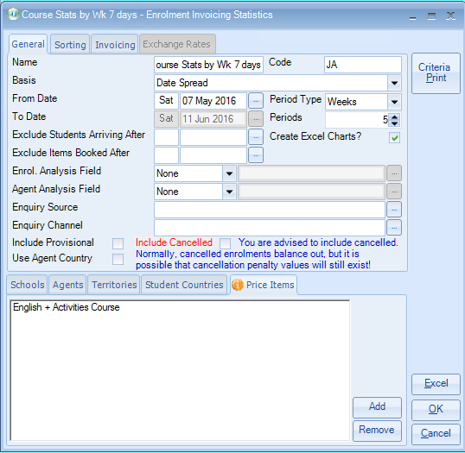

The report is based on Tuition + Statistical Weeks.

Report Results -

Vergara is booked for 4 statistical weeks and this is shown in the far right column below.

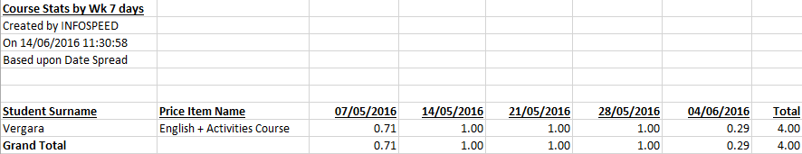

The breakdown of the calculation for this is:
Student starts their course on Monday 9th May and finishes on Sunday 5th June.
The number of days between these dates is 28, which includes the Saturdays and Sundays.

The calculation for the first week is from the course start date Mon 9^{h} May for 5 days so 4 weeks divided by 28 days, = 0.1428, multiplied by 5 = 0.7142 (this figure is rounded down 0.71), the remaining weeks are then multiplied by 7, as these will include the Saturdays and Sundays.
4 weeks divided by 28 = 0.1428, multiplied by 7 = 0.999 (this figure is also rounded up to 1). The last week is for the last Saturday & Sunday and is calculated as 4 weeks divided by 28 = 0.1428, multiplied by 2 = 0.2857 (this figure is rounded up to 0.29)
The calculation will always start on the course start date and end on the course finish date.
The end result (the total) equals the 4 weeks.

