Class.Net – Help Document

Booking & Production Statistics

This document explains how to produce a report showing comparisons for this year against last year.

To produce this information go to: Reporting > Reporting Module
Select: Reporting > Booking & Production

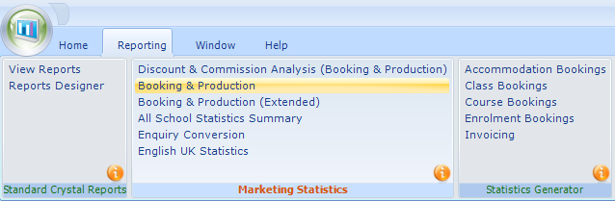

Select ADD to create a new report
Name - Give the new report a name

Basis -
Booking Item Based - based on the date the booking item was entered into the system. This refers to the course, accommodation, etc, and not the date that the student’s enrolment was entered in to Class.
Production Based - based on spreading the enrolment element (e.g. Tuition) over the duration of the study/stay (dates attended).

NOTE: The student weeks are calculated from the Statistical Weeks from within the price item.

The examples below are based on Production Based.

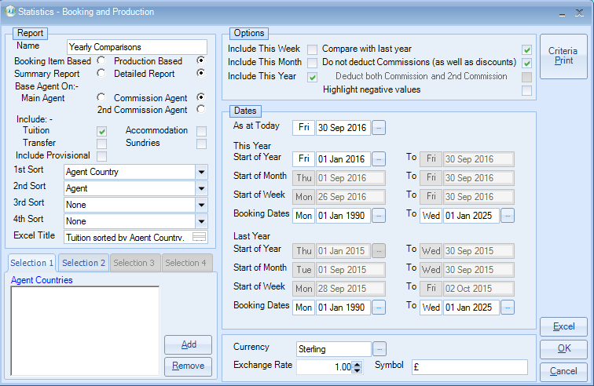

The report can be produced as a Summary or Detailed.
Examples of the report results are shown further down this document.

Base Agent On: Main, Commission, 2nd Commission.
Commission Agent is the default and most popular choice.

Include (Category) - Tuition, Accommodation, Transfers, Sundries
Select as required.

Include Provisional - Unticked if you do not wish to include provisional bookings.

Sort – You can choose up to 4 sort options from the list below:
- School
- Student Territory
- Student Country
- Agent
- Agent Lookup
- Agent Code
- Agent Territory
- Agent Country
- Stats Grouping Agent
- Price List Item
- Price Item Group
- Group Name
- Group Code

Selection: 1 to 4 – additional filter criteria based on the selected sort option(s).

Include This Week/This Month/This year - allows you select the column headings for comparison purposes.

Compare with last year - tick to see 2 years of comparisons

Do not deduct Commission (as well as discounts) - untick if you wish to deduct both commission and discount from the figures within the report.

Deduct both Commission and 2nd Commission - tick to deduct both

DATES:

As at Today - select the date that you wish to compare up to.
This Year
Start of Year - select the date that you wish to compare from.

Last Year
Start of Year – if the option to compare last year has been selected, the dates will be populated as the same date range as ‘This Year’ but for the previous year.

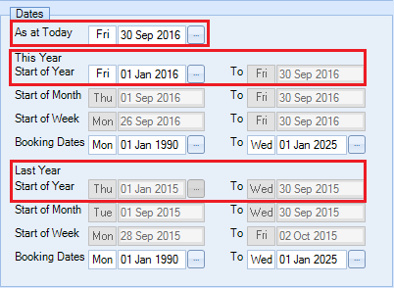
Booking Dates – (only available when running the report as Production Based)
This additional date filter enables you to filter by the date that the item was added to the students enrolment.

Once happy with the selection select Excel to produce the report results.

EXAMPLE REPORTS

Summary Report - This Week:

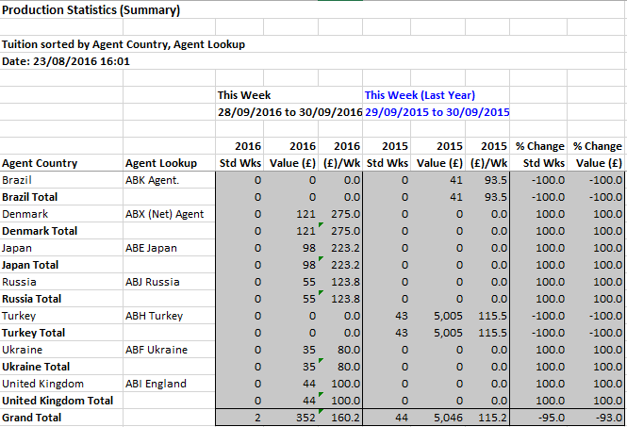

Summary Report - This Month:

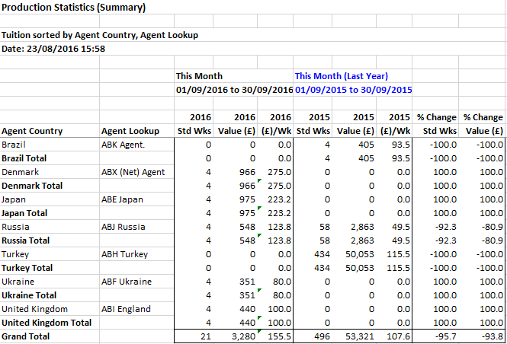
Summary Report - This Year:

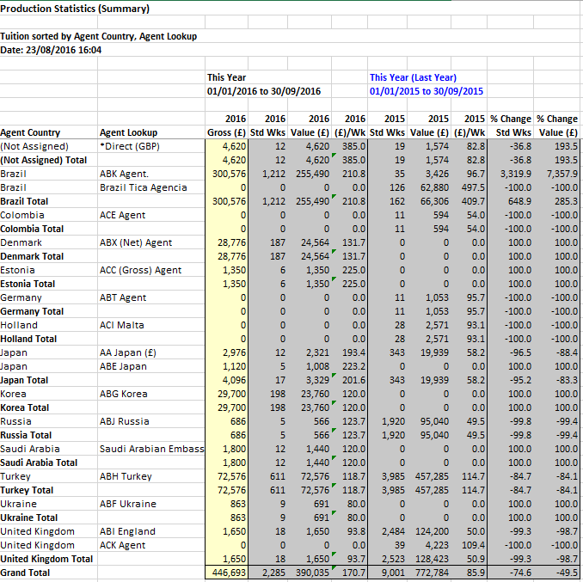

Running the report as Detailed will include the students surname, Id and weeks as well as the Invoice number (if processed)

Detailed Report – This Week:

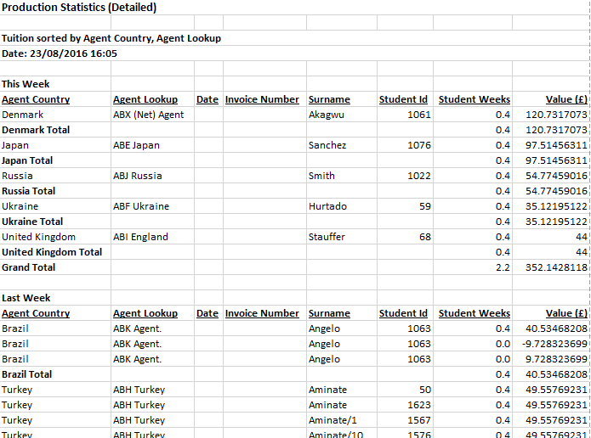

Detailed Report – This Month:

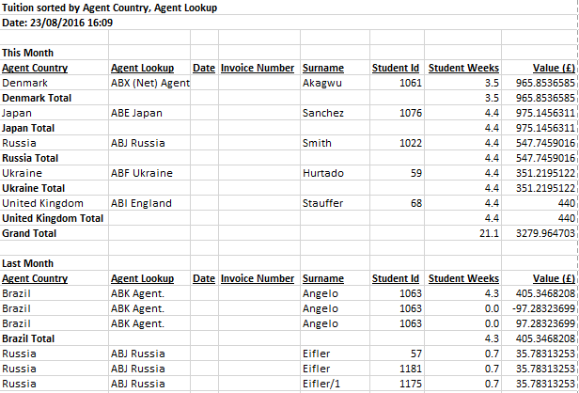
Please note that in the report results:
- All values include sales tax
- Line totals are rounded, sub totals are exact

Please also refer to help document: HS169 Statistics – Individual Agent Statistics.
This is a quick way to see how an agent is performing over a specific period. Student numbers as well as statistical weeks and values can be found quickly from within an agent’s record.

