Class.Net – Help Document

ENGLISH UK Marketing Statistics

Infospeed work closely with English UK in order for our customers who are affiliated to English UK to generate the required reports from Class.

The ENGLISH UK Statistics provide a breakdown of Student Statistical Weeks by course and country in a format specified by ENGLISH UK.

The reports available are:

- Standard Annual Report (Annual Returns for all members)
- QUIC Statistics Submission Form
(available in Class version 8.2 onwards)

Both reports are generated within:

Reporting > Reporting Module
Reporting > English UK Statistics

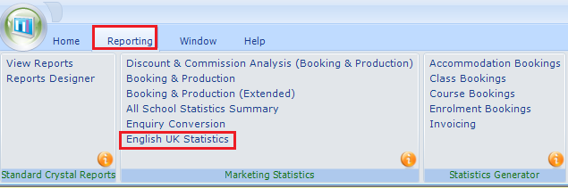

Selection screen and Criteria -

Within the English UK Statistics complete the ‘English UK Details’ and ‘Criteria’ as this is the information displayed at the head of the report.

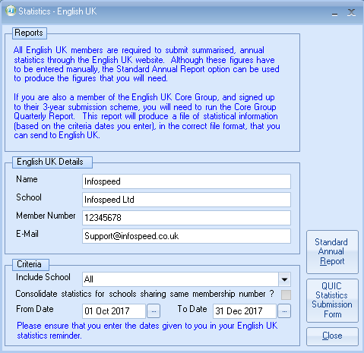

Name - The Class users login name. This can be overtyped if necessary

School - Main school name

Membership Number - English UK member number

The membership number can be set up against your school(s) within:
Maintenance/Settings > Schools
Open the school.
Go to the Courses/Classes/Logo tab and add the English UK Member No.

Include School - A single school can be selected or choose to include all schools.

Consolidate statistics for schools sharing same membership number?
If a range of schools have the same member number, enter the number in to the required schools (within Maintenance/Settings > Schools, as above).

Please note for QUIC a separate report needs to be returned for each premise, even when these share the same member number. For the annual return the statistics for schools sharing a member number should be consolidated.
The From Date and To Date range is used to filter the results to bookings within a specific time period.
Note: Please ensure that you enter the dates given to you in your English UK statistics reminder.

Click the ‘Standard Annual Report’ or ‘QUIC Statistic Submission Form’ button to produce the statistics for the given criteria.

If when trying to run either of the reports you get this following message you will need to set the Member Number within the school

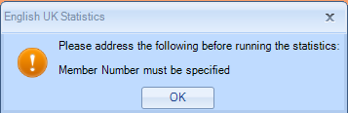

Maintenance/Settings > Schools
Open the school.
Go to the Courses/Classes/Logo tab and add the English UK Member No.

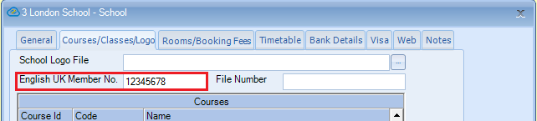

Statistics Layout:

Standard Annual Report – example

All countries listed together:

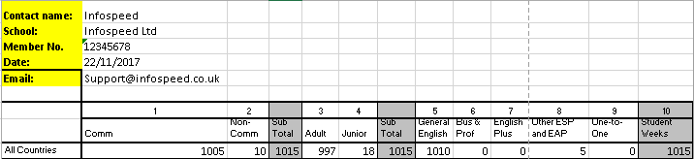

QUIC Statistic Submission Form – example

Split by country:

QUIC Statistic Submission Form – example

Split by country:

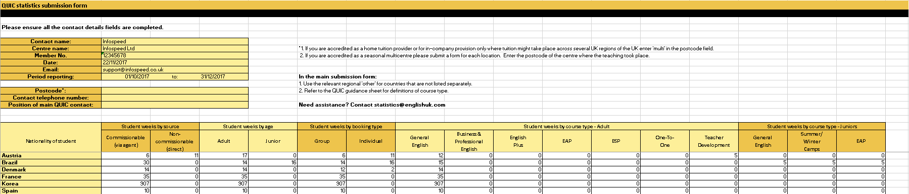

Comm/Non-Comm
This represents either Commission or Non-Commission and is based upon whether the student is an Agent Booking (Comm) or a Direct Student (Non-Comm).

If it is an agent booking it is the commission agent’s Direct flag that determines which column the student fall in to.

Course setup:

Select: Academic > Courses
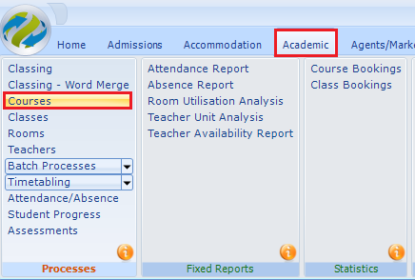

English UK may not require statistics for all the courses that you run. Therefore, you must assign just the courses that are required for the statistics.

Within a course choose the correct details for:

- English UK Category
- English UK Age

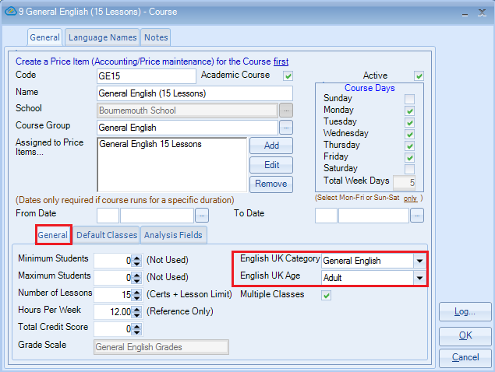

English UK Category – Course type
These headings are fixed by ENGLISH UK and indicate the category of the booking.

Note: Teacher Development and Summer/Winter Camps available from Class version 8.2 onward.

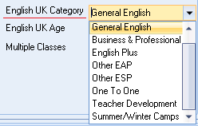

English UK Age - Adult/Junior
These headings are fixed by ENGLISH UK and indicate the student age range of the booking.

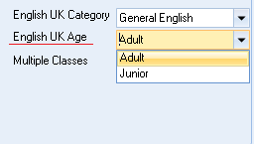

Country Setup:

Country Breakdown
The report is based on the student’s country.
The countries shown on the quarterly report are not the countries assigned in Class as these are likely to be different to those required by ENGLISH UK.

Within Class, each Country has an additional field against it:
- English UK Country

This field is used in the ENGLISH UK Statistics and needs to be linked to the existing Country data within Class.

To do this, open the System Settings module:
Maintenance & Settings > General Settings
Company > Countries (International)

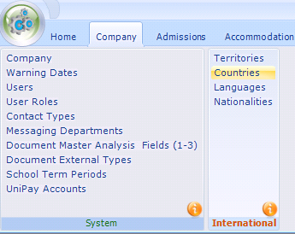

Example:

English UK Country -
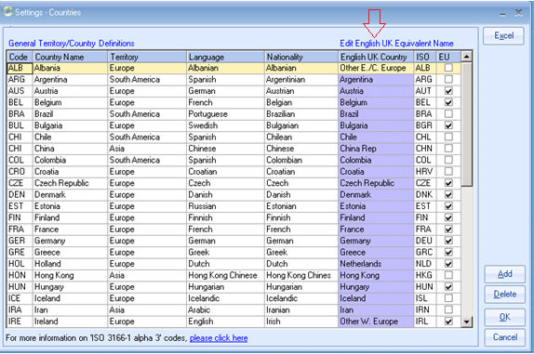

Note: Provisional Bookings are not included in the English UK Statistics report.

