Class.Net – Help Document

Creating an invoice for additional fees using the finance option: ‘Use Credit and Re-Invoice Method’

How to produce an invoice for additional fees without affecting the original invoice.

Students often request additional options after arrival and once they have started their studies. Their invoice has often been processed and all fees paid, but they need to be invoiced for further items. Some examples of the additional fees are:
- Extra lessons
- Exam Fees
- Book Fees
- Accommodation
- Transfers
- Excursions/Activities

Within the Invoicing screen of a student’s enrolment there is an option ‘Use Credit and Re-Invoice Method?’ and this can be used for producing a new invoice just for the additional fees without affecting the original invoice.

As long as the final invoice has been produced for the items that the student has paid for and not just the proforma, a new invoice can be produced for the additional fees.

Example:

Finance screen below shows greyed out lines. These indicate that the final invoice has been processed.

A new booking item has been added for a Book Fee and a new invoice for just the unprinted item is required.

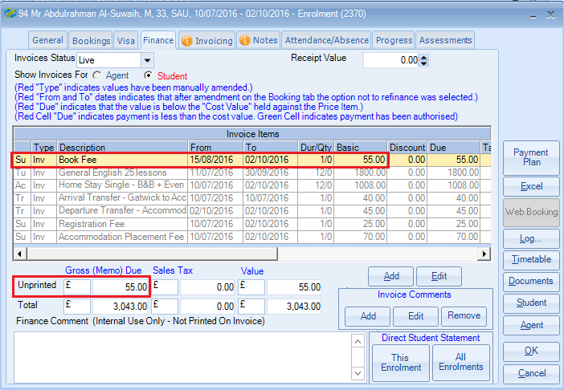

The invoicing screen shows that a final invoice has been produced.

Untick the option Use Credit and ReInvoice Method?
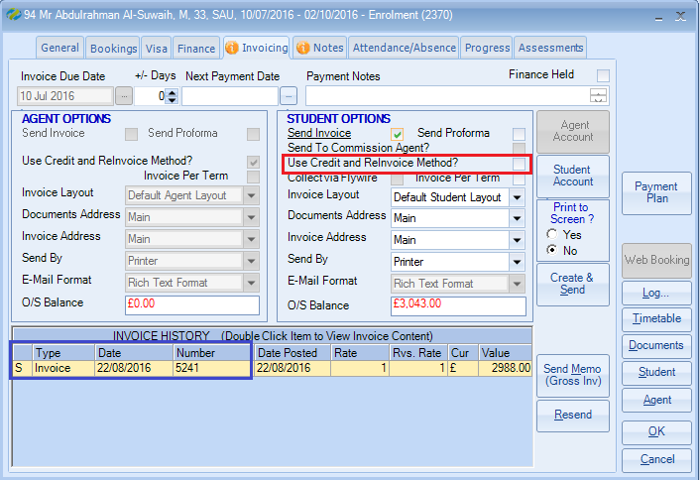

Select Create & Send to produce a new invoice for the Book Fee.
A new invoice will be produced for just the additional fees.
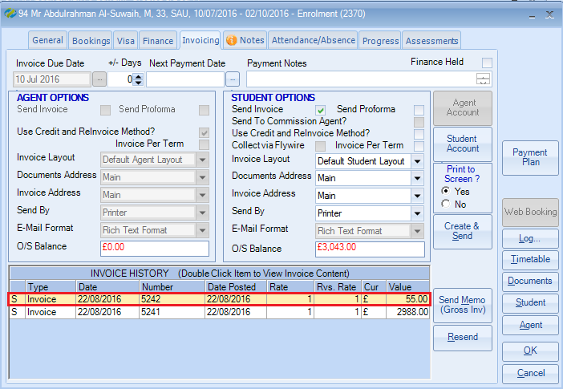

What does the tick box do?:

- Use Credit and ReInvoice Method? - Box Ticked:
Will cancel out the original invoice in full with a credit note and produce a new invoice for the full finance value.

- Use Credit and ReInvoice Method? - Box Unticked:
Will produce a new invoice just for the new or amended item, leaving the previously produced invoice(s) untouched.
The setting for ‘Always Credit and Re-Invoice?’ is assigned to each agent individual record.

The default is normally set for the credit notes to be produced, but as this document indicates, this can be amended at the point of invoicing.

Example agent record showing where the default is set up:
