Class.Net – Help Document
Class Ledger - Take on after Class has been in Use
This document is for clients who have used Class for some time but have not used the Class Ledger.
The purpose of this document is to explain how to clear old balances and take on the Class Ledger.
There are two stages to this process:
- Ensuring the settings are in place
- Clearing the balances

- SETTINGS
Finance / Ledger – Accounting Codes
Check the format is set up correctly.
This is done within: Maintenance/Settings > General Settings. Company > Company
Finance > Ledger
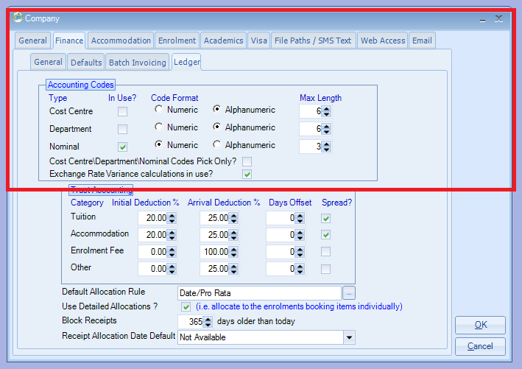
Nominal Codes (Accounting Codes), Cost Centres & Department Codes -
Ensure these are set up correctly.
This is done within: Maintenance/Settings > General Settings
Accounting - Cost Centre Codes, Department Codes and Nominal Codes.
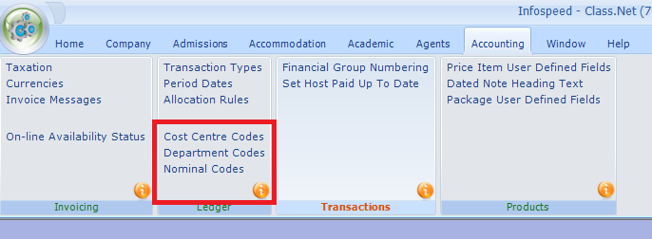
Nominal Codes (accounting codes) – ensure the codes are set up to match those set within your accounting package, i.e. Sage, QuickBooks.
Prices Items -
Ensure these are set up with the correct Nominal Code.
Also Cost Centre and Department (if applicable)
This is done within: Maintenance/Settings > Maintenance.
Open the price items to check the details.
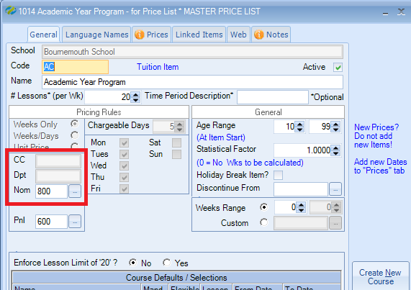

Transaction Types -
Ensure you have a transaction code set to be used for paying off old balances.
This is done within: Maintenance/Settings > General Settings > Accounting - Transactions Types
Name this ‘Old System Update’ or ‘Old System Balance’
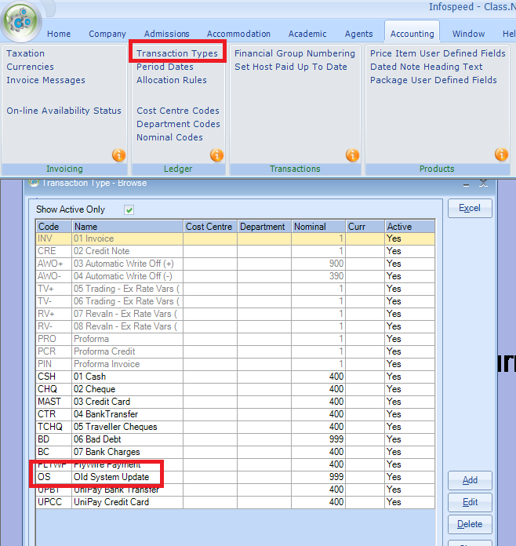

Period End Dates -
The period end dates are only used for validating Receipt transactions.
We recommend the first day of every month is entered.
These are maintained within:
Maintenance/Settings > General Settings > Accounting - Period Dates
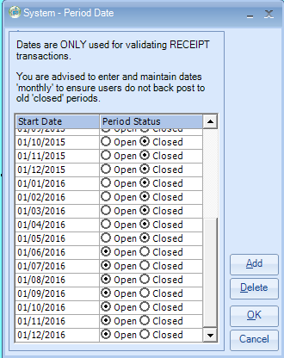

- CLEARING BALANCES
Running the Special Function to “zeroise selected accounts”.
IMPORTANT:
Ensure you have an up to date backup.
Ensure all users are logged out of Class and the Class Ledger

Within the Ledger – Accounting/Ledger
Select: Ledger > Ledger Verification
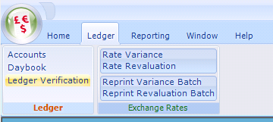
Ensure that the “Attempt to fix any errors found” box is ticked.
Click on “Verify”
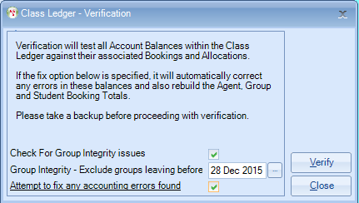
Please report any errors to Infospeed

In the Ledger select: File > Special Functions > Auto Pay Old Bookings…
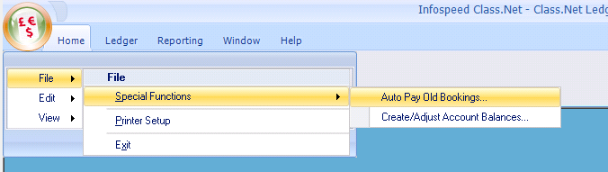
You will then see the following login screen:
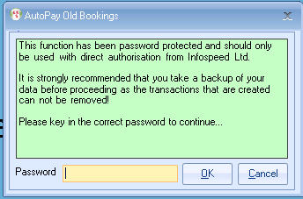
The password is: letmein (in lower case).
You will then see the following selection screen:
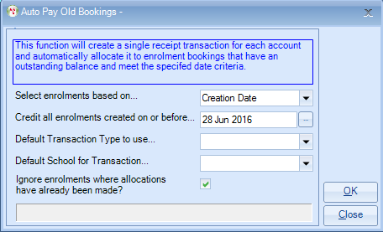
Default Transaction Type to use… - select ‘Old System Update’ or similar.
If you need any further help in completing the above screen please let the Support Desk know.
Click on “OK”
Once completed run the ledger verification again:
Select: Ledger > Ledger Verification
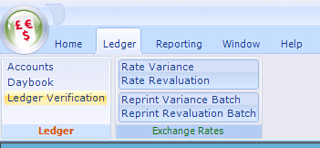

Ensure that the “Attempt to fix any errors found” box is ticked.
Click on “Verify”

Once this is done we would suggest that you run the Aged Debt and check that you are happy with the balances that are left on the ledger. If you have any problems please contact the Support Desk.

