Class.Net – Help Document
How to create and use Disc/Comm (Price Item) Groups
The disc/comm price groups are for use with agents pricing.
They provide a method of grouping price items together.
For example a price group called ‘General English’ could consist of GE15, GE20 and GE25 lessons in order to apply a special rate of discount/commission.
A price group can be assigned to any number of agents and each agent can have a different discount/commission rate applied for the price group.

Setting up

Maintenance/Settings > Disc/Comm (Price Item) Groups

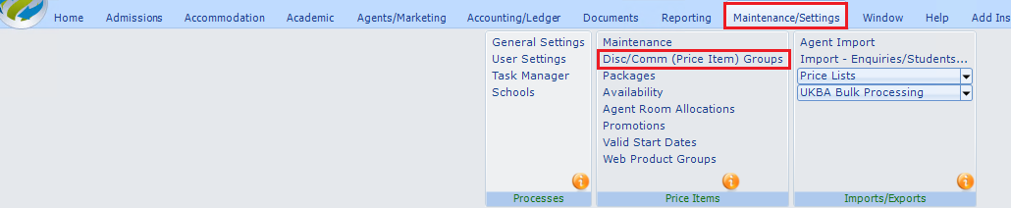
Select ADD
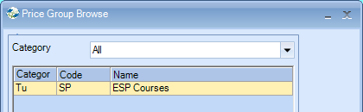
Enter a Code and Name
Category = Tuition.
Price groups can also be created for Accommodation, Transfer and Sundry
List School Filter - select one school if required

Available Items - Highlight the courses to be added to this price group.
Use CRTL and SHIFT keys to select multiple items.
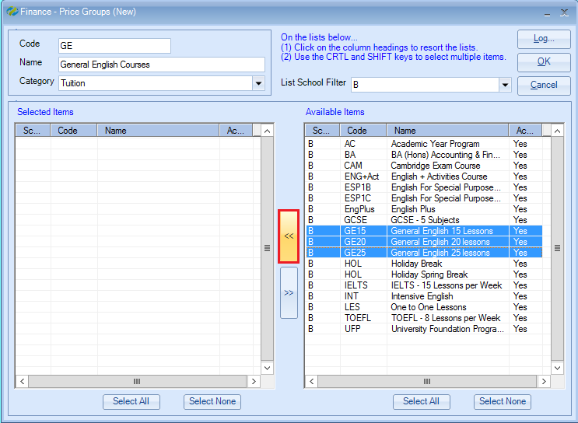

Selected Items - Select the << arrow key to add the courses to the list.
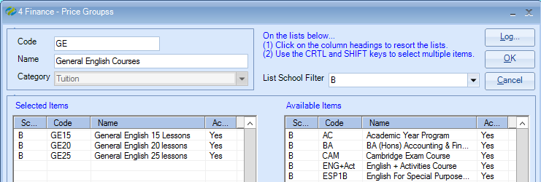

Once the relevant courses have been selected, click the OK button.

Assigning the price group to an agent

Open the agent record.
Go to the Finance Details > Pricing screen.

Here you will see the agents Tuition default disc% / comm%
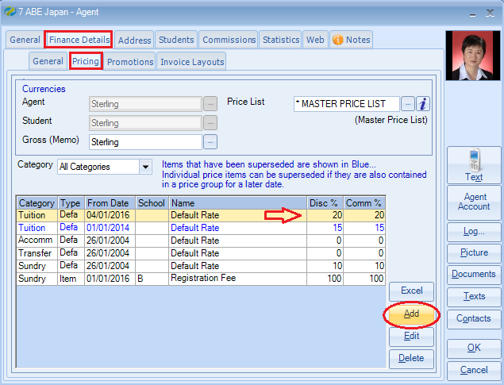

Select ADD to assign the price group.
Category – Tuition
Price Group Type – Group
Name – select the price group from the list
Booking From Date – select the date that the additional disc/comm commences
Discount Rate / Commission Rate – enter the percentage

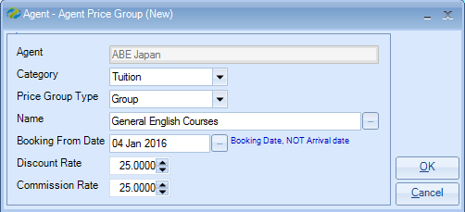
Select OK

The new Group disc/comm rate will be displayed.
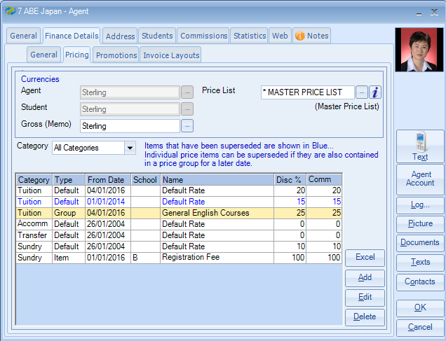

In the example above, from 2016 the agent will receive 20% disc/comm for all courses booked except for the General English Courses GE15, GE20, GE25 where the agent will receive 25% disc/comm.

The default rate displayed in blue indicates that it has been superseded by a price group with a later date.

Also see help document HS095 for more information about the different agent pricing options.

