Class.Net – Help Document

Quick Reports – List of Groups

How to produce a list of Groups?

This can be achieved by using the Quick Reports.

The example below explains how to produce a list of all Groups present in the School.

From the main menu select: Reporting / Quick Reports
Alternatively, use the shortcut picture

Report Type – select “Group”

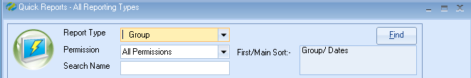

Click ADD to create a new report.

Report owned by – this will show your Class login and is linked to the Permission.
Permission:
- Public – other users can amend the criteria and run this report.
- Public Read Only – other users can run this report but not amend the criteria.
- Private – only the ‘owner’ can amend and run the report.

Name: Give your report a name
Code: a suggestion is to enter your initials

Date Filter – Set this to Present and add the date range you want to report on.

Now you can add the required fields to the report

Select Add Item

Open Group / Group
Highlight the fields as in the example below.

Example:
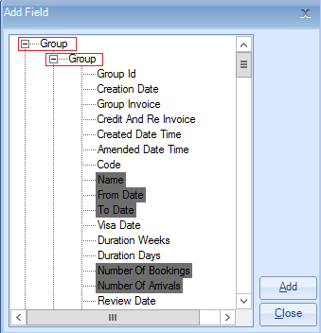
Select ADD

Open Group / Group Country
Highlight the field Name
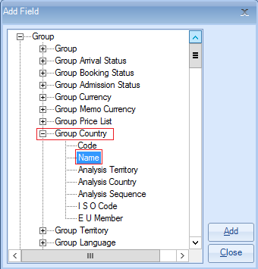
Select ADD to place the fields in to the report.
Once all the required fields have been added to the report select CLOSE
Example:

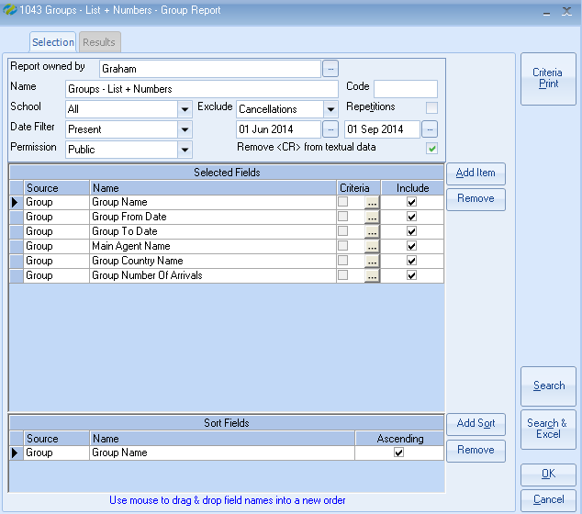

The report must contain at least one sort field
Select Add Sort -
Open Group / Group
Highlight ‘Name’
Select Add
Select Close

Exclude: ‘Cancellations’ This will exclude any Cancelled Groups.

Once happy with your selection select Search.
This will display the list of groups that match your selection criteria.
The number of records found is listed at the top of the screen.

Select Search & Excel to produce the list in an Excel Spreadsheet

TIPS:
Within the ‘Group’ quick report you can also use the criteria to be selective by a number of other fields. Some examples are:
Country, agent.

