Class.Net – Help Document

Statistics – Enquiry Conversion Statistics

A report can be produced to see which enquiries have converted to confirmed bookings.

This can be achieved by using the Statistics Module.

Go to Reporting > Reporting Module. Reporting > Enquiry Conversion

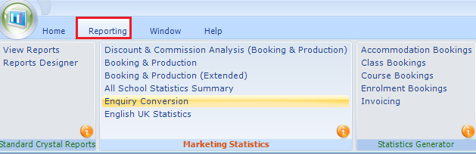

Date From / Date To: This is the date range that the enquiries were added to Class.
1st Sort: The most popular selection is by Source.
This is normally how the student heard about your organisation.
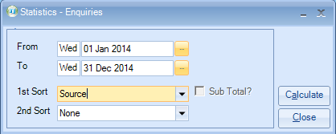
Make your required selection and click ‘Calculate’.

Example report:
For the given period you will see a breakdown of enquiries by Source.
The report shows:
- Number of Enquiries
- Number of students converted from enquiry to confirmed booking
- Conversion percentage
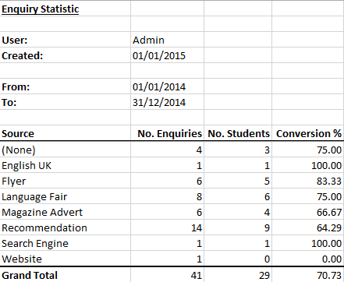

2nd Sort: Enter a second sort to break the report down further.
Adding a second sort gives the option to add a sub-total on the 1st sort
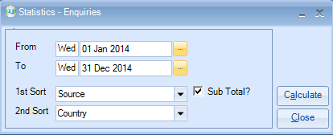
Make your required selection and click ‘Calculate’.

Example report:
A further breakdown is given together with the sub-total, if selected.
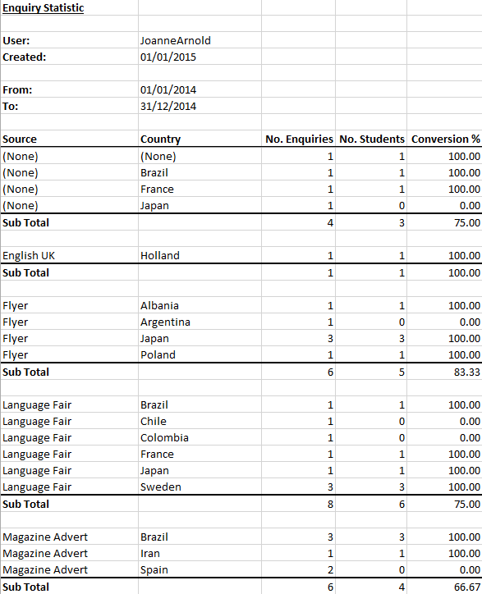

What students are included in this report?
Student Browse
When the option ‘Add Enquiry’ is selected to create a new student the status is set as Enquiry.
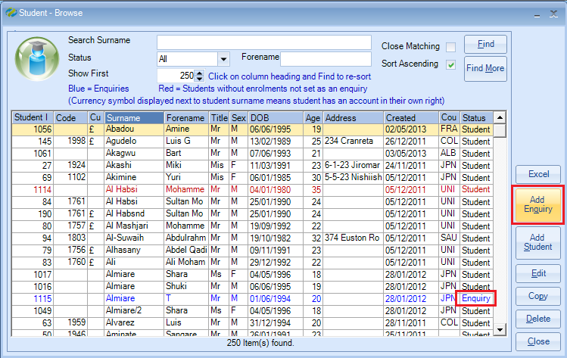
Within the students record the Origin as Enquiry is then set to YES.
This is the prompt which defines if the student is to be included in the report.
NOTE: when using the Add Student option the Origin as Enquiry is set to No and therefore, these students are not included in the Enquiry Conversion statistics report)
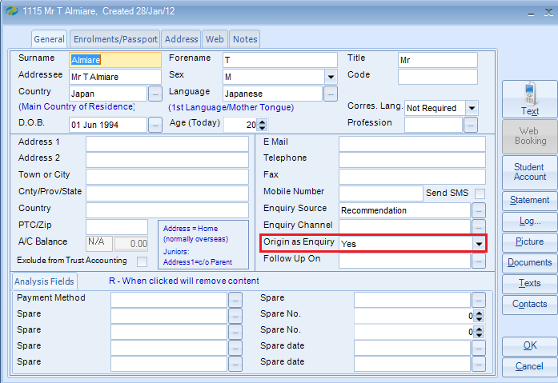
How do I add items to the ‘Enquiry Source’ and ‘Enquiry Channel’ lists?
Go to Maintenance/Settings > General Settings. Admissions
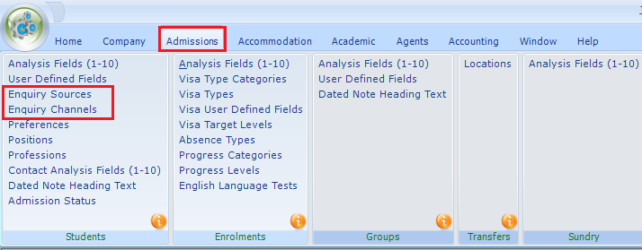

Select ADD to add items to the list.
You can make items inactive by unticking the Active box.
