Class.Net – Help Document

Correspondence Languages

How to set up and use Correspondence Languages
Class is not multilingual, however all of the products sold that are set up within the price list including tuition, accommodation, transfers and sundries can be named in the relevant languages in order for invoices and documents to be produced showing the booking details in the required language.

There are four steps to take before Correspondence Languages can be used as explained below:

- Settings

Go to Maintenance/Settings > General Settings. Company > Languages

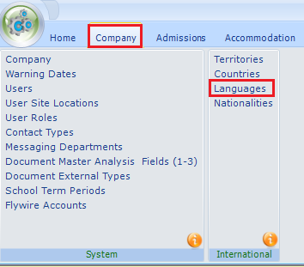
Within this screen put a tick against the Correspondence Languages for the language names you wish to use within Class.
Web Language can also be used but only required if you are using the Class Online Toolkit module (Web booking form)

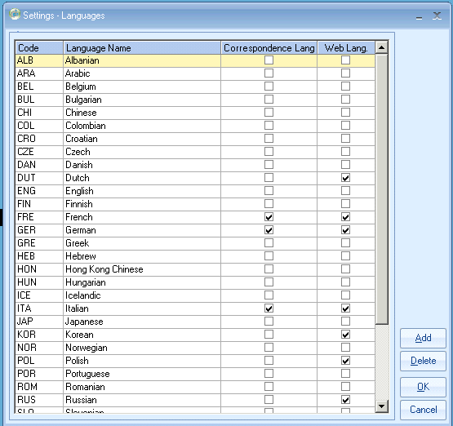

- Price List

Go to Maintenance/Settings > Maintenance
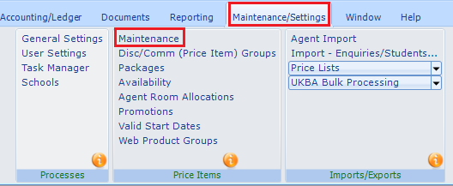

This will display all of your prices: Tuition, Accommodation, Transfers, Sundry.

Open up the first price item that you wish to update.

Within the ‘Language Names’ tab you will see the names of the language countries that were set up in step 1) above.
If you do not see a specific language listed then refer back to option 1.

Enter the name of the price item against each of the language names listed.

Example

Price Item: (General English 25 lessons)
Input the course name for each language.

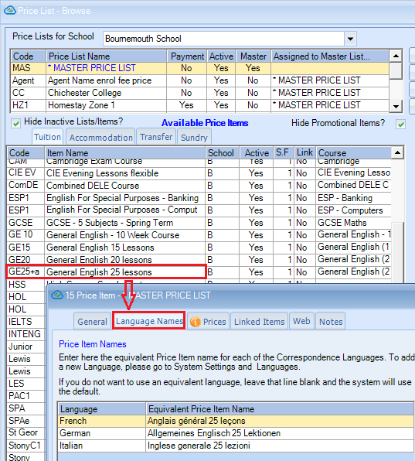

Leaving a language line blank will force the system to use the default language (English)

- Agents
Agents can be assigned to a corresponding language in order for their correspondence to be sent including the price item details in the language assigned.
Within the agent record go to the Address tab and select the relevant corresponding language from the dropdown list.

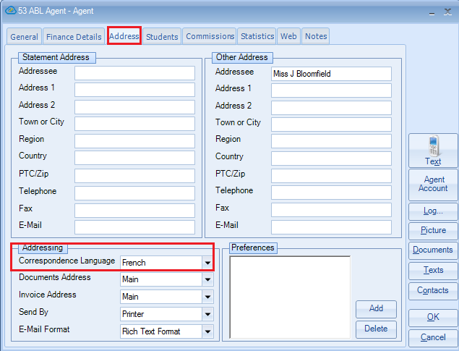

- Students
Students can also be assigned to a corresponding language in order for their correspondence to be sent including the price item details in the language assigned.
Within the student record go to the Address tab and select the relevant corresponding language from the dropdown list.

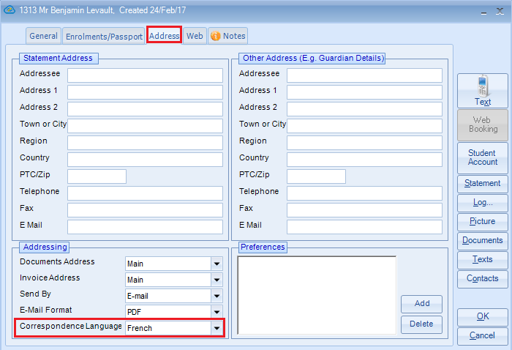
USING THE CORRESPONDENCE LANGUAGE

Booking Example

This student is booked with a French agent. Both the student and agent have the correspondence language of French.

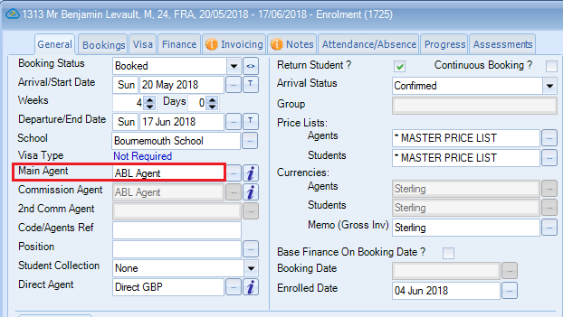

The student is studying on General English 25 lessons

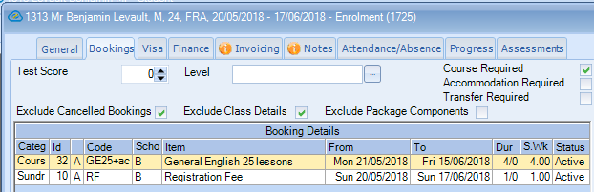

Invoice Template

This master Invoice template shows the merge code required to pick up the correspondence language. [Invoice-Lines.txtLanguageName]

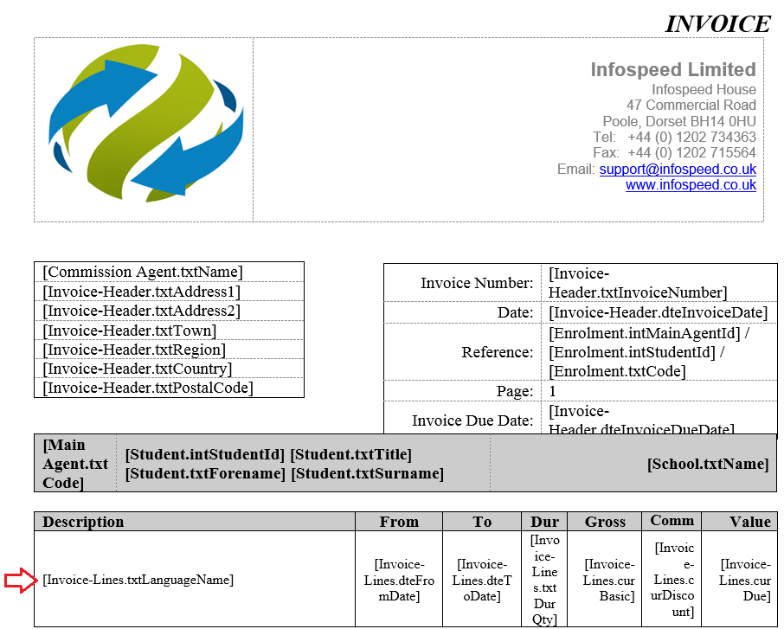

If no language name is found the system will use the default language (English)

Invoice Merged

This merged invoice shows that the course name has picked up the relevant correspondence language - French.

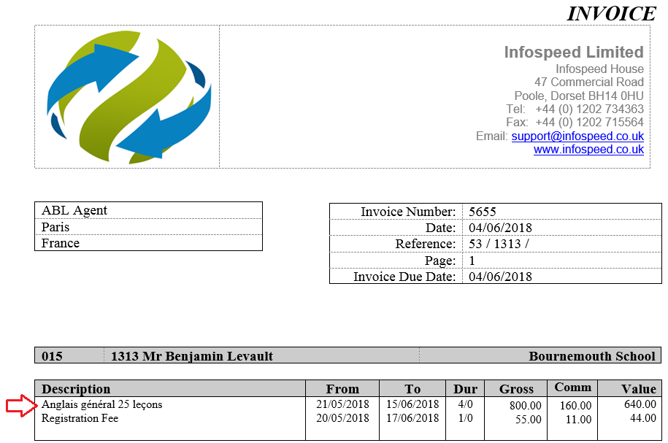

Using the Correspondence Language in general documents/letters.

The price list item Correspondence Language field was introduced to the Class system to enable the financial documents (invoices) to be produced in the language that the student/agent can understand.
Therefore, although the merge field has been added for use within the master “Enrolment” documents, there is not actually a field dedicated to merging either the course, accommodation, transfer or sundry language price item name.

If the merge field is added as [Invoice-Standard-Line.txtLanguageName/1/1] because the course is always displayed on the first line of the invoice the /1/1] at the end of the merge code would automatically pick up the course from the invoice.

To pick up the second line of the invoice you would need to enter the merge code plus /1/2].
To pick up the third line of the invoice you would need to enter the merge code plus /1/3], and so on.

If a student has a booking of one course and one accommodation the code /1/1] would pick up the course and /1/2] would pick up the accommodation.
However, if a student is booked on two courses and one accommodation, both codes /1/1] and /1/2] would pick up the courses and /1/3] would pick up the accommodation.
Document Template

The field within an "Enrolment" master document that is needed to pick up the Correspondence Language name can be found as follows:
Invoicing Fields > Invoice_Standard_Line > txtLanguageName

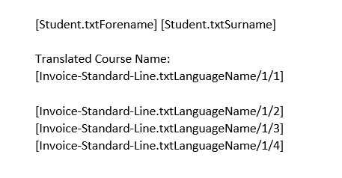

Merged Document

Merged document for student with translated course name

