Class.Net – Help Document

Reporting – Accommodation Booking Report

How to produce a list of students requiring accommodation?

This can be achieved within the Reporting Module

There are various uses for this report, but the most popular use is to find a list of students who have requested accommodation but have not yet been allocated to their homestay, residence or hotel.
Running this report will ensure that you haven’t ‘missed’ any students.

Select Reporting (using the Icon below)
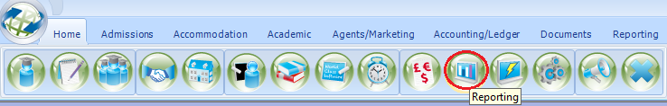
Select Reports
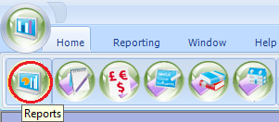

From the list of reports select “Accommodation Booking”
Select “Run”
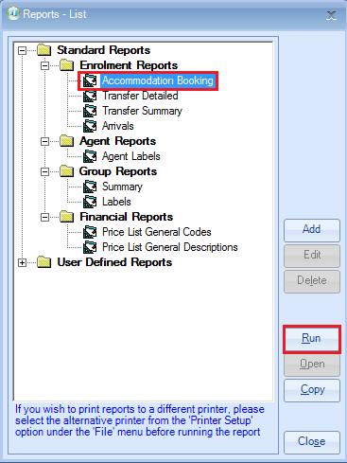
The example below shows how to produce a list of students arriving between a certain date range who have requested accommodation but have yet to be placed.

Amend the criteria as necessary:
Host Booking Status = Awaiting Booking
Enrolment Booking Status = Booked (can also be set to Provisional if required)
Select required date range
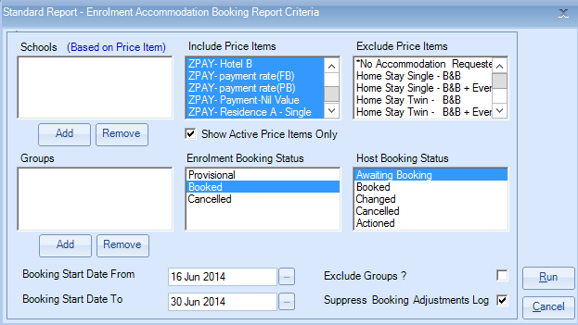

Select RUN
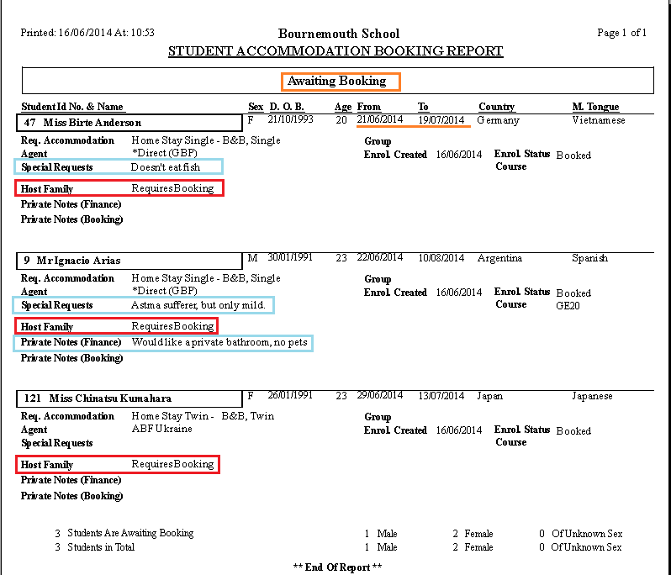
The report picks up the information from within the students enrolment accommodation screen and includes information entered in both the ‘Private Notes’ and ‘Special Requests’, as highlighted below.

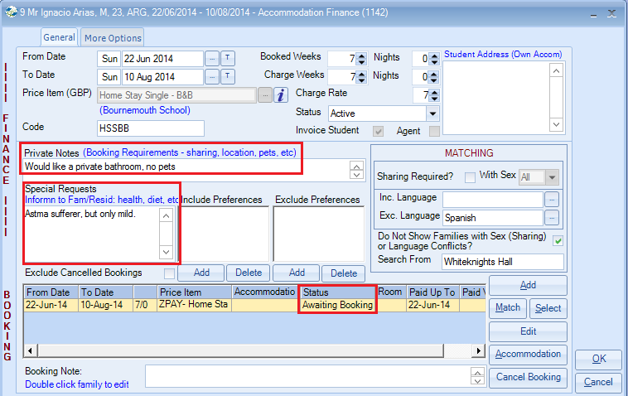

The report can also be run with a further breakdown, by -
- School
- Price Item (include or exclude)
- Group Name
- Exclude Groups (to get all individuals only)

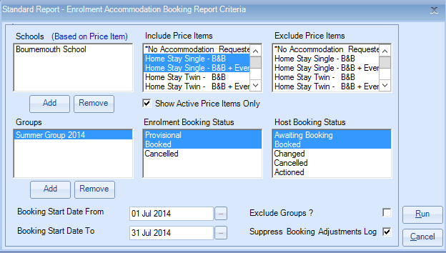

The Accommodation Booking report can also be used to produce the following:

- All students who have changed their accommodation requirements since the accommodation was allocated.
- All Students who have cancelled since their accommodation was allocated.
- All Booked accommodation.

Suppress Booking Adjustments Log
This is used when running the report to include booked, Changed and Cancelled students.
Unticked, the report will include a list showing amendments made to the student’s accommodation booking.
Tick this option to stop this information from being included.

