

Class.Net – Help Document

Promotions

This document explains how to set up and use promotions within Class.

A Promotion is an additional incentive for selected students, agents and products, typically for a temporary period of time.
The promotion value which appears as a separate line on the invoice is potentially extra to an Agents’ existing discount/commission. It appears separately in statistics (as a price item) and each promotion can be charged to a different accounting code.

Note: Group bookings are excluded from promotions

INDEX

Page

Promotion - Types and Overview 2

Promotion – Type 1 – Percentages 5

Promotion - Type 2 – Booked/Free Weeks 9

Promotion – Type 3 – Absolute Value 11

Promotion Parameters 13

Promotions are set up within Maintenance/Settings > Promotions

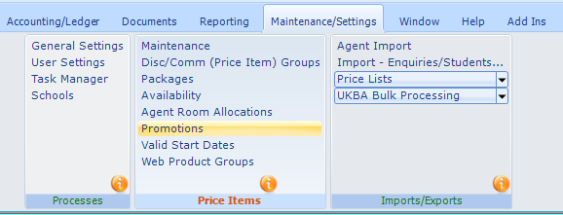

General

The Promotion can be applied to both “Net and “Gross” agent types.

There are three Promotion types:

- Percentages - Additional percentage Discount/Commission
- Booked/Free Weeks - Buy ‘x’ weeks including ‘y’ weeks free
- Absolute Value - Fixed value discount per booking or week

There are also rules covering when it applies, how it is calculated, and how Class reacts to changes after the initial booking

Promotions can apply to each category:
- Tuition
- Accommodation
- Transfers
- Sundry

More than one promotion can be added to an enrolment providing they are for different Price Items e.g.

Book 4 weeks and get 1 week free and receive a free transfer
or
Book 4 weeks and get 1 week free and get 10% off private lessons.

Accounting: If Cost Centres and Departments are used (in addition to Nominal Codes) you are advised to set up default Promotional Cost Centre/Department for each school prior to adding the first Promotion. The system will make use of these defaults later in the Promotion setup, saving time.

School Record (Maintenance/Settings > Schools)

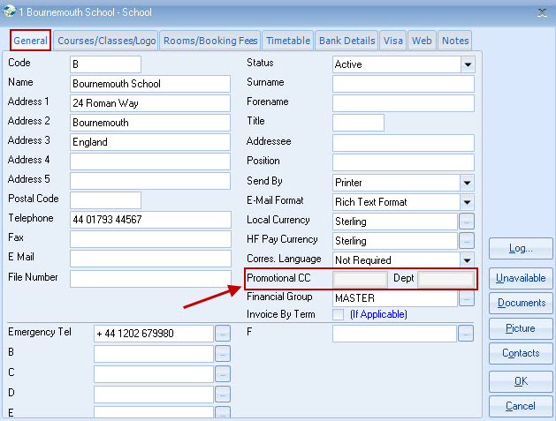

Promotion Browse Screen (Maintenance/Settings > Promotions)

Select Add to create a new promotion or double click to open an existing promotion.
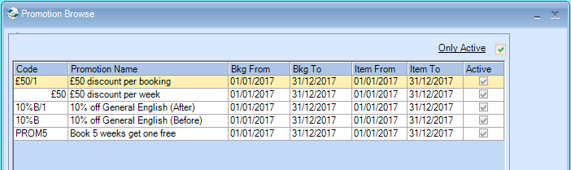

Please note Restrictions when seasonal pricing is in use!

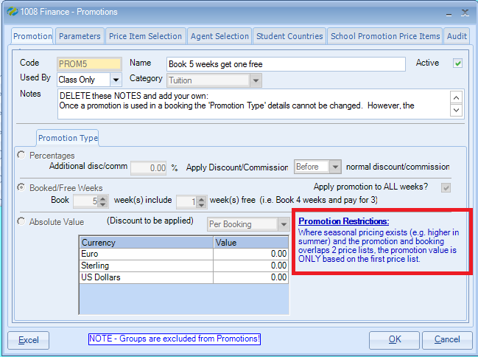

Be careful when creating promotions where dates overlap with other promotions. If the same product/agent is assigned to more than one active promotion and the dates overlap, it will be random as to which promotion is applied to the booking! It is best to either adjust the dates to avoid the conflict or deactivate one of the promotions.

Code must be entered – any 10 characters

Name
Enter description of promotion. (This is for internal use only and will only be seen when a finance line is edited, and does not appear on the invoice). The Price Item Name (explained later) appears in the booking and on the invoice.

Used By
Class only: This promotion is only available when making bookings direct into Class.

Class & Web: This promotion is available when bookings are entered either directly into Class or via the web page (Class On-Line)

Web Only: This promotion is only available when bookings are entered via a web page (Class On-Line)

Category
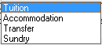

Notes - Free format notes

Promotion Type: Only 1 from the 3 options may be chosen
Promotion Type 1 - Percentages

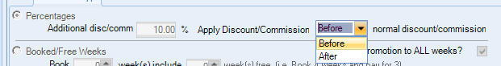

Additional Discount/Commission
Enter the percentage additional discount/commission. The system will automatically determine whether discount or commission applies, based on the Agent’s rules.

Apply ‘Before or After’ normal discount/commission
This is best explained with an example:

In the agent record they received 10% as their normal discount.

Before: This shows that the additional discount has been applied on the gross value (“Basic” column) £2500 minus £250, prior to the agents 10% discount being applied (“Due” column) £2250 minus £225.

So, the agent pays £2025.00

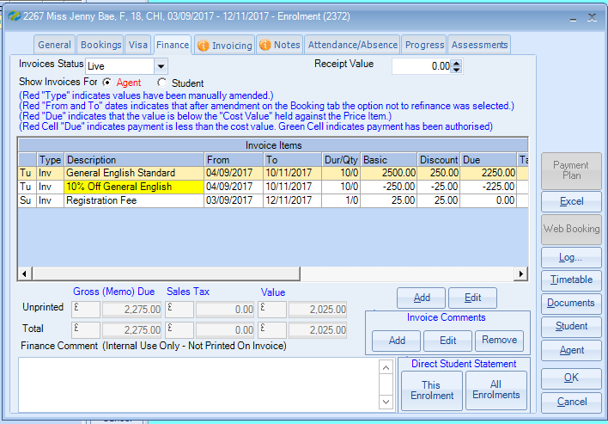

The above example is calculated with the Parameters “Apply relevant agents discount/commission to promotional value (ticked)

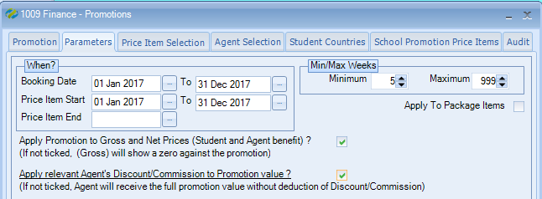

If this setting is unticked no discount is being applied to the promotion item, see below example where the discount column for the promotional item (yellow line) shows zero.
So, the agent pays £2000.00

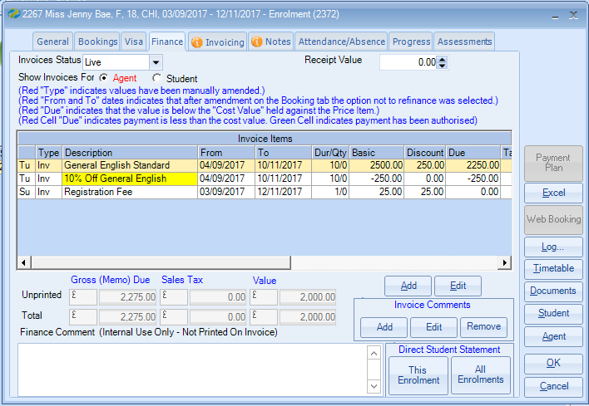

After: This shows the agent has firstly received their normal 10% discount on the (“Basic” column) value £2500 minus £250. Then the promotion discount of 10% is applied to the (“Due” column) value, £2250 minus £202.50 as 10% is deducted from the discount that has already been applied. See “Discount” column £250 minus £22.50.

So, the agent pays £2047.50

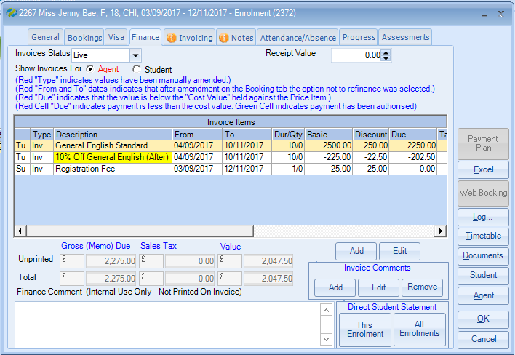

Parameters “Apply relevant agents discount/commission to promotional value” (ticked)

If this setting is unticked no discount will be applied to the promotion item highlighted in yellow. So, the agent pays £2025.00

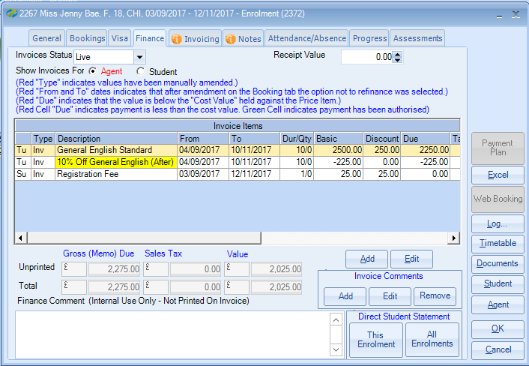

Promotion Type 2 - Booked/Free Weeks

Enter the total weeks and the INCLUDED free week(s) e.g.
- 5 weeks including 1 week free
- 10 weeks including 2 weeks free

Apply promotion to ALL weeks*
This is best explained with an example:

 |  | Free Weeks
 |  | Apply ALL  Weeks ✓ | Apply ALL  Weeks 
Weeks booked | 2 | 0 | 0
Weeks booked | 5 | 1 | 1
Weeks booked | 7 | 1 | 1
Weeks booked | 10 | 2 | 1
Weeks booked | 15 | 3 | 1

* The number of weeks in which free weeks apply is controlled by the MIN/MAX weeks in the Promotion Parameters tab.

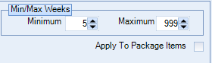

Calculating the amount to be deducted.

The following prices are used for this example, £300 per week.

If the student books 10 weeks or more, the price goes down to £250.00 per week.

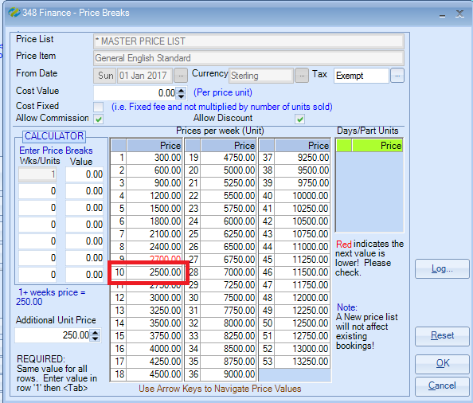

In the example below the student has booked 10 weeks, so has 2 weeks free.
The system calculates this by looking at the 10 week price £2500 dividing it by 10 weeks to get £250 and then multiples by 2 as there are two free weeks. Therefore, discount is £500.

These are Gross values so the agent could possibly get further discount on this price.

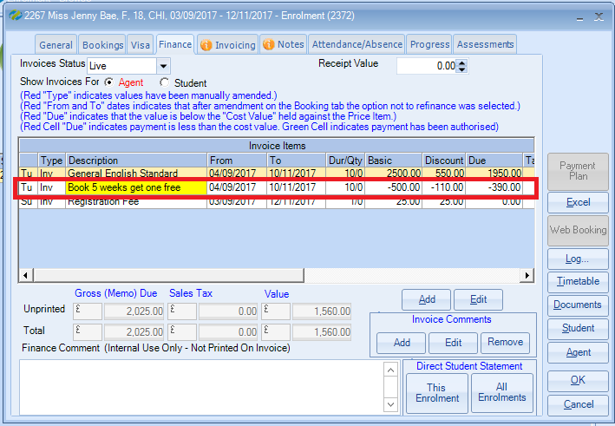

Promotion Type 3 – Absolute Value

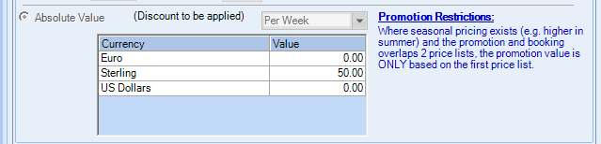

Enter the values required against each currency, unless not required, in which case leave as zero. If the Agent’s currency has a zero value in the Promotion, the promotion discount will show as zero.

The value may be ‘Per Booking’ or ‘Per Week’ *

*The number of weeks against which the weekly value is to be applied is controlled by the MIN/MAX weeks in the Promotion Parameters tab.

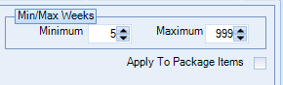

Per Week:

The student is studying for 10 weeks
Discount is £50 per week
£50 x 10 weeks = £500 discount (basic column)
10% agent discount is then applied to both the “Discount” and the “Due” columns, as seen in the below example

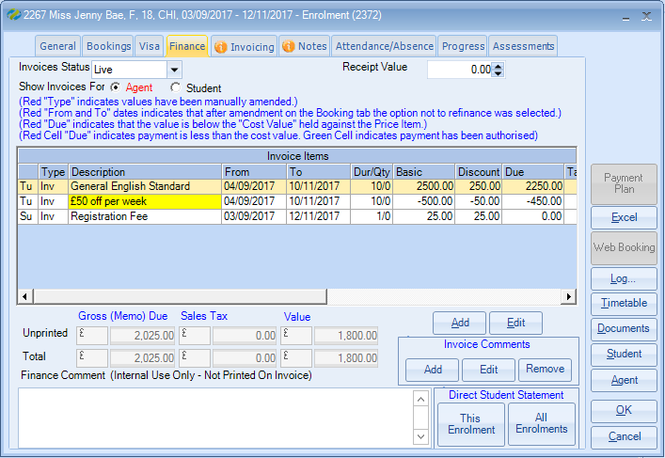

Per Booking

Irrespective of the length of study £50 discount per booking/enrolment will be applied.
10% agents discount is then applied to both the “Discount” and “Due” columns as in the below example.
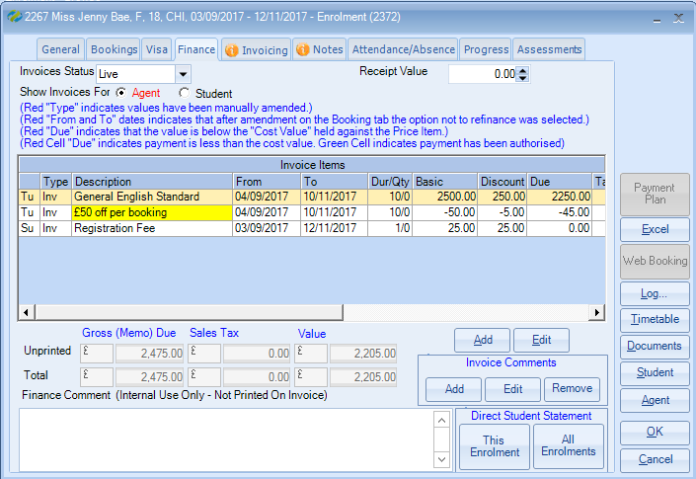
Promotion Parameters

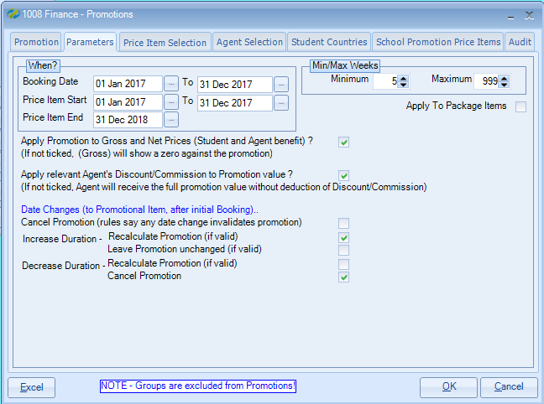

Booking Date
From and To Dates

The date applied is the date the Price Item is actually entered onto the booking/enrolment. This date is held within Class but cannot be viewed.

Note: It is not the date that the original enrolment was entered or the start of the student’s course/accommodation etc.

Price Item Start
From and To Dates
The date applied is the date that the course/accommodation etc. actually starts.
It is not the arrival date of the student.

Price Item End
The date that the course/accommodation etc. must be completed by. In the above example it is 31st December 2018.

Min/Max Weeks
The Minimum/Maximum weeks which apply to the Promotion.
For example, the 10% discount could only apply to bookings between 5 and 10 weeks duration.
Bookings that exceed the maximum receive the discount applicable to the max weeks.

In the example above this would be 10 weeks.

Apply To Package Items
If selected, if the item is within a package it will have the Promotion applied
Apply Promotion to Gross and Net Prices

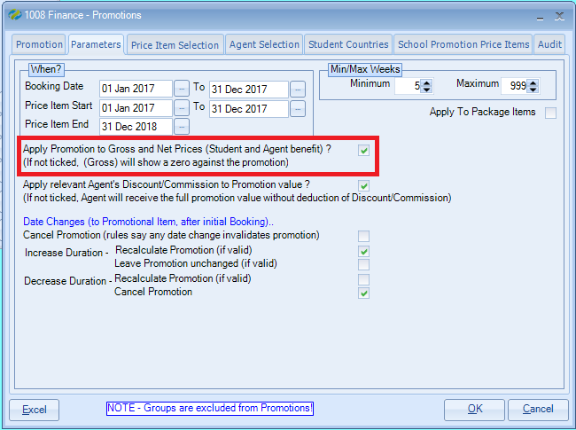

For this example the following are used:
25% Agent Discount/Commission
10% Promotion Discount (after discount)

 |  | Student and Agent benefit (ticked) | Only Agent benefits (unticked)
 | Student pays (GROSS) | Agent pays (NET) | Agent pays (NET)
Gross Price | 400.00 | 400.00 | 400.00
*Agents Disc/Commn  25% | N/A | -100.00 | -100.00
Total Price | 400.00 | 300.00 | 300.00
Promotion – additional  10% | -40.00 | -30.00 | -30.00
Balance due | 360.00 | 270.00 | 270.00

* Whether or not Agents normal Discount/Commission is deducted is determined in another rule, explained below.

Apply Relevant Agent’s Discount/Commission to Promotion Value

This tick will indicate whether the agent is to receive their full percentage discount or whether it should be reduced by the discount value with the promotion

This is ticked as a default so the agents are not given additional discounts.

Example
Additional Discount/Commission
In the agent record they received 10% as their normal discount.

Before: This shows that the additional discount has been applied on the gross value (“Basic” column) £2500 minus £250, prior to the agents 10% discount being applied (“Due” column) £2250 minus £225.

So, the agent pays £2025.00

The above example is calculated with the Parameters “Apply relevant agents discount/commission to promotional value (ticked)

If this setting is unticked no discount is being applied to the promotion item, see below example the discount column for the promotional item (yellow line) shows zero.
So the agent pays £2000.00

Date Changes (to Promotional Item after Initial Booking)

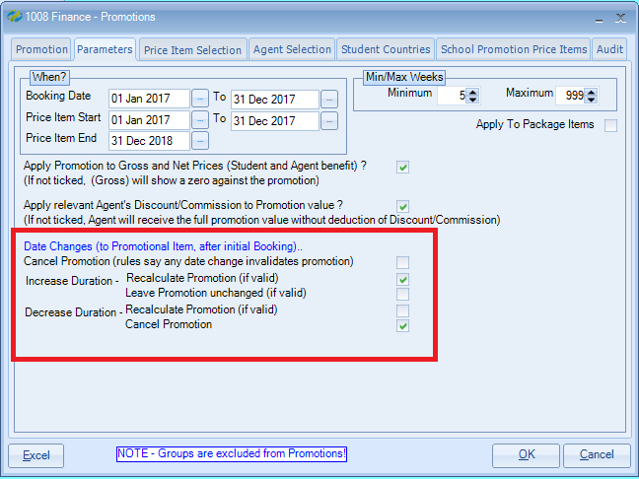

Cancel Promotion (rules say any changes invalidates promotion)
Any date change to the promotion item will automatically cancel the applied Promotion.

Increase Duration
Recalculate Promotion (if valid)
If the duration is increased, the value of the promotion will be recalculated according to the rules.
e.g. the dates may be changed in such a way that the start date now falls outside the promotion period and therefore no longer applies.

Leave Promotion Unchanged (if valid)
Class will recalculate and either display the new promotion or remove it if not valid.

Decrease Duration
Recalculate Promotion (if valid)
If the duration is decreased the value of the promotion will be recalculated according to the rules.
e.g. the dates may be changed in such a way that the start date now falls outside the promotion period and therefore no longer applies.

Cancel Promotion
If the duration is decreased the promotion is cancelled and removed from the enrolment.

Price Item Selection:

Select the price items to be included in the promotion.
Items can be added or withdrawn at any stage.

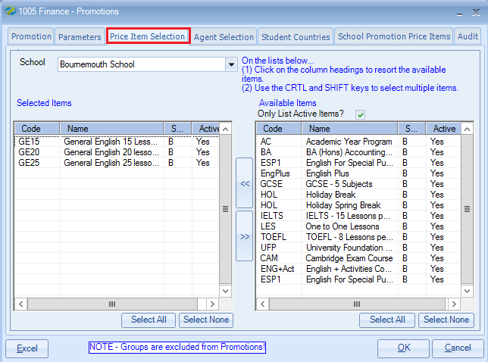

Agent Selection:

Select Agents to be included in the promotion.
Agents can be added or withdrawn at any stage.
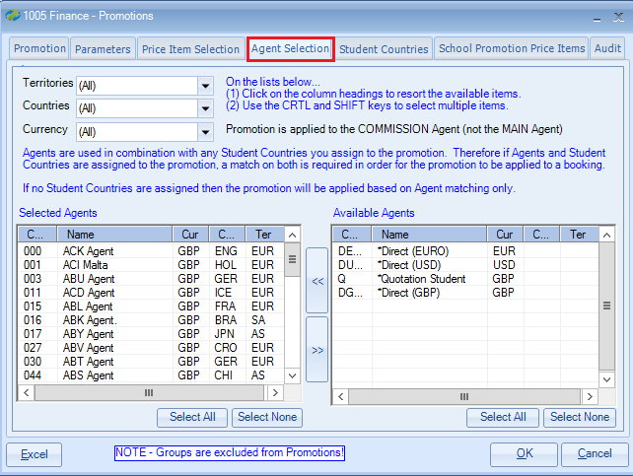

Note: Promotions do not apply to the second commission agent within an enrolment.

Student Country Selection
Select Countries to be included in the promotion
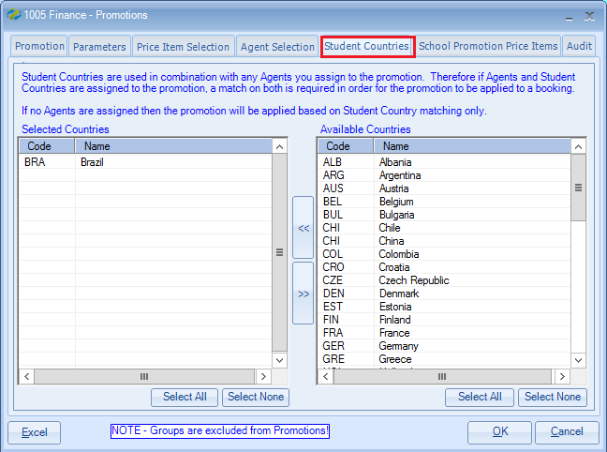

School Promotion Price Items:

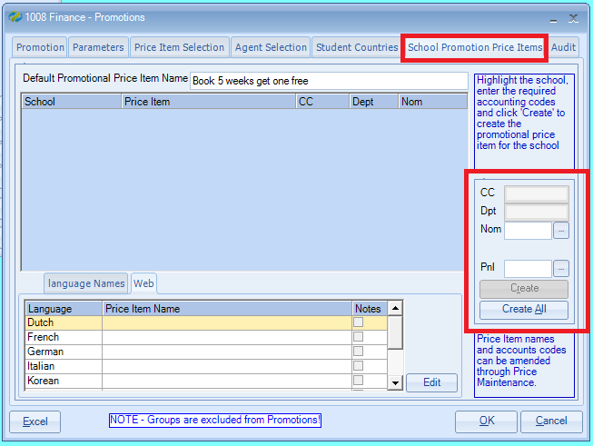

- Add the ‘Default Promotional Price Item Name’ before completing the accounting codes. This is the name that will appear on the invoice.
If the name is created incorrectly, changes are automatically updated to the Price Item.

- Schools used in the promotion are automatically displayed, and if the School has a default Cost Centre/Department entered in the school record then these will be preset. Alternatively, for each school, enter Cost Centre/Department/Nominal Code as appropriate, then select “Create”, or if there are several entries to which the Nominal Code is to be applied, select “Create All”

- As each promotion has a unique Price Item for each school, statistics will clearly show the income affect against, schools, agents, countries etc. Nominal Codes also provide the facility to charge each promotion to different areas of the business, if required.

Language Names/Web
If these are in use Foreign Language Names can be added and maintained from this screen.

Maintenance/Settings > Maintenance

The Price Item browse screen shows promotion price items at bottom of the list displayed in Red.
The promotion price items will only be displayed within the list when the ‘Hide Promotional Items’ flag is un-ticked.

