Class.Net – Help Document

Valid Start Dates

How to set up intake dates for courses.
Also available for Accommodation/Transfers/Sundries

Valid intake dates can be set up to ensure courses are booked to start on the correct day or within the correct week.

Select: Maintenance/Settings > Valid Start Dates (Price Items)

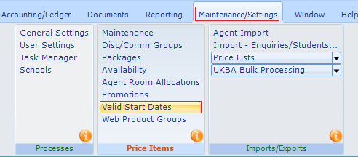

Select a School (if applicable)
To create a new set of intake dates select ADD
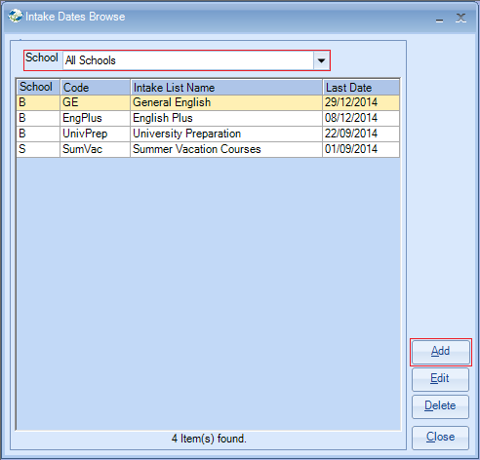
Below you will find several examples for setting up intakes.

Example 1)
General English courses run all year and start every Monday.

Give your list a code and a name.
The current year will be displayed.

If you have a group of courses that run all year and start every Monday, then you can accept the defaults under the ‘Date Generator’.

For example:
Weekly Interval: 1
From: Mon 06 Jan 2014 (this is the first Monday of the current year)
Start Days... Monday

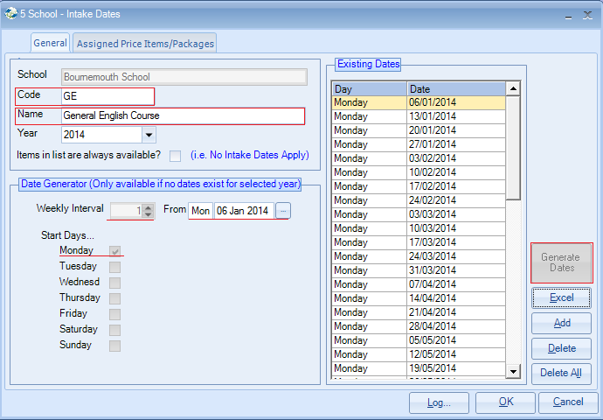

Select Generate Dates.
This will automatically add every Monday of the current year.

Select the tab Assigned Price Items/Packages
Available Items
Only List On Line Items? – untick this box.
Highlight the courses that are to be assigned to this intake -
(Use Ctrl to select multiple individual items, Use Ctrl/Shift to select e.g. top to bottom)
Click on the << arrow in the middle of the screen to move transfer the highlighted items to the Selected Items list.
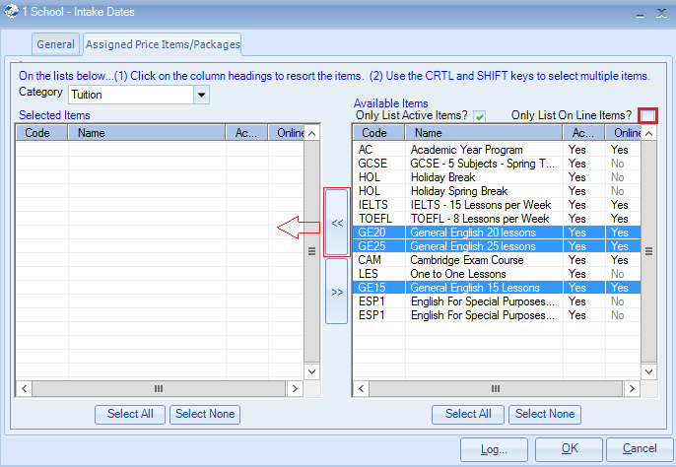

Prices assigned to the intake list:

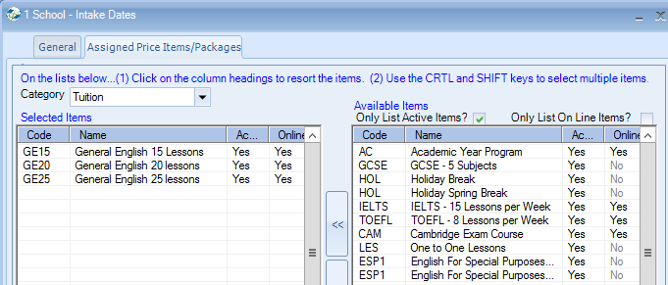

Example 2)
English Plus courses start every four weeks.

Create a new intake from the intake date browse screen.
Weekly Interval = 4
From = enter first Monday of the year (normally the default)
Start Days… Monday
Select ‘Generate Dates’
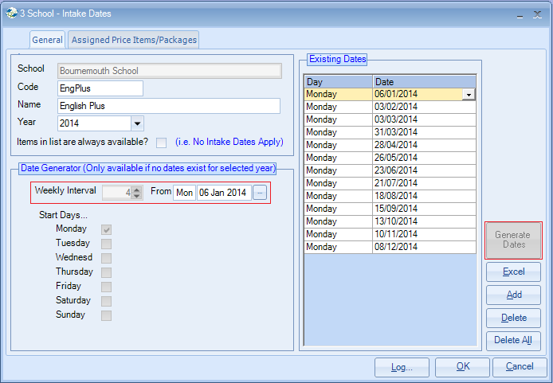

Go to the ‘Assign Price Items/Packages’ tab and assign the course(s) to this intake list.

Example 3)

Term courses
To create a new intake from the intake date browse screen select ADD on the right hand side of the screen.
Use the drop down arrow to choose the first term date from the calendar or type the date manually.
Select ADD again to enter the start of the 2nd term and so on.
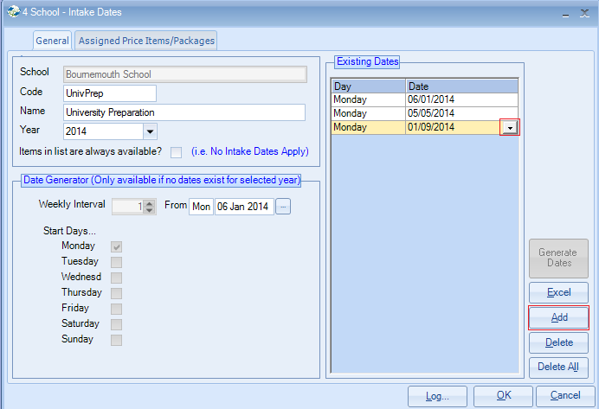

Go to the ‘Assign Price Items/Packages’ tab and assign the course(s) to this intake list.

Further years -
The intakes are set up for one year only.
For a new year you are required to select the YEAR.
The From date will automatically default to the first Monday of that year.
Add the intake dates as before.
The courses are already assigned but you can add/amend if required.

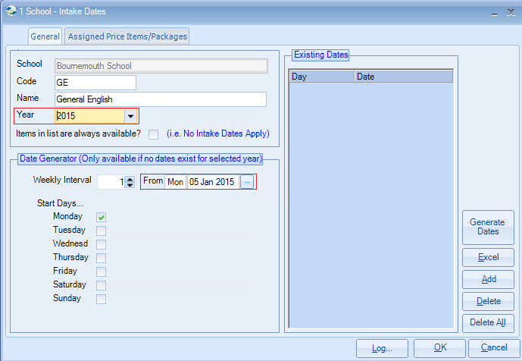

Bank Holidays –
Where there is a bank holiday and the school is closed on the Monday, you can amend the start day to the Tuesday of that week by either, clicking on the date within the list and amending it manually or clicking on the drop down arrow and choosing the Tuesday from the calendar.

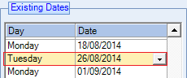
When booking a student to start a course on Monday 25/08/2014 a warning message will be displayed advising that the Monday is not a valid intake date.
The Tuesday date is highlighted and you have the option to ‘Use highlighted intake date’ or ‘use booking date’ (this will book at Monday)
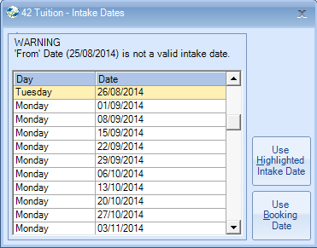

Also refer to Help Document: HS085 Maintenance_Settings - Warning Dates:
If a course start date falls on a national holiday/school closure, dates can be added to display a warning message to stop the user from selecting this date for the start of a course.

