# 

Class.Net – Help Document

# Price List – Accommodation

#### How to set up and link an accommodation price item with a host payment price item.

Accommodation requires the creation of two Price Items (Invoice charge + Payment rate). The two price items then need to be linked together.

#### This can be achieved as follows:

Price List Browse Screen

From the main menu select: Maintenance/Settings > Maintenance

Ensure the correct school is displayed.

Click on the **Accommodation** tab to see a list of your existing prices.

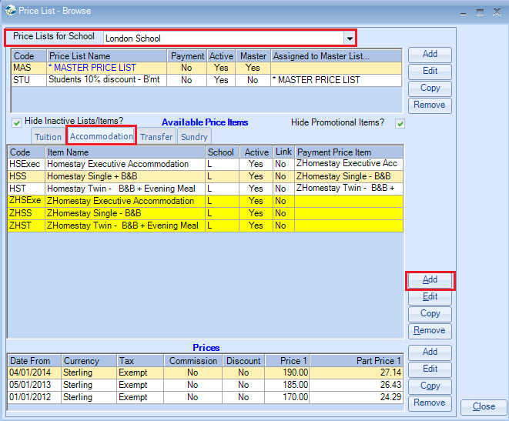

To add a new accommodation price item select **ADD**

Enter the **Code** and **Name** (The name will appear on the invoice)

Select the **Nom**inal Code.

#### Count Days/Nights

Under the heading “Pricing Rules” you can select to count days or nights.

For most accommodation prices “nights” are counted, not days! Select this if it is not selected automatically.

# “Use For”



**Invoice Only** is used for Accommodation Sale Prices (Price to charge student)

**Payment Only** is used for Accommodation Payment items. (Price to pay host family)

**Invoice & Payment Items** are for backwards compatibility and users are advised to select one of the first two options only.

Select Invoice Only

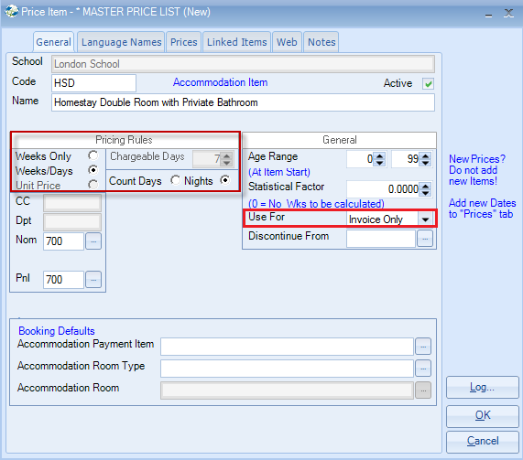

Click on the **Prices** tab.

Select **ADD**

Select YES to the Warning message

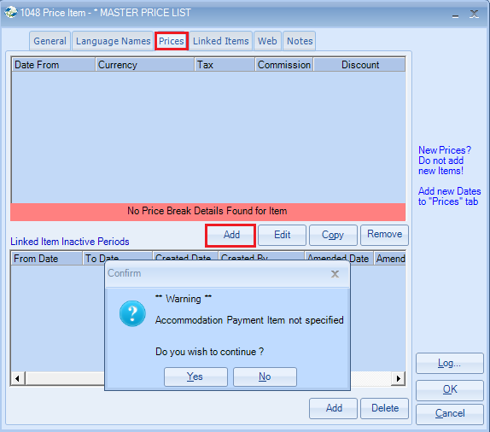

**From Date** – enter the date that your price list starts

Select the **Currency** and **Tax**.  
  
If the prices are charged at the same rate for every week, for example £210, enter this in the Value column within the Calculator.

The prices from week 1 to week 53 will be calculated based on this price.  
  
**Days/Part Units** – If accommodation is invoiced as a “week” for 6 or 7 nights (e.g. Sunday-Saturday or Saturday to Saturday), the rate for day 6 should be the same as the weekly rate.

In the example below the rate for 5 or 6 nights is shown as the same as the weekly rate.

These are the nightly prices and can be overtyped.

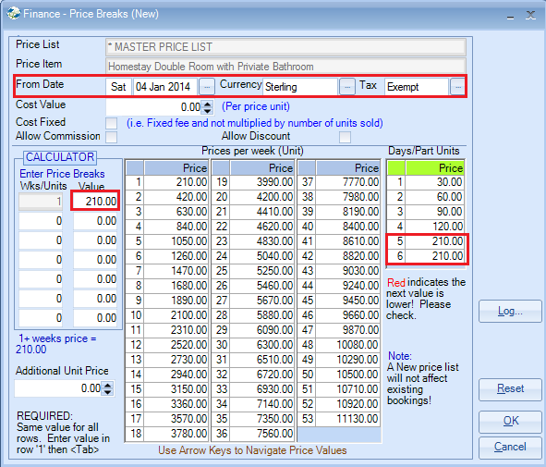

Select OK and close this price item.

(you will receive a warning to say that no Payment Item is specified – Click **Yes**)

Adding the Payment price:

Price items are required for “Accommodation payment” rates and a separate price record should be created for these.

Highlight the new price that you have just created and select **Copy**

Highlight the school and click **Select**

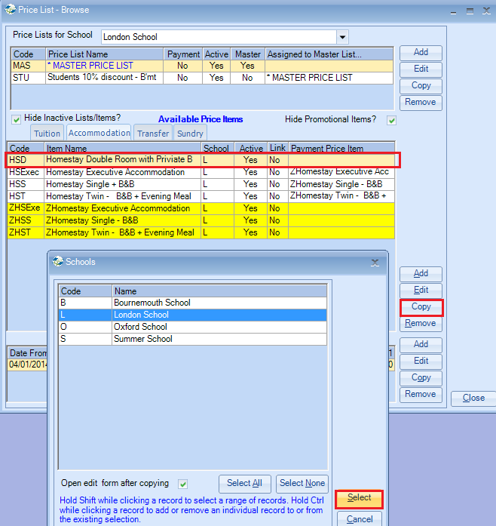

This will create a duplicate price item.

Prefix the **Code** and **Name** to include a “Z” at the beginning.

This is to help identify the payment items.

Use For – Amend to Payment Only

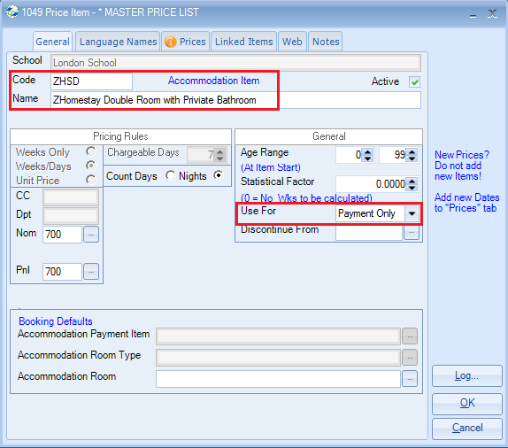

Click on the **Prices** tab

Select **Edit**

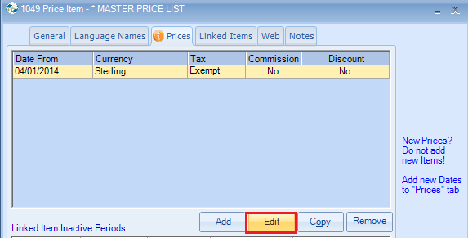

Select **Reset** to bring all the prices back to zero.

Within the Calculator enter the weekly payment price that you will be paying to the families.

Amend the Days/Part Units if required.

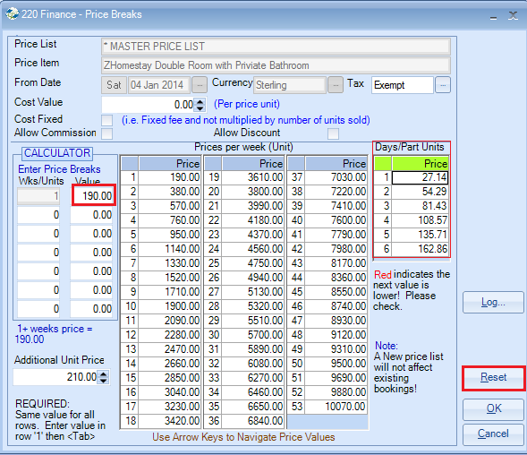

Select OK to close the payment price item.

# Linking the two items together

Having created two Price Items (Invoice + Payment) the items need to be linked together.

Return to the “Invoice” item you first created and on the General screen at the bottom of the screen you can select the **Booking Defaults** as follows:

**Accommodation Payment Item**: add the ‘Z’ payment item.

**Accommodation Room Type**: select the type of room associated with this price item

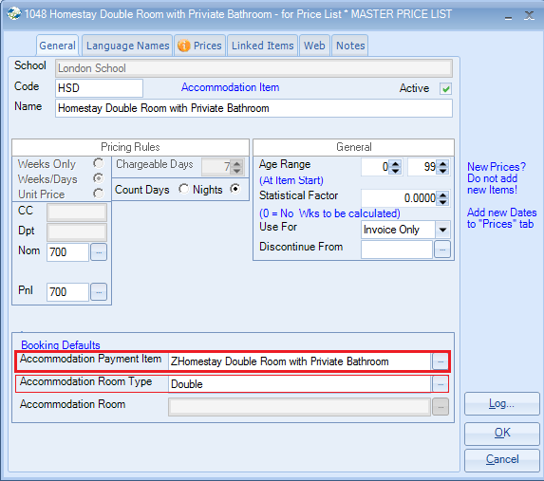

Select **Close**

The Price List Browse screen now shows the invoice item and payment item together.

(“Link” will still read no this is for linking other Price Items – see “Linked Items” Help sheet)

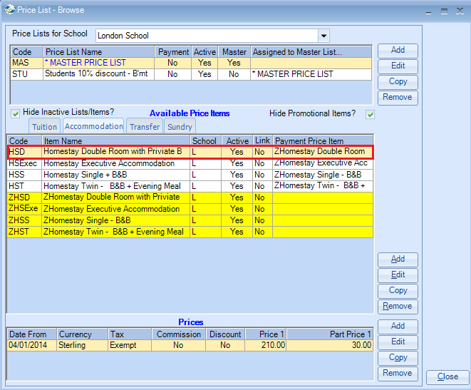

You will also notice in the above screen that all the invoice prices are listed at the top of the screen and all the ‘Z’ payment items are listed at the bottom highlighted in yellow so show they are the payment items.