Class.Net – Help Document

Agent/Statistics – Individual Agent Statistics

This is a quick way to see how an agent is performing over a specific period. Student numbers as well as statistical weeks and values can be found quickly from within an agent’s record.

To produce this information for just one agent go to the Agent Browse and select the specific agent record.
Go to the Statistics tab.

Booking Based - based on the date the booking item was entered into the system.
This refers to the course/accommodation/etc, and not the date that the student’s enrolment was entered in to Class.
Production Based - based on spreading the enrolment element (eg. Tuition) over the duration of the study/stay (dates attended).

Enter the required date range by selecting the “Year Starting” date and “As at Today”.

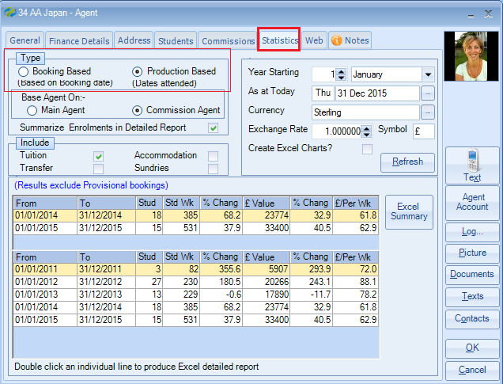
Include - The most popular option is to run this report for Tuition only. However, you can select any of the other options and also ALL options.
Note: if multiple options are chosen the Student Weeks calculation will be based upon the items selected.

Results - This Year / Last Year - will give student numbers and student weeks for the selected date range.

A further 5 year comparison for each full year is also listed.

Refresh - If changes are made to the selection this must be selected to refresh the results.

Excel Summary - The results can be sent to Excel.

Excel Charts? – If required charts can also be included in the Excel report

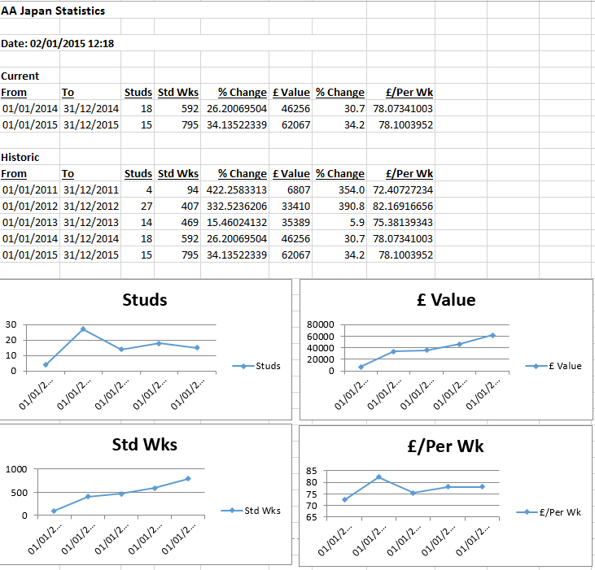

Note: Provisional bookings are excluded from the results.

Detailed Report - Double click an individual line to produce an Excel detailed report. This will show a breakdown of students that make up the numbers.

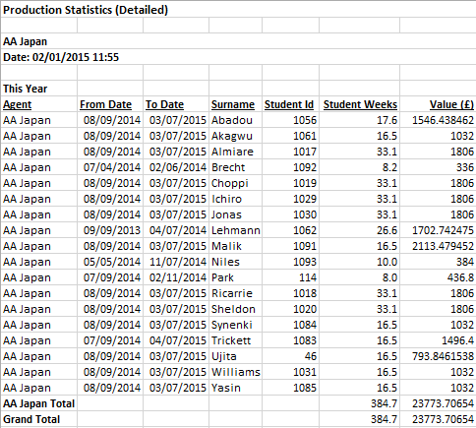

Please note: Other statistics help documents are available.

