

# Class.Net – Help Document

**Web Camera / Card Printer**

**We are often asked to recommend a webcam or card printer that works well with Class.**

**Please find below our recommendations:**

**Web Cam**

The Webcam that we have tested and works well with Class.Net is Microsoft LifeCam HD-3000.

We have recommended this model to other clients.

Cost from £20

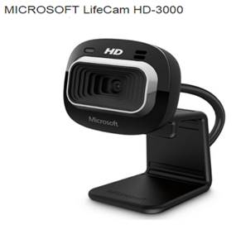

**Card Printer**

We have several clients using IDP Smart printers and they find these easy to use and good for producing student cards within Class.

You can buy single sided printers or double sided printers.

This link gives helpful information about the printers available, but shop around for the printers and consumables as the prices vary.

<http://www.idpcardprinters.co.uk>