Class.Net – Help Document

Enrolment – Booking Status & Arrival Status

This document explains the use of the above two status options and how they affect the enrolment process.

Booking Status -
Options: Booked, Provisional
Arrival Status -
Options: Confirmed, Provisional, Delayed, No Show
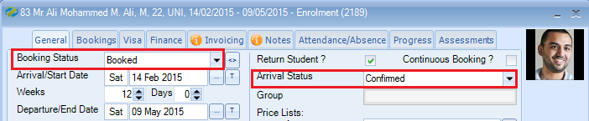
When adding a new enrolment the most popular defaults are ‘Booked’ and ‘Confirmed’ as shown in the example above. However, within the company settings the defaults can be changed to your own requirements.
To check or amend the settings go to:
Maintenance/Settings > General Settings
Company > Company
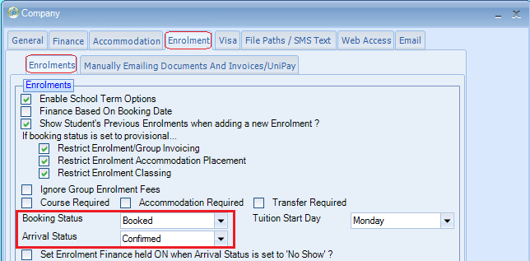

Booking Status:
Booked: will allow full processing of an enrolment.
Provisional: This is only applicable if the company settings restrictions are in place and a couple of examples of its use are:
- Student/agent has confirmed their booking but you are awaiting their visa details.
- Student/agent has confirmed their booking but you are awaiting payment.
There are 3 separate restrictions available when the Booking Status is provisional –
Restrict Enrolment/Group Invoicing
Only the Proforma invoice can be produced for both individual and group bookings.
Note: If the final invoice has been produced you cannot change the Booking Status back to Provisional.
Restrict Enrolment Accommodation Placement
The student cannot be placed in to their host family / residence / hotel.
Note: If the student has already been placed in to the Homestay you cannot change the Booking Status back to Provisional.
Restrict Enrolment Classing
The student cannot be placed in to a class.
Note: If the student has already been classed you cannot change the Booking Status back to Provisional.
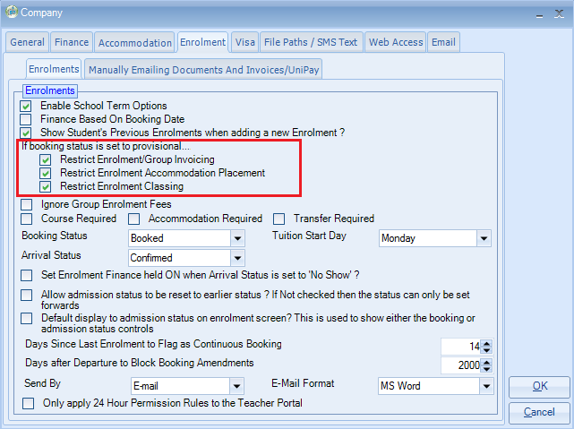
Any or all of the above restrictions can be removed if required.

Arrival Status:
This status is linked to the Homestay Payment Run
Confirmed: will allow the homestay payment to be processed.
Provisional, Delayed, No Show: Either of these status can be selected and will prevent the homestay payment from being processed.

Admission Status:
Please refer to separate help document HS213
