Class.Net – Help Document

Enrolment – Copy/Cancel

*** INDIVIDUAL ENROLMENTS ONLY***

There are several uses for this function:

Example 1) The wrong agent has been invoiced
You have booked a student and produced the final invoice. You then realise that the wrong agent was assigned to the booking.
The Copy/Cancel function can be used to create a new enrolment which will allow the correct agent to be selected and the existing enrolment will be cancelled.

Example 2) Booking siblings
You could have bookings for two siblings both studying the same course at the same time. Add the first student and enrolment as normal.

The Copy/Cancel function can be used to create a duplicate record. Then just change the name and age of the duplicated student.

PROCESS - Example 1) The wrong agent has been invoiced

The Final invoice has been produced with the wrong agent assigned and you need to produce an invoice for the correct agent.
The Main Agent is greyed out so you can’t assign the correct agent.

It is not necessary to cancel the existing enrolment and then add all the details manually in to a new enrolment. Instead use the Enrolment Copy/Cancel function

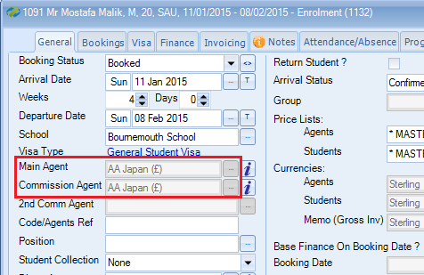

From the enrolment browse screen find the student who has been assigned to the incorrect agent.
Ensure the student is highlighted.
Select Copy/Cancel

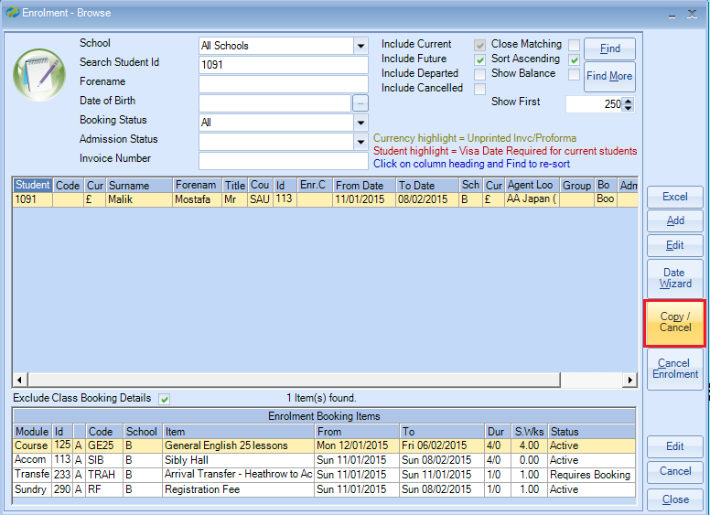

Do you wish to create a new student as well as a new enrolment?
Select NO
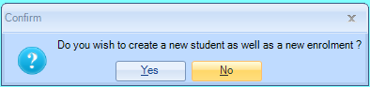

Enrolment Copy Options screen -
The default items that are already ticked should remain selected.
Other options can also be copied in to the new enrolment by ticking the required items.

Package Bookings:
If the student has been assigned to a package tick the items within this list.

Regular Bookings:
If the student has been booked in to individual booking items tick the items within this list.

Visa Details, Attendance & Progress Details, Assessments, Other:
The items that are not ticked are self explanitory, but if in doubt we would suggest ticking all items as this can not do any harm.
Enrolment – Reset Creation Date?
Leave this unticked if you require the ‘Enrolled Date’ within the students enrolment General screen to remain unchanged. This will be set to the same date that the original enrolment was entered.
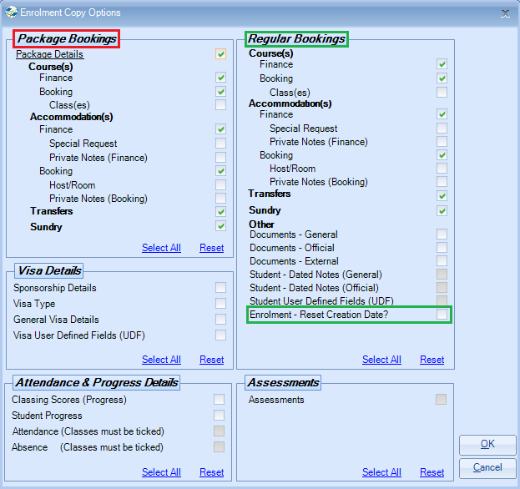
Tick any additional items you wish to copy to the new enrolment.
Select OK

Do you wish to cancel the Original Enrolment?
Select YES
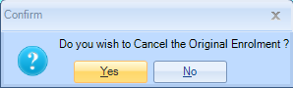

Do you want to remove any unprocessed documents from this cancelled enrolment?
Your choice, but we would suggested selecting YES
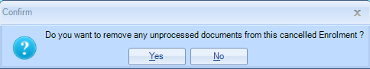

To display both the new enrolment and the cancelled enrolment tick the ‘Include Cancelled’ option and select FIND.

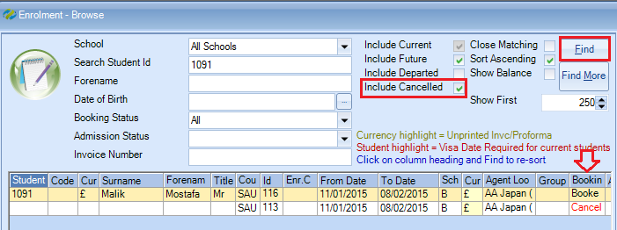

NOTE:
The Cancelled enrolment will require a credit note to be produced to cancel out the incorrect invoice. Also, if a payment/receipt has been entered against the incorrect agent, then the receipt will need to be reversed within the Ledger.

New Enrolment –
Open up the newly created enrolment and from the General screen select the correct agent.

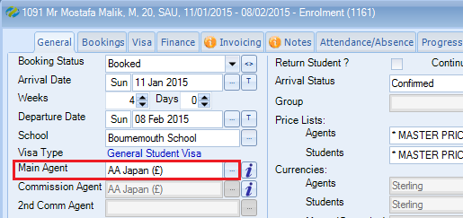

Select YES to recalculate the finance based on the new agent.
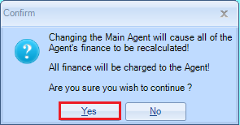

Do you want to select a second Commission Agent before the enrolment is refinanced?
Normally NO, but select YES if you wish to assign a 2nd agent.
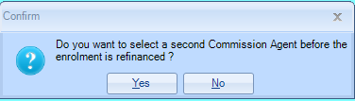

Ensure the agent is now assigned correctly.
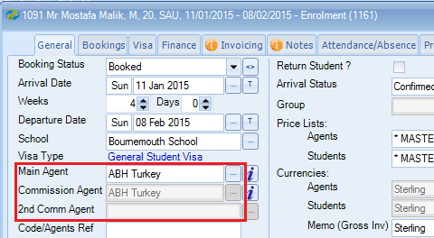

You can now check the Finance screen to ensure the prices have calculated correctly before producing the new invoice for the agent.

With regards to any attendance/absence records, host bookings, documents, visa details, notes, etc, as long as you ticked the option to copy this information the details will appear in the new enrolment.

Remember to add any payments within the agent’s ledger account for this new enrolment.

PROCESS - Example 2) Booking siblings

Enter the first student in the normal way together with his/her course, accommodation, sundry items, etc.
When this is completed go to the Enrolment Browse screen and highlight the student.

Select Copy/Cancel

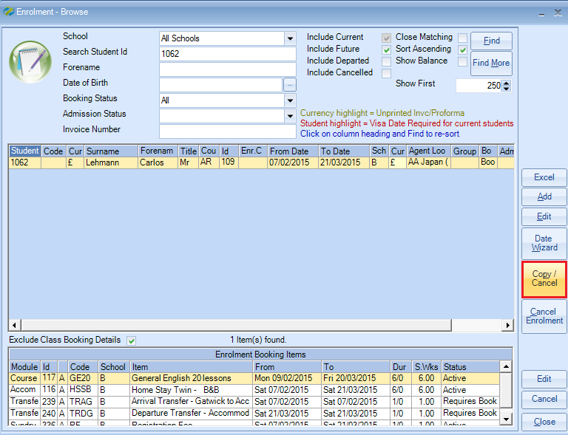

Do you wish to create a new student as well as a new enrolment?
Select YES
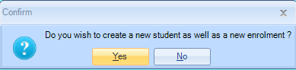

Enrolment Copy Options screen -
The default items that are already ticked should remain selected.
Other options can also be copied in to the new enrolment by ticking the required items.

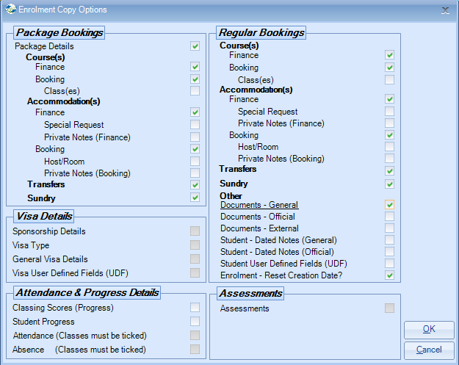
Select OK

The copied student will be displayed with a unique Student Id number.

Go in to the copied student’s record to amend the name and aged/DOB.
Also, make any amendments to the enrolment, if required, i.e. book the accommodation host/room.

