Class.Net – Help Document

BACS Output File – Homestay Payments
How to produce a list of host payments to send to your bank.

Within the homestay payment run there is a BACS file that can be created which is saved in an export file.

This file is generated for all families whose payment method within their banking screen is set to 'Transfer' and their bank details entered correctly.

Example shows host families banking details:

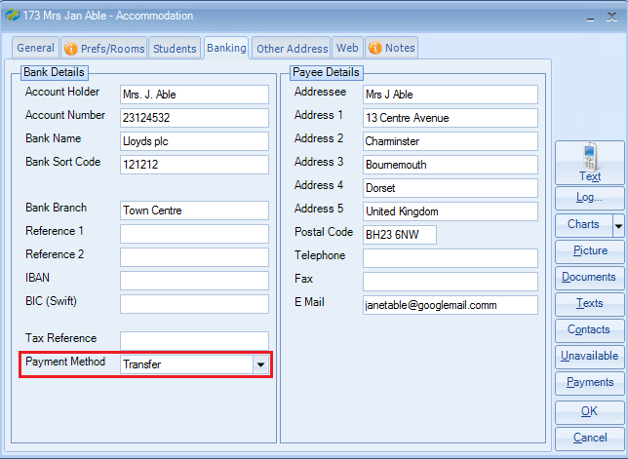

Reference 1:
If the host has a building society account the field is used to record the Building Society Roll Number.

IBAN & BIC (Swift):
These fields are used for the ‘European Credit Payments - SEPA’ in order for the payment BACS files to be generated to meet the SEPA specifications.

One off setting - Maintenance/Settings > Schools:

Edit the school and in the Bank Details tab set the schools bank details and IBAN, BIC Swift and Originator ID Number (if applicable)

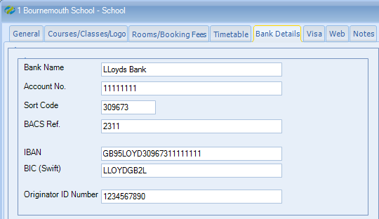

PROCESS
Within- Accommodation > Payments:

Once the ‘Final’ homestay payment run has been completed, the Reports screen will include the option to produce the BACS Output File.

This will save a file within an export folder in the location stipulated.

Example:
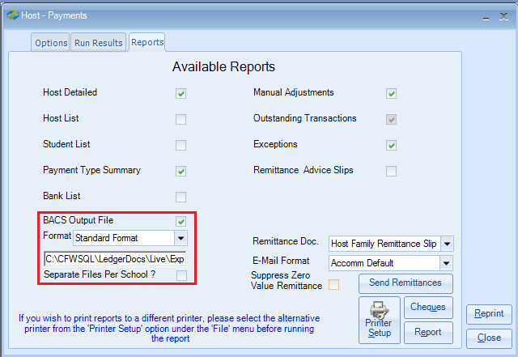

There are a variety of different formats available as different banks use different formats.

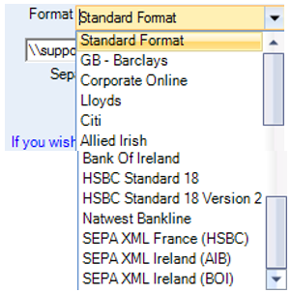

NOTE: If your bank is not listed please contact the support desk.

When selecting the required BACS Output File, messages similar to the following will be displayed, showing where the file has been saved, together with the total number of BACS payments and total payment value.

Each time you produce a payment run and create the BACS output file, the previous file is overwritten.

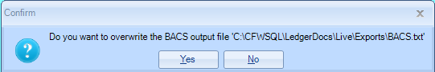

Select YES

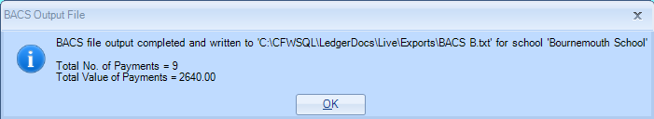

Select OK

The BACS file will now be created.

Browse to the location of the Export file to open the new BACS payment list.

FOR CLASS CLOUD CLIENTS:

Click on the File Explorer icon in Class

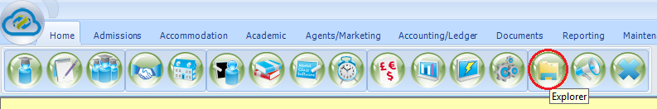

Browse to the location of the Exports folder.
Find the newly created BACS file.
Right click on the file and select Copy.

Now browse and Paste to your local Workstation where you would normally upload the file to the bank.

Below please find examples of the difference layouts available.

If you are using the BACS file for the first time, we would suggest you send a copy of the example BACS files to your bank and ask if they can use any of these formats.

Example of the ‘Standard Format’ BACS output file:

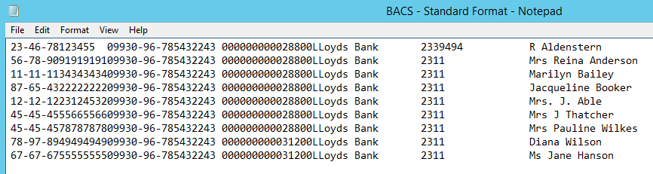

Example of the ‘GB Barclays’ format BACS output file:
(Barclays is a UK bank and they request no ‘-‘ within the sort code):

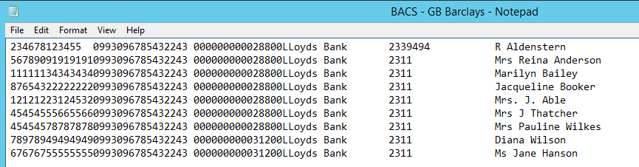

Example ‘Corporate Online’ format BACS output file:

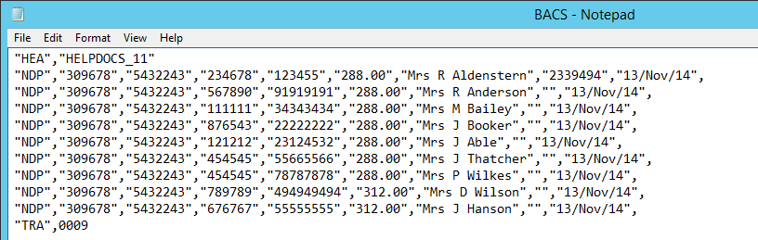

Example ‘Lloyds’ format BACS output file:

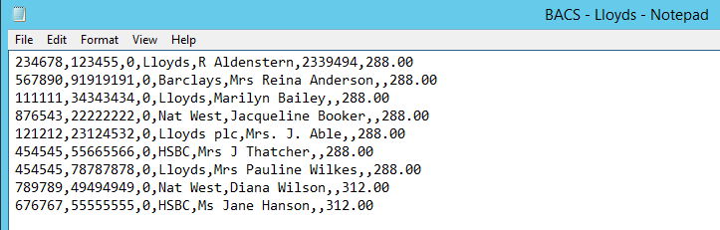

Example ‘Citi’ format BACS output file.

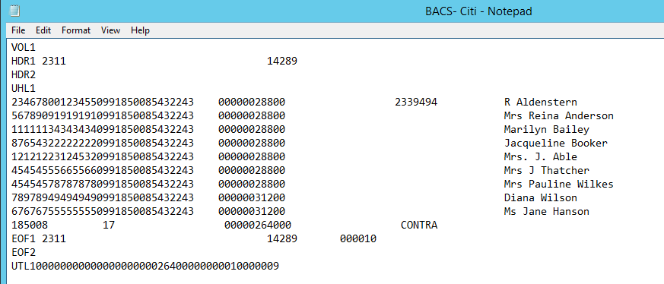

Example ‘Allied Irish’ format BACS output file.

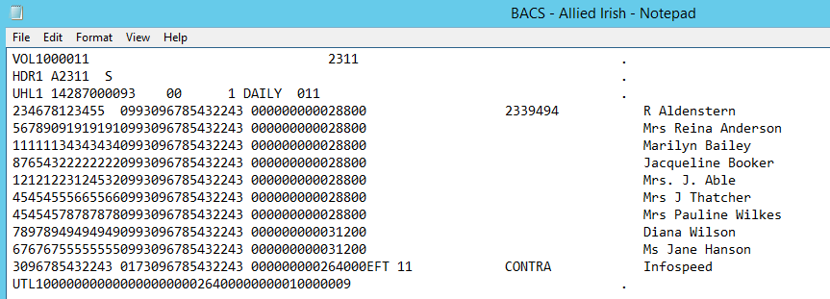

Example ‘Bank of Ireland’ format BACS output file.

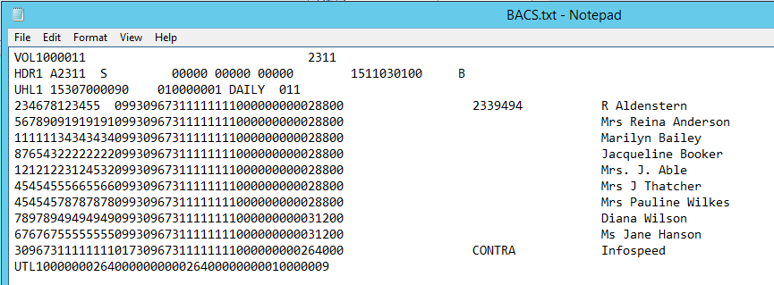

Example ‘HSBC Standard 18’ format BACS output file.

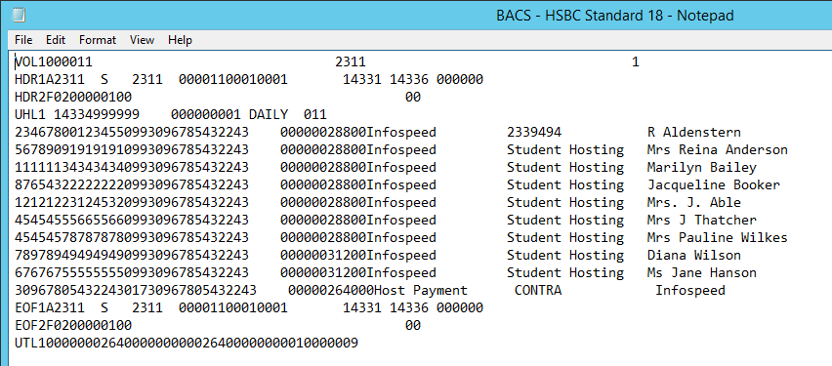

Example ‘HSBC Standard 18 Version 2’ format BACS output file.

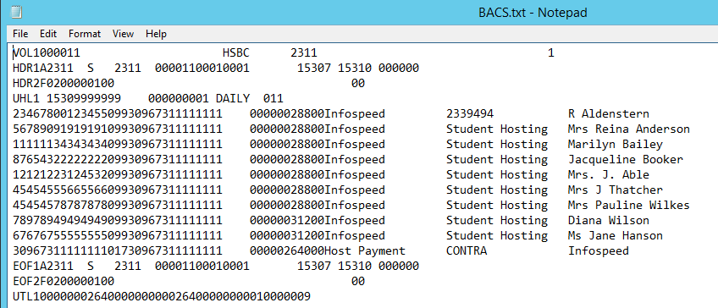

Example ‘Natwest Bankline’ format BACS output file.

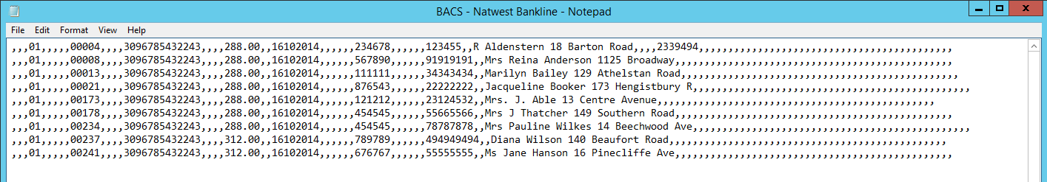

Example ‘SEPA XML France (HSBC)’ format BACS output file.
* Please request the file from Infospeed.

Example ‘SEPA XML Ireland (AIB)’ format BACS output file.
* Please request the file from Infospeed.

Example ‘SEPA XML Ireland (BOI)’ format BACS output file.
* Please request the file from Infospeed.

*The SEPA XML BACS output files are in a different format and hold much more information. If you require a full example of one of the above SEPA files then please contact the support desk quoting your bank. support@infospeed.co.uk

Office Use Only - SEPA files can be found in:
K:\Docs\Class\Class Net Specific\Support Class.net\Sample BACS Output Files

