# 

# Class.Net – Help Document

**Teacher Payment Grades**

**How can I set payment grades for different teachers and different classes in order to calculate their pay?**

TEACHERS**:**

**Payment Grades**

Set up the payment grades in each of your teacher’s records.

This can be the rate they are paid for teaching different classes.

For example:

* The payment rate for a beginner’s class could be £10.00 (Grade 1)
* The payment rate for an intermediate class could be £12.00 (Grade 2), etc.

Please also refer to text in blue below:

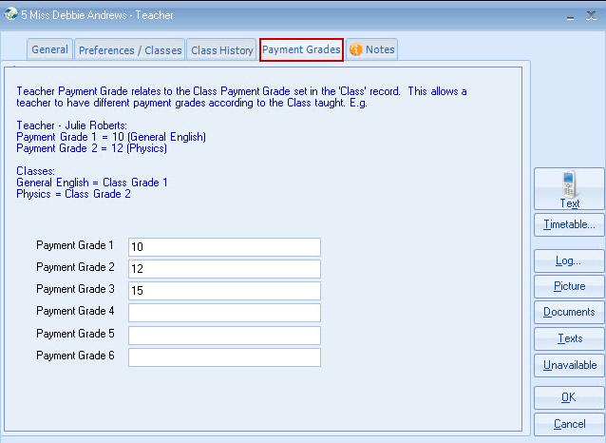

Other options are to set the Payment Grades as - 1,2,3,4,5,6 or A,B,C,D,E,F.

CLASSES:

In each of your Classes you will need to enter the Payment Grade which relates to the class.

This will also relate to the payment grade entered within the teacher’s records.

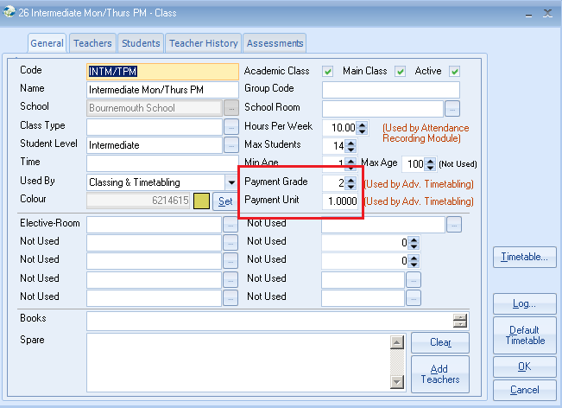

In the example above class INTM/TPM is grade 2 so the teacher will be paid £12.00 for each payment unit.

Back in the teacher’s record:

On the ‘General’ screen enter the Grade that the teacher usually teaches.

No. Pay. Units – this is the number of units/hours the teacher is scheduled to teach in a week.

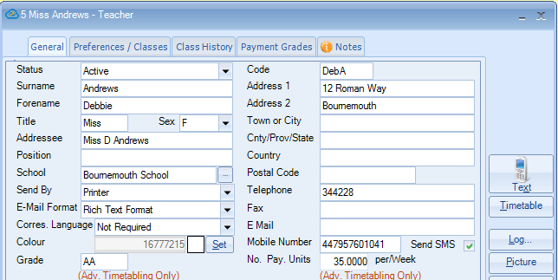

Teacher Payment Unit Analysis Report:

Academic > Teacher Unit Analysis

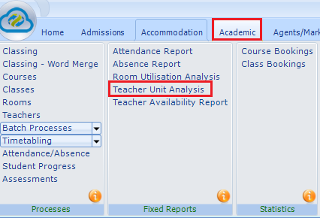

Make your required selection:

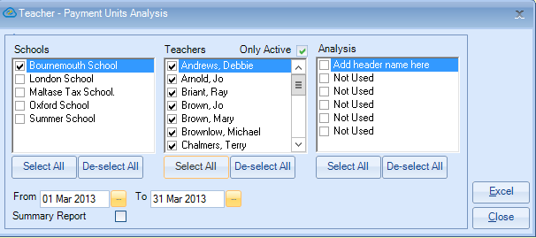

Each class that the teacher has taught is listed showing the ‘Class Grade’ and the ‘Teacher Pay Grade’

In the example below it shows that Debbie Andrews has taught a total of 37 units/hours.

The Class Grade picks up the teacher’s pay grade.

From this you can calculate the teacher’s pay for the week/month.

