

Class.Net – Help Document

Reporting –
Student Visa/Passports & UK Sponsorships Report

This document explains how to report on students whose visas, passports or UK sponsorship numbers may be expiring whilst the student is still studying.

Go to: Admissions > Visas/Passports & UK Sponsorships

Create your own reports from this menu using the ‘Add’ button.

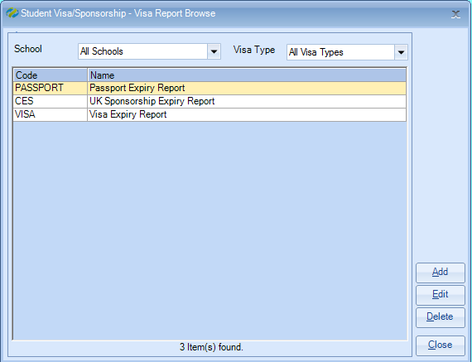

Criteria:

Give your report a name.

The report can be run for a specific group or student, but leaving this criteria blank will search for all students.

Enter your required selection:
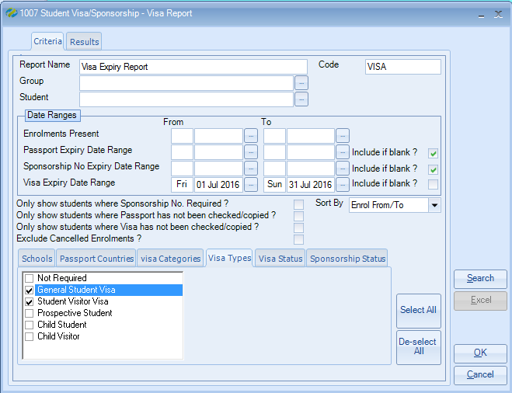

There are various date range search options.

Enrolments Present will include all students in the school during a specific date range.
Passport Expiry Date Range will include all students whose passport will expire in a particular date range.
Sponsorship No. Expiry Date Range will include all students whose Sponsorships will expire in a particular date range.
Visa Expiry Date Range will include all students whose visa will expire in a particular date range.

Tip: It may be best to have a separate report for Passports, Visas and Sponsorship. E.g. include all the students “Present” within a particular date range and whose passport expires during a date range.

Further selections are available within the tabs at the bottom of the report:
Schools, Passport Countries, Visa Categories, Visa Types, Visa Status and Sponsorship Status.

Select Search to find the results

Higlight a student in the list and select either the ‘Enrolment’ or ‘Student’ button to access the student details.

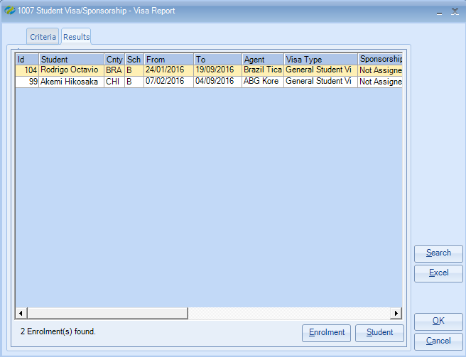

Select EXCEL to export the results in to a spreadsheet.

