# Class.Net – Help Document

## Academic - Assessments

**The purpose of assessments is to record the student marks, typically at the end of a course before moving onto University. The marks can be weighted according to assessment type and course structure. Exit marks can also be recorded which are usually held for information purposes only.**

**Note: Assessments is part of the Advanced Academic Module**

#### Settings - Assessment Grade

Different grade scales can be set up according to course pass/fail marks and assign courses accordingly. For example a pass mark for one course could be 70 but for another a course could pass with 40.  
  
Maintenance/Settings > General Settings.  
Academic > Assessment Grades.

From here you can **Add,** **Edit**, **Delete** and **Copy** Assessment Grades...

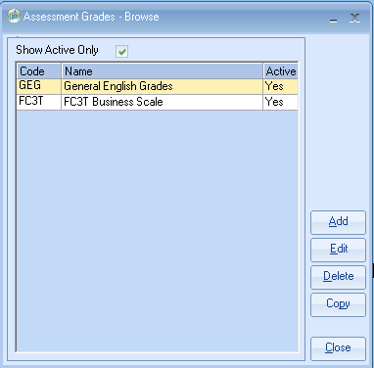

Clicking Add or Edit will display the following form...

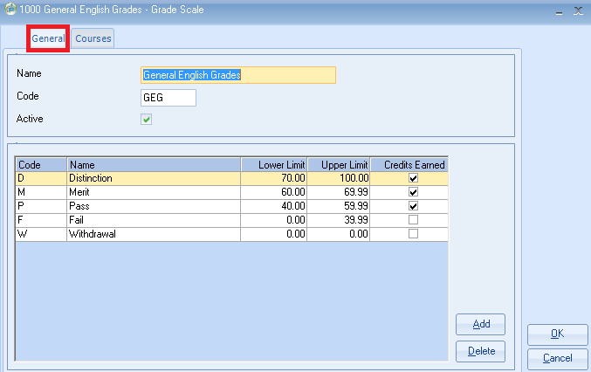

* Type in the Assessment Grade **Code and Name.** The Active checkbox will default checked.
* When you click on **Add**, a new row will be added to the Grade Scale items grid, to enter the **Code, Name, Lower Limit, Upper Limit**, and a checkbox to indicate whether Class Credits are earned for the student at this level.
* Please ensure that in the Upper Limit you input the decimal places e.g. 39.**99** so that calculations on the students enrolment Assessment tab are calculated correctly.
* **Credits Earned:**

**Box Unticked**

This would mean that if the student’s score was within these bands then **no credits** **will be added** within the students Enrolment / Assessment screen.  This is the most common option if a student fails.

**Box Ticked**

This would mean that if the student’s score was within these bands then **credits will be added** within the student Enrolment / Assessment screen.  This is not the most popular option as it means that a student will gain credits even if he fails.

* Clicking on the **Courses** tab, will allow you to assign course to this Assessment Grade...

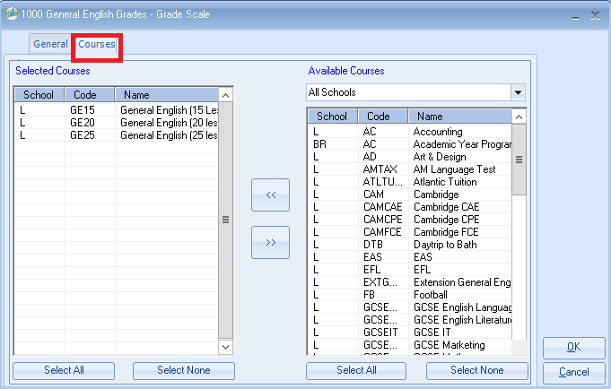

* Courses can be filtered by **School**, multiple courses can be selected by holding down the **CTRL** key and clicking on the **Available Courses**, and clicking on the **<<** button will assign these courses to this Assessment Grade.
* Likewise to un-assign courses, multiple courses can be selected by holding down the **CTRL** key and clicking on the **Selected Courses**, and clicking on the **>>** button will un-assign these courses from this Assessment Grade

**Note:** courses cannot be assigned to more than one Assessment Grade Scale.

#### English Language Exit Grades or Elective Classes

As well as setting up grade scales for Courses, you can also setup up a special grade scale for the English Exit Class, this will have to be assigned to the Class that has been nominated as English Language Class, this will typically have two grade items Pass & Fail with no creditsas these are not counted in the final grade.

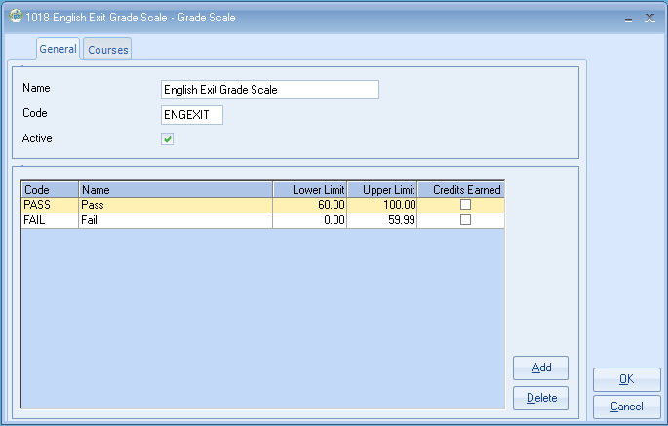

#### Setting up Assessment Types

From Maintenance/Settings >General Settings. Academic > Assessment Types

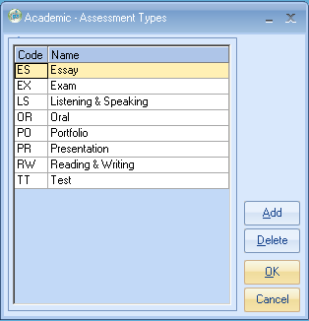

* From here you can **Add** and **Delete** Assessment Types
* Clicking **Add**, will add a new row where you can add **Code** and **Name** for the Assessment Type.
* To **Edit** an Assessment Type, you can double click into the required cell and change text accordingly.

#### Setting up Assessment

From Maintenance/Settings > General Settings select **Academic -> Assessments**

Different courses may have different assessments with different weightings which need to be created here. For example on one course an Exam could be worth 50% but on another could be only 30%.

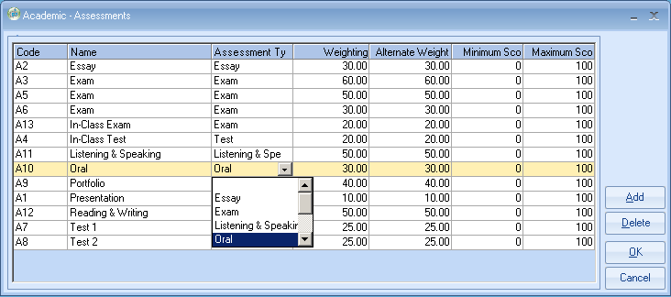

* From here you can **Add** and **Delete** Assessments
* Clicking **Add**, will add a new row where you can add **Code** and **Name, Assessment Type, Weighting, Alternate Weighting, Minimum Score** and **Maximum Score** for the Assessment.
* **Alternate Weight** – an example for it’s use would be if an assessment was used for students studying to move to a university and the university may have a different weighting system than the school.
* To **Edit** an Assessment you can double click into the required cell and change text accordingly.

**Set Up – Courses**

From the Course (Academic > Courses) the Total Credit Score allows you to add the credit value for this course

This would normally be 0 for Exit classes.

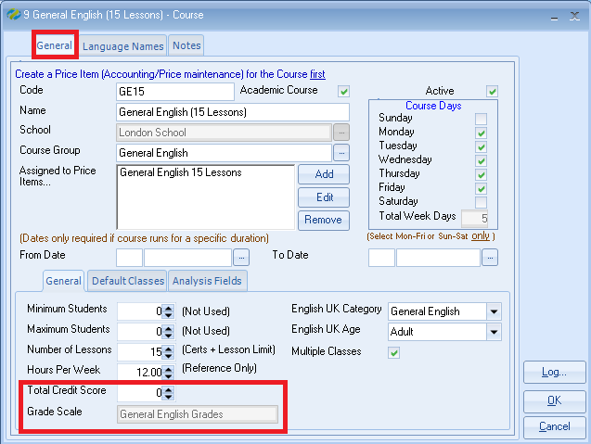

Also, a read-only field has been added to indicate, which Grade Scale this course has been assigned to, if no grade scale has been setup for this course, it will display “*Not Assigned*”.

#### Set Up – Classes

#### Within the class record select the Assessments tab

* Clicking on **Add**, will allow you to select from a list of Assessments to be assigned to this class. Duplicate assessments are not allowed.
* It is advised that the “Weighting” in the table of assessments should add up to 100
* Clicking on **Delete**, will un-assign selected Assessment from this Class.
* No. of **Credits** – set the credit value for the amount of credits to be earned if the student passes this class.
* **Grade Scale** – classes can also be assigned to a grade scale so they can be included in the total grade, for example if the grade scale is not assigned the grades for this class will not appear on the students assessments results. If the Grade scale is set to Assigned by Course it will pick up the grading from the course grade scale and be included in the final assessment result. One last option would be to override to an alternative grade scale from the default if required. (Normally you would use Assigned by course or Not Assigned).

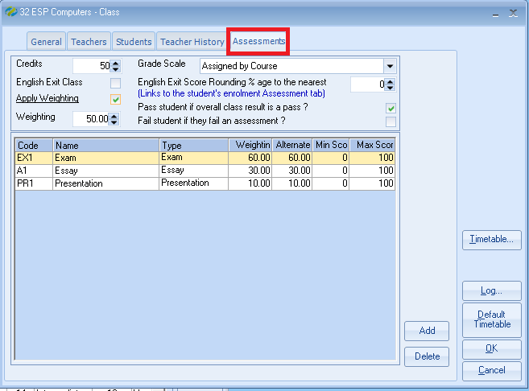

**English Exit Class and Score Rounding %**

You can also nominate a Class as being used for the English Language Exit Score so the scores are not counted, and where these scores are rounded you can, if required adjust the rounding percentage used.

**Apply Weighting**

Tick this box if the Weighting value, (in this example 50) is to be applied to the assessment scores for this class.

#### Permissions

There are User Permissions for Add, Edit, View and Delete Assessment Scores...

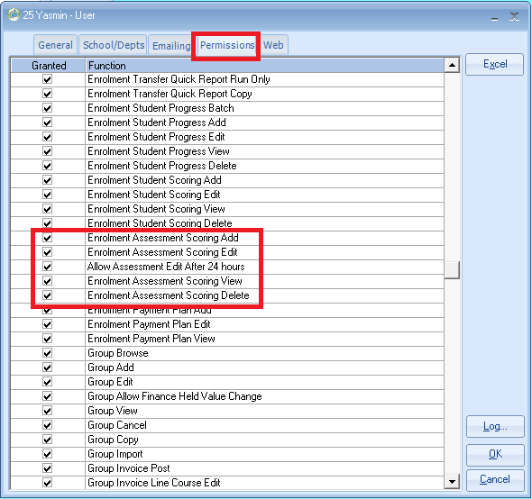

#### Enrolment Assessment Scores

Assessment Scores can be viewed/created from the students enrolment Assessment tab. The top half of the screen is to create the assessment scores and the bottom half is to view the students current scores and totals.

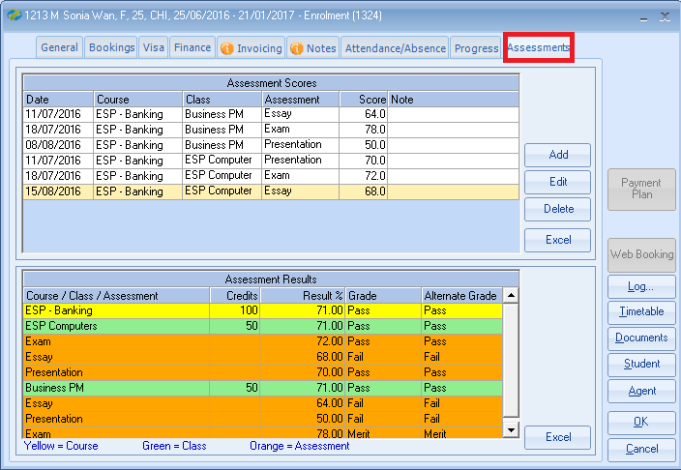

* Yellow line = Course
* Green lines = Class
* Orange lines = Assessment

When you click Add or Edit, you will be presented with the following form.

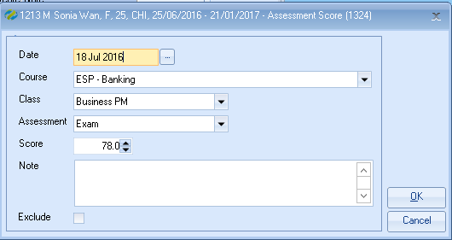

* The **Date** will default to Today, but can be changed if required.
* The **Course** dropdown will be pre-populated with only the Courses assigned in the enrolment, that have Classes assigned.
* The **Class** dropdown will be populated with the Classes within the selected Course.
* The **Assessment** dropdown will be populated with the Assessments assign to the selected Class.
* The **Score** is a free form numeric field.
* The **Note** is a free form text field.
* **The Exclude checkbox once checked will exclude the score from the overall results, this would typically be used where a student re-sits an assessment, and the previous assessment taken can be excluded.**

#### Assessment Results

The grid to the bottom of this Assessments tabs shows you the student’s current assessment results and if they are on track to pass the course.

The example below has been sent to Excel to give a clearer display, this could be printed out and given to the student.

**Explanation of results:**

Course: ESP Banking

Classes: ESP Computers and Business PM

Assessments: Exam 60% Essay 30% Presentation 10% (these are the same for both classes).

Result for ESP Computers 71, this comprises of:

Exam – 72 this is worth 60% which gives a total of 43.2 marks for this assessment

Essay – 60 – this is worth 30% which gives a total of 20.4 marks for this assessment

Presentation 70 – this is worth 10% which gives 7 marks for this assessment

These three values total 70.6 which is rounded to 71 for the overall score for this class ESP Computers.

Result for Business PM 71, this comprises of:

Exam – 78 this is worth 60% which gives a total of 46.8 marks for this assessment

Essay – 64 – this is worth 30% which gives a total of 19.2 marks for this assessment

Presentation 50 – this is worth 10% which gives 5 marks for this assessment

These three values total 71 for the overall score for this class Business PM.

Therefore these two class totals add up to 142, and as the two classes are worth 50% weighting of the overall course result this equals 71% so this student has passed the course.

#### 

#### Quick Reports

When creating a new, or amending an existing Quick Report of **Enrolment Type**, there is a section of fields where you select the **Add Field** button, this section is called **Student Assessments**, and contains three sub-sections **Assessment**, **Class**, and **Course**, which contain respective assessment related fields.

|  |  |  |
| --- | --- | --- |
| **Assessment** | **Class** | **Course** |
|  |  |  |

#### Word Merge

When creating a new or amending an existing **Master Document Template** of **Enrolment Type**, a section of fields has been added to the **Word Edit** form, that shows when you are editing/create a Master Document Template, this section is called **Student Assessments**, and contains three sub-sections, **Assessment**, **Class** and **Course**, which contain respective assessment related fields ...

|  |  |  |
| --- | --- | --- |
| **Assessment** | **Class** | **Course** |
|  |  |  |

#### Batch Entry

This can be done either from within the main part of Class or the Teacher Portal.

**Class**

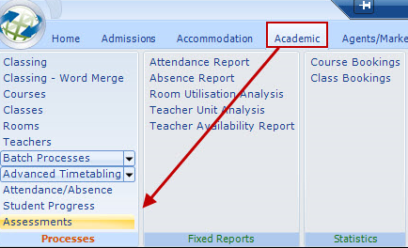

A selection screen is displayed, where you can update the assessments by course, class or student.

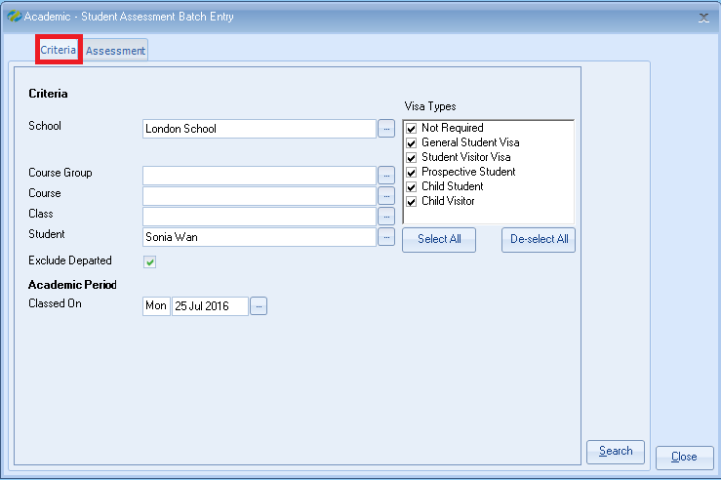

The student’s will be listed and the grades can then be added.

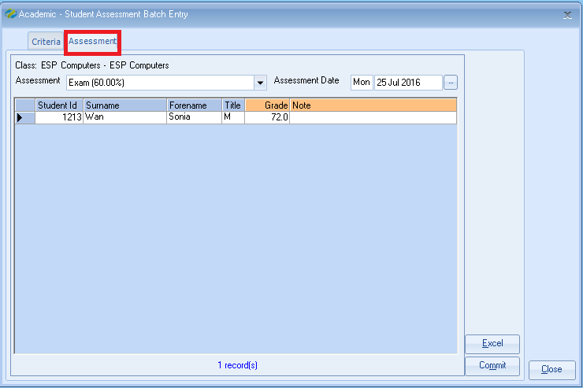

Click on “Commit” to update each of the student’s enrolments.

#### Teacher Portal

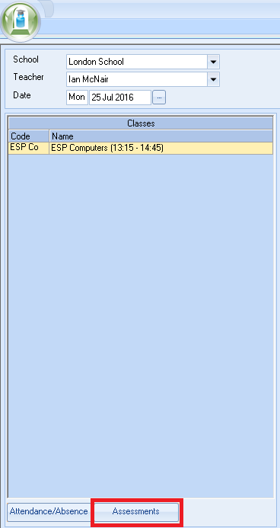

* Click on “Assessments” and the following screen will be displayed.
* Input the “Grades” and then click on “Commit” which will then update each of the students enrolments.

