Class.Net – Help Document

Statistics – All School Statistics Summary

This is a quick way to see how your school(s) are performing over a specific period. Student numbers as well as statistical weeks and values can be found quickly from this report.

To produce this information go to:
Reporting / Reporting Module.
Reporting / All School Statistics Summary
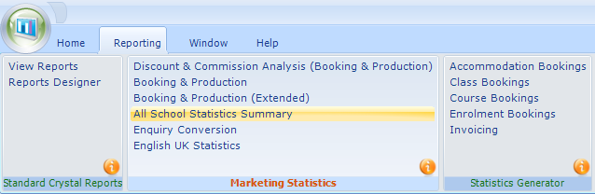

Booking Based - based on the date the booking item was entered into the system.
This refers to the course/accommodation/etc, and not the date that the student’s enrolment was entered in to Class.
Production Based - based on spreading the enrolment element (eg. Tuition) over the duration of the study/stay (dates attended).
Enter the required date range by selecting the “Year Starting date” and “As at Today”.

Include - The most popular option is to run this report for Tuition only. However, you can select any of the other options and also ALL options.
Note: if multiple options are chosen the Student Weeks calculation will be based upon the items selected.
Results - This Year / Last Year - will give student numbers and student weeks for the selected date range.
A further 5 year comparison for each full year is also listed.
Refresh - If changes are made to the selection this must be selected to refresh the results.
Excel Summary - The results can be sent to Excel.
Excel Charts? – If required charts can also be included in the Excel report
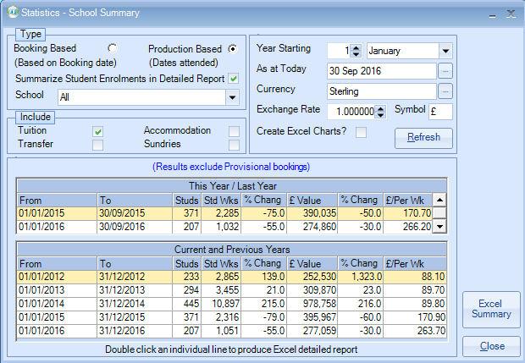

Note: Provisional bookings are excluded from the results.
Detailed Report - Double click an individual line to produce an Excel detailed report. This will show a breakdown of students that make up the numbers.

