Class.Net – Help Document

Enrolment – Amendments after Final Invoice

How to amend a student’s finance after the Final invoice has been produced

Occasionally after the final invoice has been produced an amendment needs to be made to the booking which requires a new invoice.

This help document is based on the following example:
The Final invoice has been produced for the wrong course value and a new invoice needs to be created with the correct course value. It also needs to include all the other booking items; accommodation, transfers and Sundry.

EXAMPLE:

Students Enrolment - Invoicing screen.
This shows that the Final Invoice has been produced:

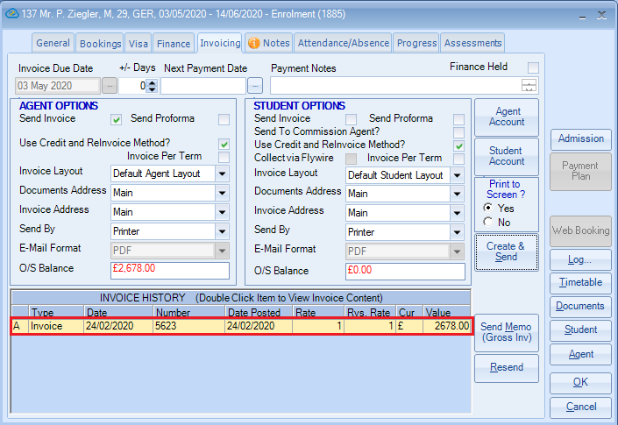

From the Bookings screen open up the booking line that is incorrect:
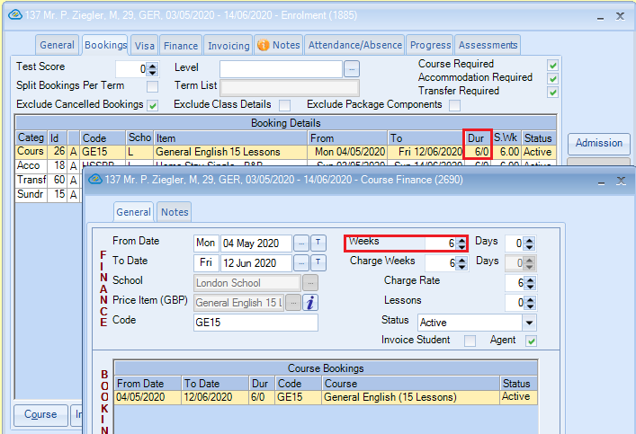

To force a recalculation of the finance amend the Weeks to one week more:
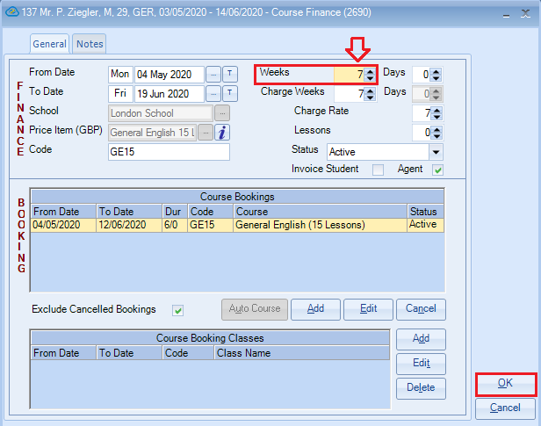

Select OK

Select YES to the following message:

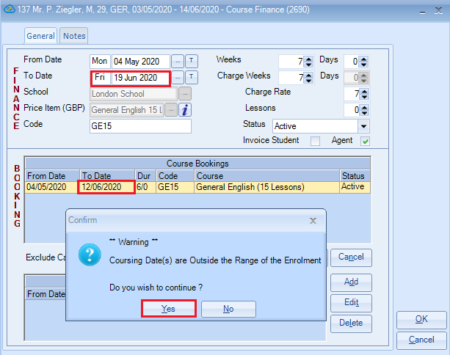

Select YES to re-finance:
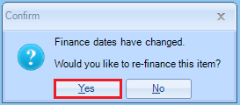

Select YES to bring the underlying Course Booking date in to line:
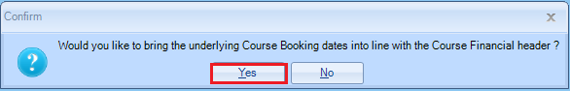

Now check the dates to ensure they all match (they will be 1 week less)
Select YES to proceed:

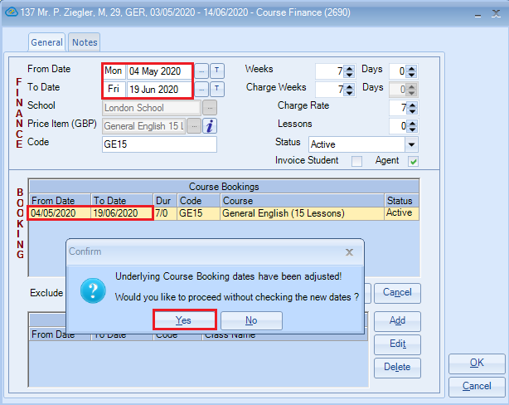

Bookings screen - The course line is now displayed with one additional week:

(The date may be displayed in red. This is to indicate that the To Date is outside of the range of the departure date).

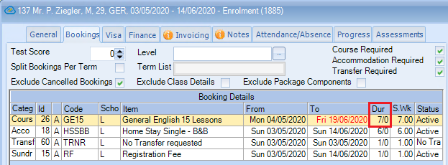

Open up the course line again and amend the Weeks back to the correct value

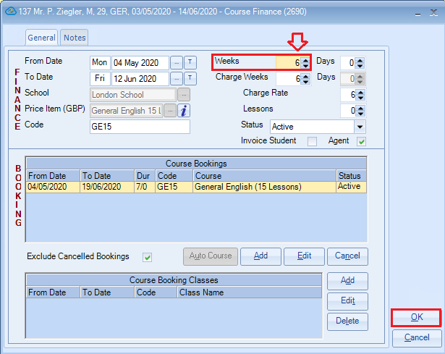
Select OK

Select YES:
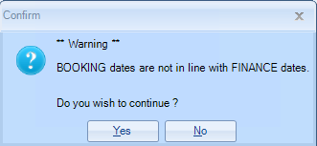

Select YES:

Select YES:

Check the dates all match and are correct
Select YES:

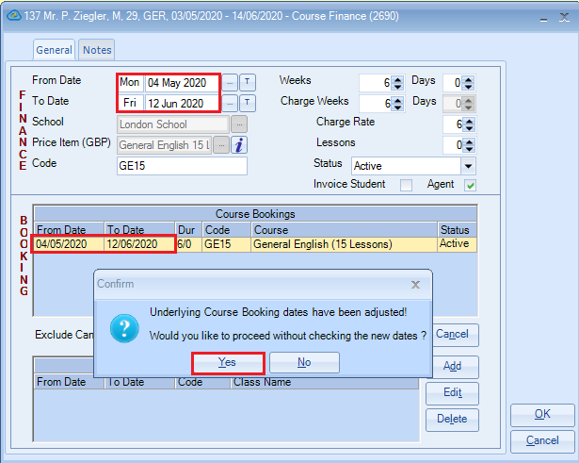

Bookings screen – the course now shows the correct number of weeks.

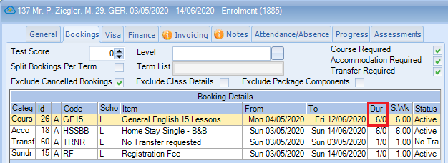

Finance screen:

You will see a ‘Credit’ line to cancel out the original course line (or item you have amended) and a new ‘Invoice’ line.

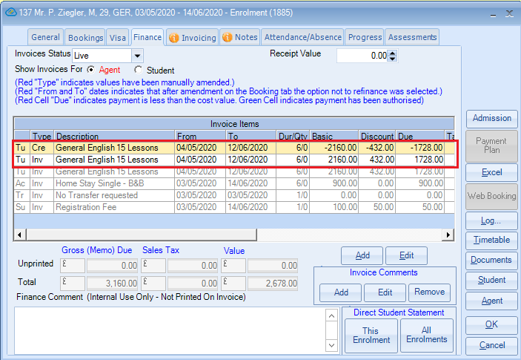

Double click on the new invoice line to open up the finance and make any required amendments:

(Example – Discount % amended and also the Basic value)

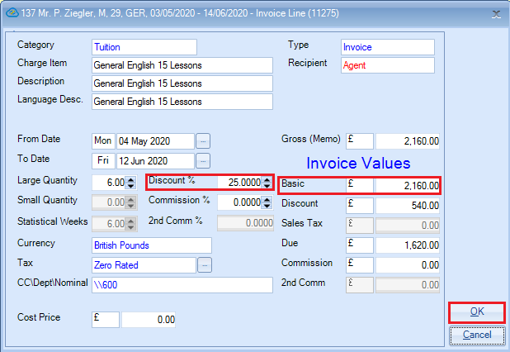

Select OK
The ‘Type’ will be displayed in red to indicate values have been manually amended.

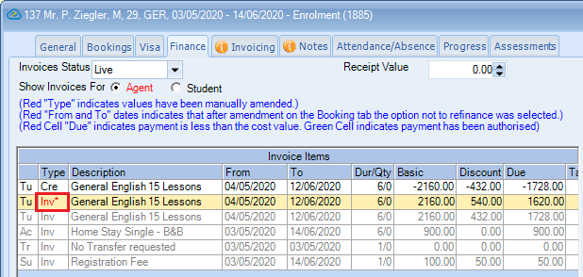

Invoicing screen:

Ensure ‘Use Credit and ReInvoice Method?’ Is selected.

Select Create & Send

This will produce a Credit Note for the original Invoice and a New Invoice for the correct value.

