Class.Net – Help Document

Trust Accounting

Purpose:
For countries (typically New Zealand) where law requires private training establishments to offer protection for student fees paid and other course-related costs. As soon as the student’s fees are deposited with a Trust they are protected. Then as they complete their studies/accommodation etc. the fees are gradually released to the school.

In the unlikely event that the school is unable to provide the booked tuition/accommodation etc. (due to closure, insolvency or course cancellation) the Trust will have the funds available to either refund the student or pay for tuition etc. at another school.

The Class Ledger must be installed for this function to be available.
Initial set up:
Maintenance/Settings > General Settings
Company > Company – Finance / Ledger

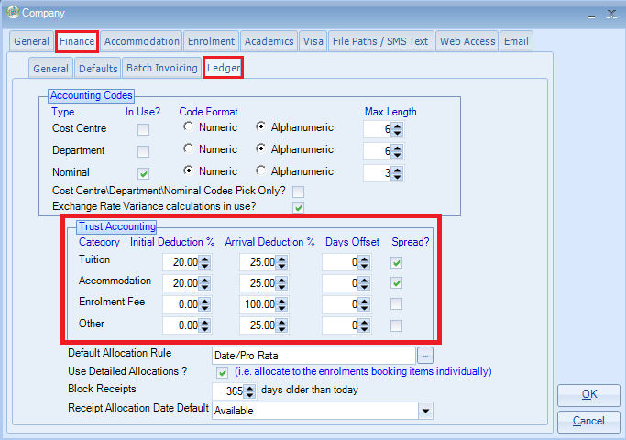

Category | Self-explanatory (Tuition, Accommodation, Enrolment Fee, Other)
Initial Deduction % | The percentage that is to be deducted when the booking is added to Class
Arrival Deduction % | The percentage to be deducted once the student has arrived.  NB: This looks at the students Arrival Date (Enrolment/General tab) not the booking item start date.
Days Offset | The number of days after the student arrived before you can take the value of the "Arrival Deduction".  Example: If set to 14 days, when the report is run 14 days must have elapsed since the student arrived before the percentage amount can be deducted.
Spread? | Ticked (the most popular) – the money received will be spread over the duration of the item which means that it will be drip-fed to the school as the student progresses through his stay  Un-ticked – the money will be made available to the school when the booking item starts.
Trust Accounting Report
Accounting/Ledger > Ledger. Reporting > Trust Accounting Analysis
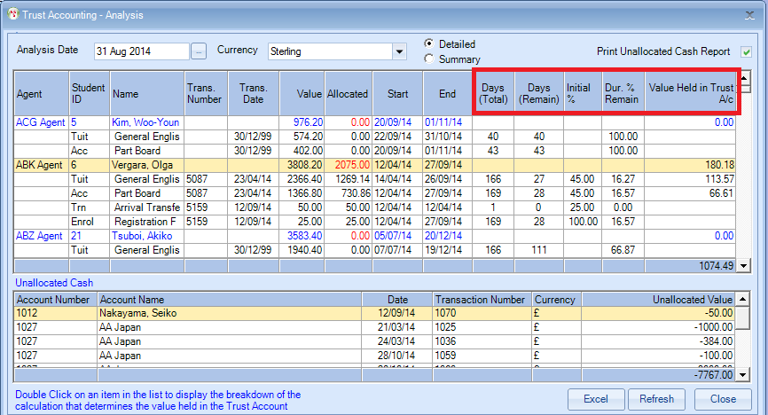
Analysis Date: Will default to today’s date, but can be changed.
Typically it would be a week or month end date.

Days (Total) | Number of days from first day of the booking item to the last day of the booking item including weekends in between.
Days (Remain) | Days remaining of the booking item after the Analysis Date.
Initial % | This figure is picked up from the Company Settings (Initial Deduction and Arrival Deduction)
Duration % Remain | This is the percentage of days left after the Analysis Date.
Value Held in Trust Account | This is the total held in Trust for this student as at the Analysis Date.
Calculations are carried out on money received and not invoices raised.
Explanations of how the “Value Held in Trust” is calculated.

NB: System Settings as per the screenshot on page 1.
Student’s enrolment used in the following examples.
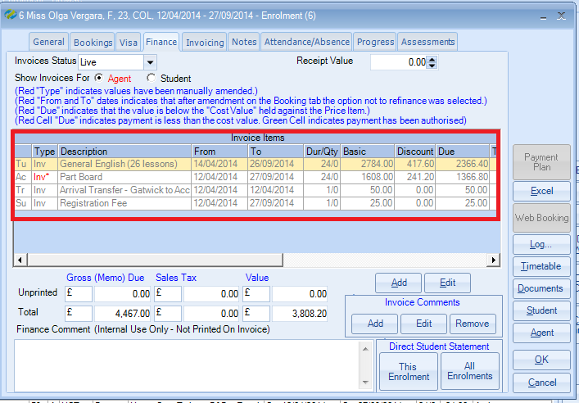
Example 1
Item | Payment | Days (total) | Days  (Remain) | Initial % | Dur % Remain | Value Held in Trust Account | Calculation
General English | £1269.14 | 166 | 166 | 20% | 100% | £1015.31 | £1269.14 - 20% (Initial Deduction) = £1015.31
Part Board | £730.86 | 169 | 169 | 20% | 100% | £584.69 | £730.86 - 20% (Initial Deduction) = £584.69
Arrival transfer | £50.00 | 1 | 1 |  |  | £50.00 | All to be left in Trust
Registration Fee | £25 | 169 | 169 |  |  | £25.00 | All to be left in Trust
The report being run with an Analysis Date prior to the student’s start.
NB: Highlighted columns are used for the calculation
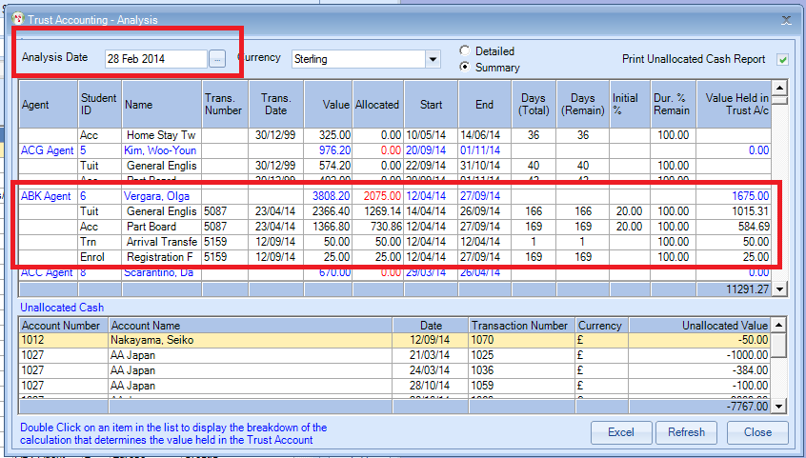
Example 2
The report being run with an Analysis Date within 14 days of the student’s start.

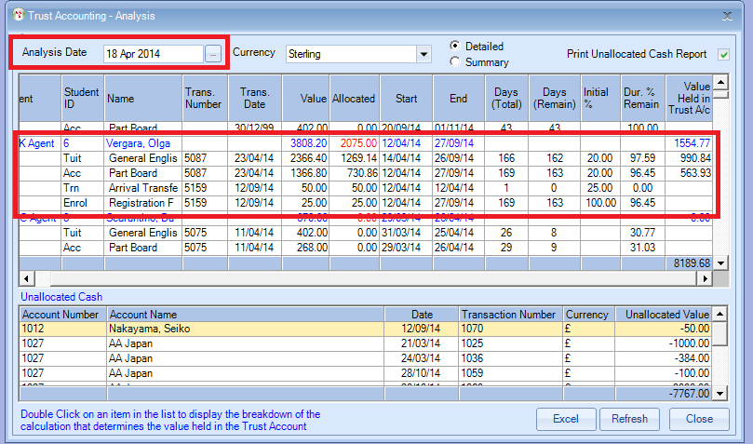

Item | Payment | Days (total) | Days  (Remain) | Initial % | Dur % Remain | Value Held in Trust Account | Calculation
General English | £1269.14 | 166 | 162 | 20% | 97.59% |  | £1269.14 - 20% (Initial Deduction) = £1015.31
 | £1269.14 | 166 | 162 |  | 97.59% | £990.84 | £1015.31 / 166 (Days total) x 162 (Days remain) = £990.84 (Held in Trust)
Part Board | £730.86 | 169 | 163 | 20% | 96.45% |  | £730.86 - 20% (Initial Deduction) = £584.69
 | £730.86 | 169 | 163 |  |  | £563.69 | £584.69 / 169 (Days total) x 163 (Days remain) = £563.93 (Held in Trust)
Arrival transfer | £50.00 | 1 | 0 |  | 0.00% | £0.00 | Arrival Date passed = none to be left in Trust
Registration Fee | £25 | 169 | 163 |  | 96.45% | £0.00 | 100% taken on arrival = none to be left in Trust
NB: Highlighted columns are used for the calculation

Example 3
The report is being run with an Analysis Date after 14 days of the student’s start. The value will change as the student’s progresses through his stay. This is just an example of one date used.

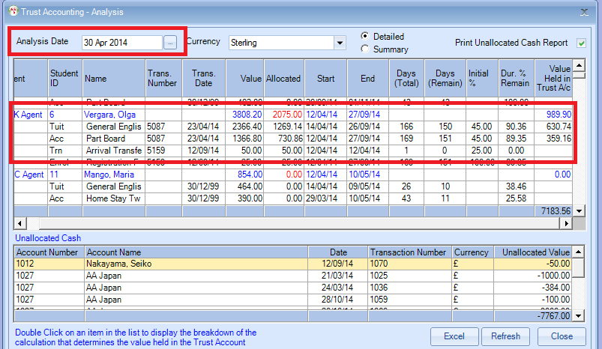
Item | Payment | Days (total) | Days  (Remain) | Initial % | Dur % Remain | Value Held in Trust Account | Calculation
General English | £1269.14 | 166 | 150 | 20% | 90.36% |  | £1269.14 x 20% (Initial Deduction) = £253.83
 | £1269.14 |  |  | 25% |  |  | £1269.14 x 25% (deducted after 14 days from students arrival date) = £317.28
 |  |  |  |  |  |  | £253.83 + £317.28 = £571.11
 |  |  |  |  |  |  | £1269.14 - £571.11 = £698.03
 | £1269.14 | 166 | 150 |  | 90.36% | £630.74 | £698.03 / 166 (Days total) x 150 (Days remain) = £630.74 (Held in Trust)  (NB £0.01 difference due to rounding)
Part Board | £730.86 | 169 | 151 | 20% | 89.35% |  | £730.86 x 20% (Initial Deduction) = £146.17
 | £730.86 |  |  | 25% |  |  | £730.86 x 25% (deducted after 14 days from students arrival date) = £182.71
 |  |  |  |  |  |  | £146.17 + £182.71 = £328.88
 |  |  |  |  |  |  | £730.86 - £328.88 = £401.98
 | £730.86 | 169 | 163 |  | 89.35% | £563.69 | £401.98 / 169 (Days total) x 151 (Days remain) = £359.16
Arrival transfer | £50.00 | 1 | 0 |  | 0.00% | £0.00 | Arrival Date passed = none to be left in Trust
Registration Fee | £25 | 169 | 163 |  | 96.45% | £0.00 | 100% taken on arrival = none to be left in Trust
EXCEL
Detailed One line for each booking item within a student’s enrolment
Summary One line per student

Detailed
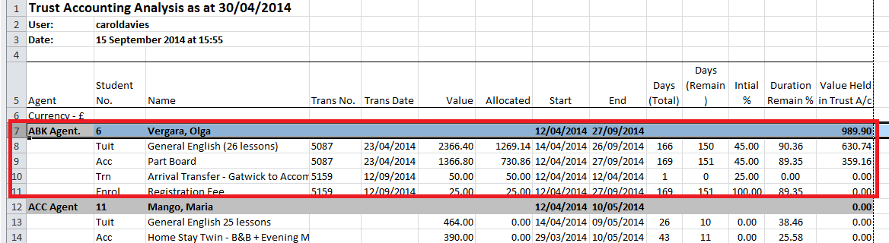

Summary
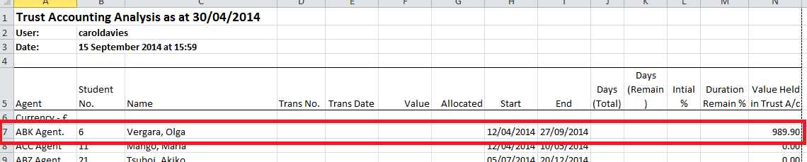
Excluding Students from Trust Accounting.
When adding a student to Class, tick the box in the General screen ‘Exclude from Trust Accounting’.
