

# 

# Class.Net – Help Document

**Difference between Class.NET and Class Cloud**

**This document gives a broad outline as to the key areas where the current Class.Net application differs when running the version hosted in the Cloud.**

They are the same application project within Visual Studio but certain features are added, modified or removed depending on which version is being run.

1. **Login Screens**

**Class.NET** – Original Class Logo remains. White background removed

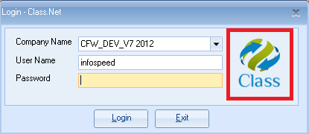

**Class Cloud** – New Class Cloud Logo  
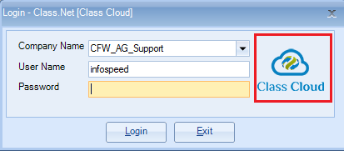

**Class Cloud** –

A generic ‘SQL Connection Error’ is shown if the database connection details are incorrect.

The message will request that you contact Infospeed support for assistance.

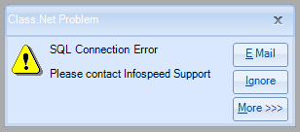

1. **Splash Screen**

**Class.NET** – Original Class Logo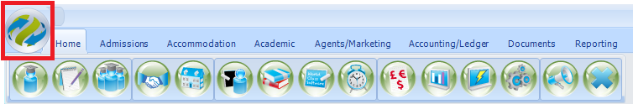

**Class Cloud** – New Cloud Logo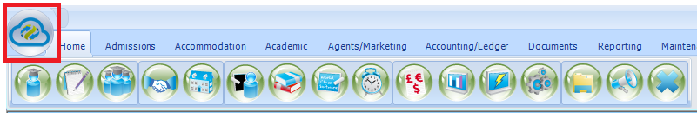

1. **Main Application**

**General**

**Class.NET** – no change

**Class Cloud** – New Class Cloud icon used throughout



Text: The wording ‘[Class Cloud]’ shown in title bar



**Status Bar – bottom left of screen**

Class.NET  


Class Cloud – Server and Database name hidden. Replaced with ‘Class Cloud’  


**Tool Bar ‘Add Ins’ - top of screen**

Class.NET



Class Cloud- the add Ins option is not available



**Tool Bar ‘File Explorer’ – top of screen**

Class Cloud – New icon for ‘File Explorer’ to provide shortcut to Windows Explorer  
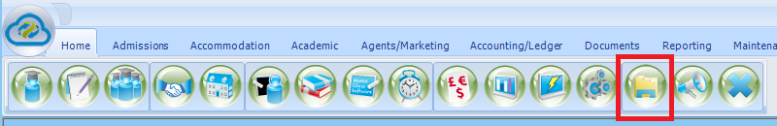

1. **Company Settings**

**File Paths**

Class.NET – details displayed and available for edit

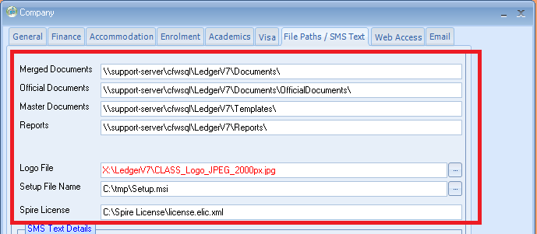

Class Cloud – details hidden as Infospeed set this up for cloud customers

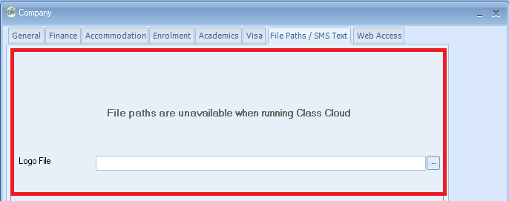

**SMS Text Details**

Class.NET – Account details displayed and available for edit  
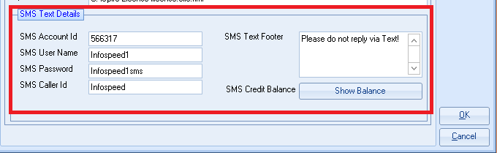

Class Cloud – Account details displayed but Read Only.   
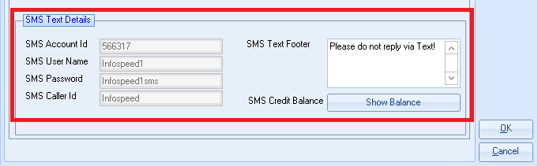

**Email**

Class.NET - – details displayed and available for edit



Class Cloud - tab hidden as Infospeed set this up for cloud customers

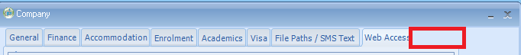

**Class Freezes**

The Task Manager option is not accessible for closing Class.

Our engineers will need to do this for you.

Contact [support@infospeed.co.uk](mailto:support@infospeed.co.uk) for assistance.