Class.Net – Help Document

Invoicing Statistics –
Student weeks by Price Item (Tuition)
This document explains how to produce a statistical weeks report based on the price items.

To produce this information go to: Reporting / Reporting Module
Select Enrolment Statistics:
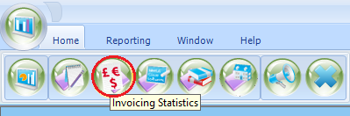

ADD a new report

The criteria of this report is split between three tabs: General, Sorting & Invoicing.
General screen

Give the report a name.
The code could be your initials.

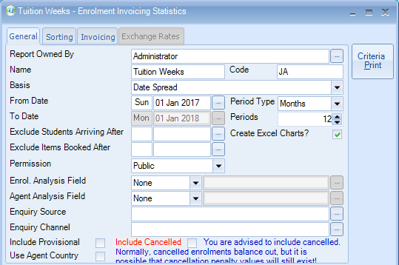

Basis -
Booking Based - based on the date the booking item was entered into the system.
This refers to the course/accommodation/etc, and not the date that the student’s enrolment was entered in to Class.
Production Based - based on spreading the enrolment element (e.g. Tuition) over the duration of the study/stay (dates attended).

Date Arrival - based on the student arrival date from the enrolment general screen

Invoice Line From Date - looks at every single finance line and puts the values against the start date.

Invoice Line To Date - looks at every single finance line and puts the values against the end date.

From Date - Enter the start date for your report

Period Type - Days, Weeks, Months or Years

Periods - Select the number of periods for the above selection
example: Days = 7, Weeks = 6, Months = 12, Years = 2

Exclude Students Arriving After – you may have set your selected date range for 1 year from 01/Jan/15 to 31/Dec/15, but exclude students arriving after 05/Dec/15.

Exclude Students Booked After – see above, but this excludes any booking items added after a certain date. For example if a long term student is starting a new course in Dec 15 you may wish to exclude this within the results.

Use Agent Country - The default for running this report is by student country, but this can be changed to report by agent country

Sorting screen

Select Add – choose Price Item Name from the list.

(You can add multiple sort fields and also subtotal if required).
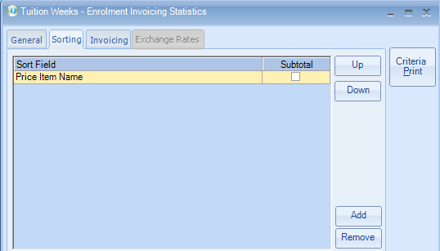

Invoicing screen

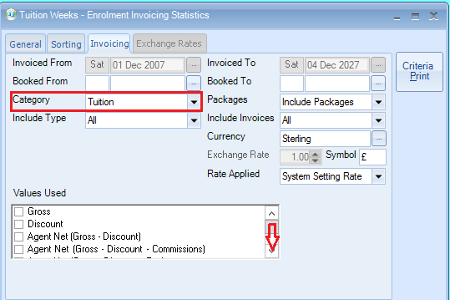

Category: The most popular option is to select Tuition, however Accommodation, Transfer and Sundry are available, or leave as All to produce stats for all categories.

Include Invoices: All

Values Used:
UNTICK - Agent Net (Gross - Discount)
Scroll down to the bottom of the list
Select Statistical Weeks

Further sort options are available:

Schools, Agents, territories, Student Countries, Price Items.

Schools – If running for a specific school, highlight the tab and select Add to choose the school name. Leave blank if reporting on all schools.

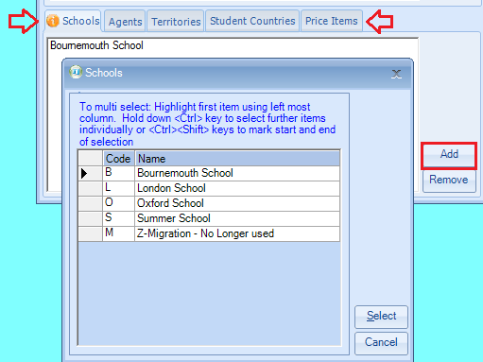

Price Items - If in the sorting tab you have selected Category=Tuition you can be selective by the course. Leave blank if reporting on all courses.

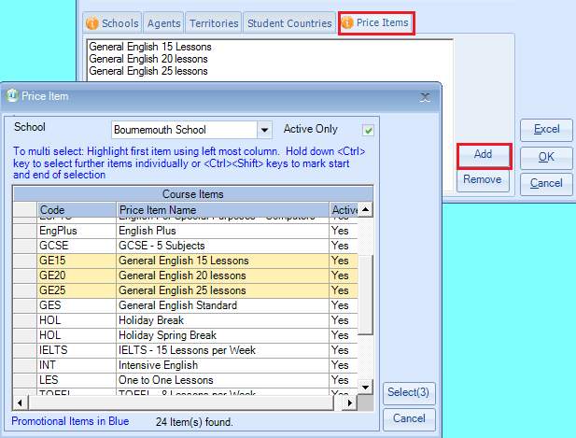

Once the criteria is set up to your requirements select EXCEL to produce the results.

Example:

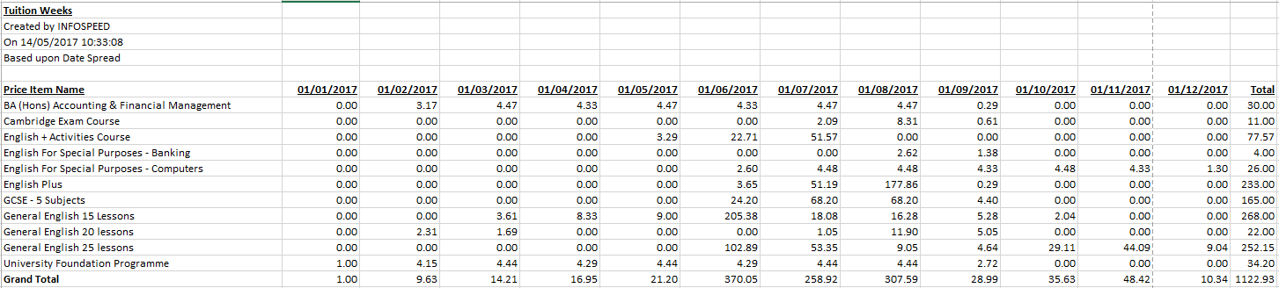

Note:
Courses generally run from Monday to Friday 5 days
The invoicing statistics are always based on 7 days
Please refer to help document HS046 to see explanation of how the statistical weeks are calculated based on ‘date spread‘.

