Class.Net – Help Document

(GDPR) General Data Protection Regulation - Right to Erasure (available in Class version 8.2.000 onwards)

In line with government regulations regarding peoples’ personal data that is held in company systems, new laws came into effect in 2018 that gave people the right to request that their personal details are removed from Company systems.
For Class, this means the removal of personal details from the following areas:
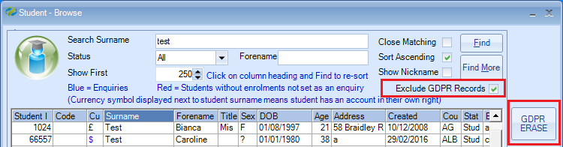
- Students
- Agent
- Host Families
- Teachers
- Users
- Web bookings
In order to maintain the integrity of the database, we cannot simply delete all the information from each area of the system so where possible, we blank the information out so that no personal information remains.
Schools can setup the UDF and analysis fields in the system to hold whatever information they require. This might or might not be personal to an individual. So as to not remove everything in these fields the UDF and analysis fields have been assigned an ‘Erase’ option in the system settings so that schools can configure what information is erased and what is retained.
In each area (type of person) there are multiple options for schools to select from so that they are in control of what information is removed. The option to ‘Erase’ a person from the system can by run multiple times on the same person, allowing schools to refine their erasure process should they miss any area still containing personal details.
For each area, the following new user permissions have been added:
- Student Data Erasure – GDPR
- Agent Data Erasure - GDPR
- Accommodation Data Erasure - GDPR
- Teacher Date Erasure - GDPR
- User Data Erasure – GDPR
- Web Booking Data Erasure - GDPR
The following information details which options are available for the types of people mentioned.
Note: some of the screen shots below include a ‘Web’ tab. You will not see this tab if you are not using the Class Online Toolkit module.
Students
Before a student’s details are removed from the system, schools should review the following areas in the system settings and select which UDF and analysis fields need to be addressed and removed during the erase process:
- Student analysis fields
- Student UDFs
- Student contact analysis fields
- Enrolment analysis fields
- Enrolment visa UDFs
- Enrolment transfer booking analysis fields
- Enrolment sundry booking analysis fields
From the main student browse screen, a new ‘ERASE’ option has been added to the top right of the screen, which is enabled when the user has been granted the ‘Student Data Erasure – GDPR’ permission or if they are an administrator. By selecting a student and clicking this option, a new screen will be displayed showing some basic details on the student and listing all the erase/delete options available. These are as follow:
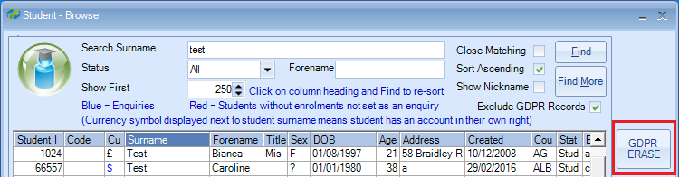
When the “Exclude GDPR Records” checkbox is ticked any records that have been processed by the GDPR erase process will be excluded from the search results.
Untick this option if you require the GDPR erased record to be included in the search results.

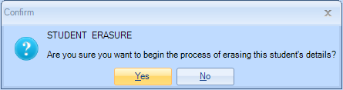
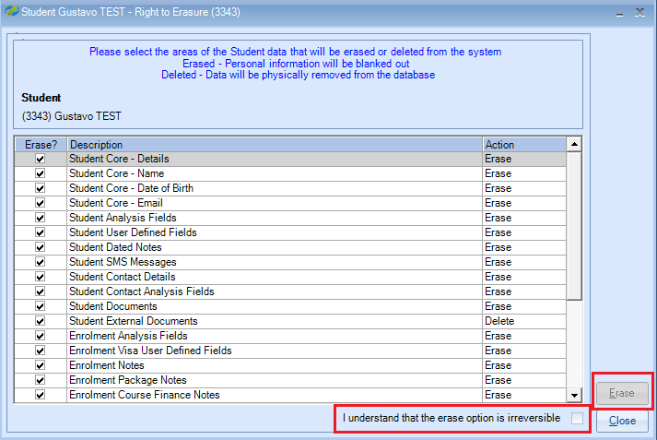

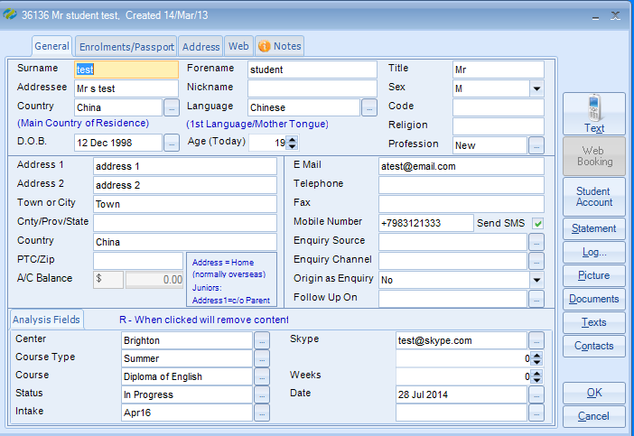

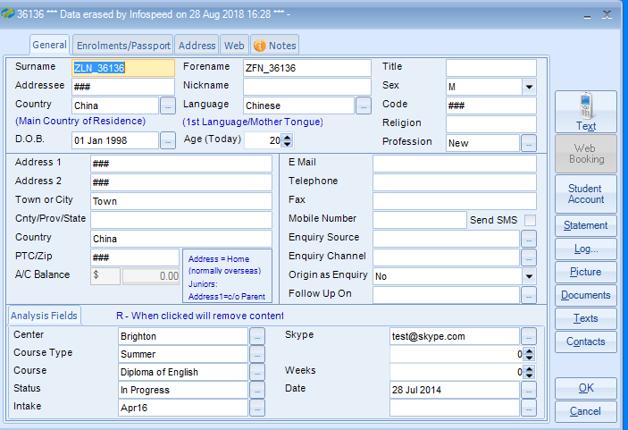
In the above example the Analysis fields the erase option is not set therefore the data will remain unchanged
- Student Core Details
  - This option cannot be switched off. The core details of the student that will be erased are:

Data Field | New Value
Code | ###
Address1 | ###
Address2 | ####
Postal Code | ###
Telephone | Blank
Fax | Blank
Statement Addressee | ###
Statement Address1 | ###
Statement Address2 | ###
Statement Postal Code | ###
Statement Telephone | Blank
Statement Fax | Blank
Statement Email | Blank
Other Addressee | ###
Other Address1 | ###
Other Address2 | ###
Other Postal Code | ###
Other Telephone | Blank
Other Fax | Blank
Other Email | Blank
Passport Number | ###
Show Note 1 | Switched Off
Note 1 | Blank
Note 2 | Blank
Note 3 | Blank
Send SMS Messages Option | Switched Off
Mobile Number | Blank
Allow Student Web Access Option | Switched Off
Web Login Username | Blank
Web Login Password | Blank
Directory Shortcut Path | Blank
Religion | Blank
Marketing OptIn | Set to False
Document Address | Set to ‘Main’
Invoice Address | Set to ‘Main’
Send By Option | Set to ‘Printer’
E-Mail Format | Set to ‘MS Word’
Student Picture | Deleted from the database

If there are any web bookings linked to the student the web booking fields will be erased as below
Web Booking Data
Data Field | New Value
Address1 | ###
Address2 | ####
Postal Code | ###
Telephone | Blank
MobileNumber | Blank
Passport Number | ###
Note | ###

If there are any payment gateway data linked to the student the fields will be erased as below
Payment Gateway Data
Data Field | New Value
Email | ###
Forename | ZFN_(StudentId)
Surname | ZLN_(StudentId)
Date Of Birth | 01/01/(DateOfBirth[Year])

If there are any payment run data linked to the student the fields will be erased as below
Payment Run Data (if applicable)
Data Field | New Value
Forename | ZFN_(StudentId)
Surname | ZLN_(StudentId)
Date Of Birth | 01/01/(DateOfBirth[Year])

- Student Core - Name
  - If selected, the name details of the student that will be erased are:
Data Field | New Value
Forename | ZFN_(StudentId)
Surname | ZLN_(StudentId)
Addressee | ###

If there are any web booking records linked to the student the fields will be erased as below
Web Booking - Name
Data Field | New Value
Title | Blank
Forename | ZFN_(StudentId)
Surname | ZLN_(StudentId)
Nickname | Blank
Addressee | ###

- Student Core - Date of Birth
  - If selected, the Date of Birth details of the student that will be erased are:
Data Field | New Value
Date of Birth | 01/01/(DateOfBirth[Year])

If there are any web booking records linked to the student the fields will be erased as below
Web Booking – Date of Birth
Data Field | New Value
Date of Birth | 01/01/(DateOfBirth[Year])

- Student Core – Email
  - If selected, the Email details of the student that will be erased are:
Data Field | New Value
Email | Blank

If there are any web booking records linked to the student the fields will be erased as below
Web Booking - Email
Data Field | New Value
Email | Blank

- Student Analysis Fields
  - Based on which options have been selected in system settings to blank out, the following updates will occur:

Maintenance/Settings > General Settings > Admissions

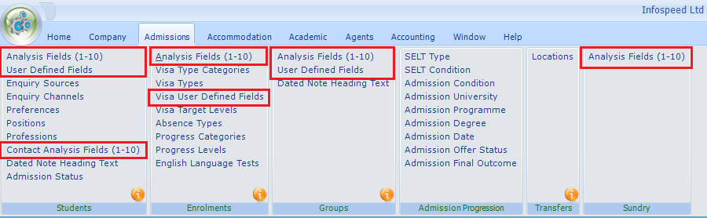

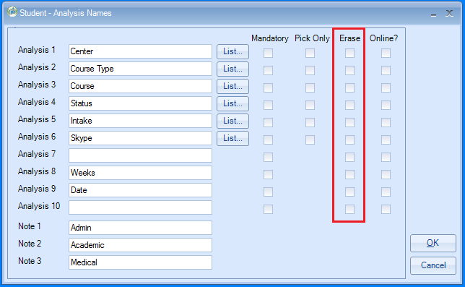

Data Field | New Value
Analysis 1 | ###
Analysis 2 | ###
Analysis 3 | ###
Analysis 4 | ###
Analysis 5 | ###
Analysis 6 | ###
Analysis 7 | 0
Analysis 8 | 0
Analysis 9 | Database Null value
Analysis 10 | Database Null value

If there are any web bookings linked to the student the web booking Student Analysis Fields will be erased using the same values as above

- Student User Defined Fields
  - Based on which options have been selected in system settings, any student UDFs flagged for erasure will be erased from the student’s details.
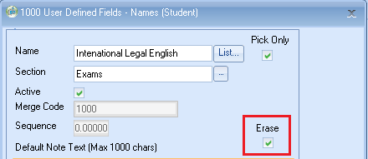

Data Field | New Value
Note | ###
Content | ###

- Student Dated Notes
  - If selected, all student dated notes will be erased from the student’s details.
Data Field | New Value
Note Heading | ###
Note History | ###

- Student SMS Messages
  - If selected, all student SMS messages will be erased from the student’s details.
Data Field | New Value
Message | ###
Mobile Number | ###

- Student Contact Details
  - If selected, the following fields will be updated on the student contact entries:

Data Field | New Value
Code | ###
Title | Blank
Forename | ZFN_(ContactId)
Surname | ZLN_(ContactId)
Company Name | ###
Addressee | ###
Address1 | ###
Address2 | ###
Postal Code | Blank
Telephone Number | Blank
Fax | Blank
Email | Blank
Position | Blank
Note | Blank
Mobile Number | Blank
Allow Contact Web Access Option | Switched Off
Allow Online Option | Switched Off
Web Login Username | Blank
Web Login Password | Blank
Active Status | Set to ‘Inactive’
Contact Picture | Deleted from the database

- Student Contact Analysis Fields
  - Based on which options have been selected in system settings to blank out, the following updates will occur:
Data Field | New Value
Analysis 1 | ###
Analysis 2 | ###
Analysis 3 | ###
Analysis 4 | ###
Analysis 5 | ###
Analysis 6 | ###
Analysis 7 | 0
Analysis 8 | 0
Analysis 9 | Database Null value
Analysis 10 | Database Null value

- Student Documents
  - If selected, then all the physical documents for the student will be deleted from the documents folder. The data entries for documents in General & Official tabs will remain in Class but the document cannot be viewed..
  - In addition to this, the remaining document database entries in Class will have the following details updated:
Data Field | New Value
Addressee | ###
Email | ###
Fax | Blank
Subject | Set to ZDocument_(DocumentId)
Email Body Text | Blank
Send Method Option | Set to ‘Printer’
Email Format | Set to ‘MS Word’
Address Option | Set to ‘Main’

- Student External Documents
  - If selected, all the physical external documents for the student will be deleted from the documents folder. All entries for the student will also be removed from the database.

- Enrolment Analysis Fields
  - Based on which options have been selected in system settings to blank out, the following updates will occur:

Data Field | New Value
Analysis 1 | ###
Analysis 2 | ###
Analysis 3 | ###
Analysis 4 | ###
Analysis 5 | ###
Analysis 6 | ###
Analysis 7 | 0
Analysis 8 | 0
Analysis 9 | Database Null value
Analysis 10 | Database Null value

If applicable Web Booking Enrolment Analysis Fields will be erased using the same values as above
- Enrolment Visa User Defined Fields
  - Based on which options have been selected in system settings, any enrolment visa UDFs flagged for erasure will be erased from the student’s enrolment details.
Data Field | New Value
Note | ###
Content | ###

- Enrolment Notes
  - If selected, the following enrolment notes fields will be updated:
Data Field | New Value
Note 1 | Blank
Note 2 | Blank
Note 3 | Blank
Payment Note | Blank
Finance Comment | Blank
Sponsorship Number | ###
Visa Number | ###

- Enrolment Package Notes
  - If selected, the following enrolment package note field will be updated:
Data Field | New Value
Note | Blank

- Enrolment Course Finance Notes
  - If selected, the following enrolment course finance note field will be updated:
Data Field | New Value
Note | Blank

- Enrolment Course Notes
  - If selected, the following enrolment course note field will be updated:
Data Field | New Value
Note | Blank

- Enrolment Accommodation Finance Notes
  - If selected, the following enrolment accommodation finance note field will be updated:
Data Field | New Value
Note | Blank
Special Request Note | Blank
Student Address | Blank

- Enrolment Accommodation Notes
  - If selected, the following enrolment accommodation note field will be updated:
Data Field | New Value
Note | Blank

- Enrolment Transfer Analysis Fields
  - Based on which options have been selected in system settings to blank out, the following updates will occur:
Data Field | New Value
Analysis 1 | ###
Analysis 2 | ###
Analysis 3 | ###
Analysis 4 | ###
Analysis 5 | ###
Analysis 6 | ###
If applicable Web Booking Transfer Analysis Fields will be erased using the same values as above
- Enrolment Transfer Notes
  - If selected, the following enrolment course note field will be updated:
Data Field | New Value
Note | Blank

- Enrolment Sundry Analysis Fields
  - Based on which options have been selected in system settings to blank out, the following updates will occur:
Data Field | New Value
Analysis 1 | ###
Analysis 2 | ###
Analysis 3 | ###
Analysis 4 | ###
Analysis 5 | ###
Analysis 6 | ###
Analysis 7 | 0
Analysis 8 | 0
Analysis 9 | Database Null value
Analysis 10 | Database Null value

- Enrolment Sundry Notes
  - If selected, the following enrolment course note field will be updated:
Data Field | New Value
Note | Blank

- Enrolment Documents
  - If selected, then all the physical documents for the students linked enrolment/s will be deleted from the documents folder. The data entries for documents in General, Official will remain in Class but the document cannot be viewed.
  - In addition to this, the remaining document database entries in Class will have the following details updated:
Data Field | New Value
Addressee | ###
Email | ###
Fax | Blank
Subject | Set to ZDocument_(DocumentId)
Email Body Text | Blank
Send Method Option | Set to ‘Printer’
Email Format | Set to ‘MS Word’
Address Option | Set to ‘Main’

- Enrolment External Documents
  - If selected, all the physical external documents for enrolments linked to the student will be deleted from the documents folder. All entries for the will also be removed from the database.
- Enrolment Invoice Documents
  - If selected, then all the physical invoice documents for the students linked enrolment/s will be deleted from the documents folder. The data entries for documents in the Financial tabs will remain in Class. If anyone tries to view them, they will be recreated, where possible with blanked out student details.
  - In addition to this, the remaining document database entries in Class will have the following details updated:
Data Field | New Value
Addressee | ###
Email | ###
Fax | Blank
Subject | Document Name_ InvoiceNumber (if invoice number exists)
Email Body Text | Blank
Send Method Option | Set to ‘Printer’
Email Format | Set to ‘MS Word’
Address Option | Set to ‘Main’

- Enrolment Invoice Data
  - If selected, then any invoices that have been created for the student will have the student’s personal details removed and any invoices created for the agent will have the memo address details updated as follows:
Data Field | New Value
Name | 'ZHeader_' + (InvoiceHeaderId)
Addressee | ###
Address1 | ###
Address2 | ###
Postal Code | ###
Fax | Blank
Memo Addressee | Blank
Memo Address1 | Blank
Memo Address2 | Blank
Memo Town | Blank
Memo Region | Blank
Memo Country | Blank
Memo Postal Code | Blank

- Student Ledger Account Notes
  - If selected, the following ledger account note field will be updated:
Data Field | New Value
Note | ###

- Student Ledger Account Payment (Receipt) Notes
  - If selected, the following ledger account receipt comment field will be updated:
Data Field | New Value
Comment | ###

Agents

Before an agent’s details are removed from the system, schools should review the following areas in the system settings and select which UDF and analysis fields need to be addressed and removed from the system during the erase process:
Maintenance/Settings > General Settings > Agents
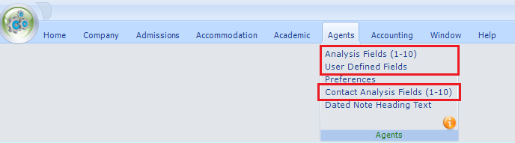
- Agent analysis fields
- Agent UDFs
- Agent contact analysis fields

NOTE: Only standard agent details can be erased from the system, direct agent details remain protected from this process.
From the main agent browse screen, a new ‘ERASE’ option has been added to the top right of the screen; which is enabled when the user has been granted the ‘Agent Data Erasure – GDPR’ permission or if they are an administrator. By selecting an agent and clicking this option, a new screen will be displayed showing some basic details on the agent and listing all the erase/delete options available. These are as follow:
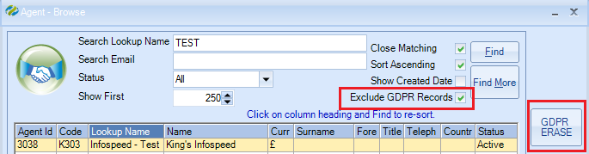
The “Exclude GDPR Records” checkbox is ticked any records that have been processed by the GDPR erase process will be excluded from the search results.
Untick this option if you require the GDPR erased record to be included in the search results.
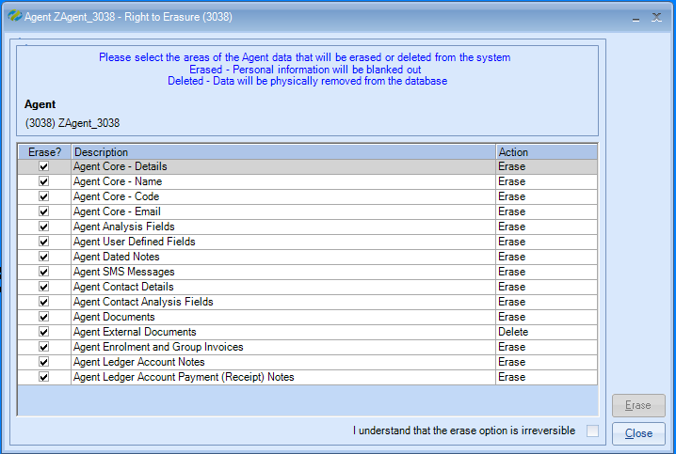
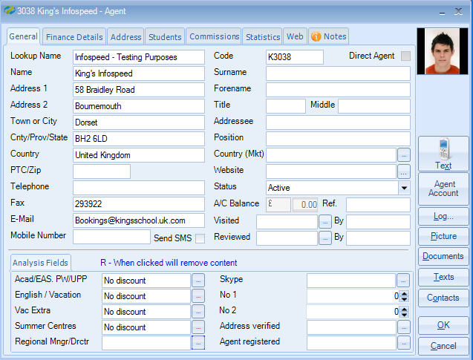
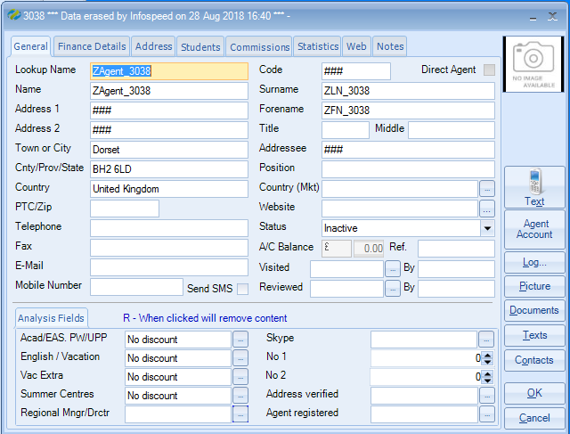

- Agent Core Details
  - This option cannot be switched off. The core details of the agent that will be erased are:
Data Field | New Value
Address1 | ###
Address2 | ###
Postal Code | Blank
Telephone | Blank
Fax | Blank
Email | Blank
Position | Blank
Statement Addressee | Blank
Statement Address1 | Blank
Statement Address2 | Blank
Statement Postal Code | Blank
Statement Telephone | Blank
Statement Fax | Blank
Statement Email | Blank
Other Addressee | Blank
Other Address1 | Blank
Other Address2 | Blank
Other Postal Code | Blank
Other Telephone | Blank
Other Fax | Blank
Other Email | Blank
Tax Reference | Blank
Show Note 1 | Switched Off
Note 1 | Blank
Note 2 | Blank
Note 3 | Blank
Send SMS Messages Option | Switched Off
Mobile Number | Blank
Allow Agent Web Access Option | Switched Off
Web Login Username | Blank
Web Login Password | Blank
Website Address | Blank
Document Address | Set to ‘Main’
Invoice Address | Set to ‘Main’
Send By Option | Set to ‘Printer’
E-Mail Format | Set to ‘MS Word’
Agent Status | Set to ‘Inactive’
Agent Picture | Deleted from the database

- Agent Core - Name
  - If selected, the name details of the student that will be erased are:
Data Field | New Value
Lookup Name | ZAgent_(AgentId)
Name | Zagent_(AgentId)
Title | Blank
Forename | ZFN_(AgentId)
Surname | ZLN_(AgentId)
Middle Names | Blank
Addressee | ###

- Agent Core - Code
  - If selected, the code details of the Agent that will be erased are:
Data Field | New Value
Code | ###

- Agent Core - Email
  - If selected, the code details of the Agent that will be erased are:
Data Field | New Value
Email | Blank

- Agent Analysis Fields
  - Based on which options have been selected in system settings to blank out, the following updates will occur:
Data Field | New Value
Analysis 1 | ###
Analysis 2 | ###
Analysis 3 | ###
Analysis 4 | ###
Analysis 5 | ###
Analysis 6 | ###
Analysis 7 | 0
Analysis 8 | 0
Analysis 9 | Database Null Value
Analysis 10 | Database Null Value

- Agent User Defined Fields
  - Based on which options have been selected in system settings, any agent UDFs flagged for erasure will be updated from the agent’s details.
Data Field | New Value
Note | ###
Content | ###

- Agent Dated Notes
  - If selected, all agent dated notes will be updated from the agent’s details.
Data Field | New Value
Note Heading | ###
Note History | ###

- Agent SMS Messages
  - If selected, all agent SMS messages will be updated from the agent’s details.
Data Field | New Value
Message | ###
Mobile Number | ###

- Agent Contact Details
  - If selected, the following fields will be updated on the agent contact entries:
Data Field | New Value
Code | ##
Title | Blank
Forename | ZFN_ContactId
Surname | ZFN_ContactId
Company Name | ###
Addressee | ###
Address1 | ###
Address2 | ###
Postal Code | Blank
Telephone Number | Blank
Fax | Blank
Email | Blank
Position | Blank
Note | Blank
Mobile Number | Blank
Allow Contact Web Access Option | Switched Off
Allow Online Option | Switched Off
Web Login Username | Blank
Web Login Password | Blank
Active Status | Set to ‘Inactive’
Contact Picture | Deleted from the database

- Agent Contact Analysis Fields
  - Based on which options have been selected in system settings to blank out, the following updates will occur:
Data Field | New Value
Analysis 1 | ###
Analysis 2 | ###
Analysis 3 | ###
Analysis 4 | ###
Analysis 5 | ###
Analysis 6 | ###
Analysis 7 | 0
Analysis 8 | 0
Analysis 9 | Database Null Value
Analysis 10 | Database Null Value

- Agent Documents
  - If selected, then all the physical MS Word documents for the agent will be deleted from the documents folder. The document entries will remain in Class but if anyone tries to view them, they will be recreated with blanked out details. In addition to this, the remaining document entries in Class will have the following details updated:
Data Field | New Value
Addressee | ###
Email | ###
Fax | Blank
Subject | ZDocument_DocumentId
Email Body Text | Blank
Send Method Option | Set to ‘Printer’
Email Format | Set to ‘MS Word’
Address Option | Set to ‘Main’

- Agent External Documents
  - If selected, all the physical external documents for the agent will be deleted from the documents folder. All entries for the agent will also be removed from the database.

- Agent Enrolment and Group Invoices
  - If selected, then any invoices or group invoices that have been created for the agent will have the agent’s personal details removed as follows:
Data Field | New Value
Name | Zheader_InvoiceHeaderId
Addressee | ###
Address1 | ###
Address2 | ###
Postal Code | Blank
Fax | Blank
Memo Addressee | Blank
Memo Address1 | Blank
Memo Address 2 | Blank
Memo Postal Code | Blank

- Agent Ledger Account Notes
  - If selected, the following ledger account note field will be updated:
Data Field | New Value
Note | ###

- Agent Ledger Account Payment (Receipt) Notes
  - If selected, the following ledger account receipt comment field will be updated:
Data Field | New Value
Comment | ###

Host Families
Before a host’s details are removed from the system, schools should review the following areas in the system settings and select which UDF and analysis fields need to be addressed and removed from the system during the erase process:
Maintenance/Settings > General Settings > Accommodation
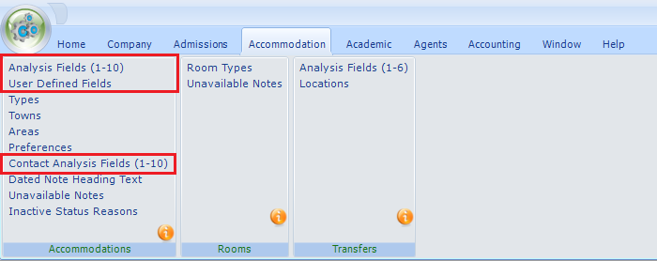
- Host analysis fields
- Host UDFs
- Host contact analysis fields
From the main host browse screen, a new ‘ERASE’ option has been added to the top right of the screen; which is enabled when the user has been granted the ‘Accommodation Data Erasure – GDPR’ permission or if they are an administrator. By selecting a host and clicking this option, a new screen will be displayed showing some basic details on the host and listing all the erase/delete options available. These are as follow:
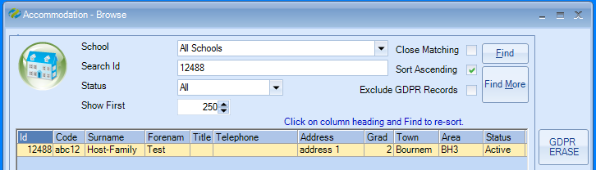
The “Exclude GDPR Records” checkbox is ticked any records that have been processed by the GDPR erase process will be excluded fron the search results.
Untick this option if you require the GDPR erased record to be included in the search results.

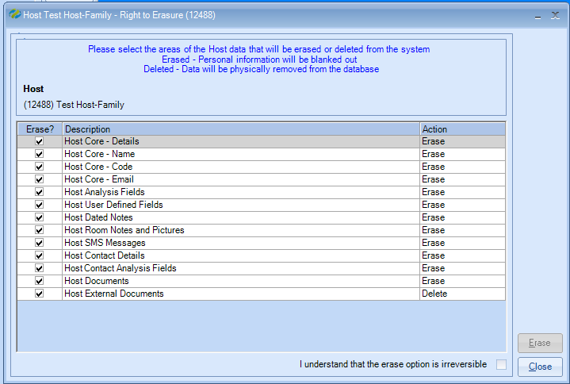

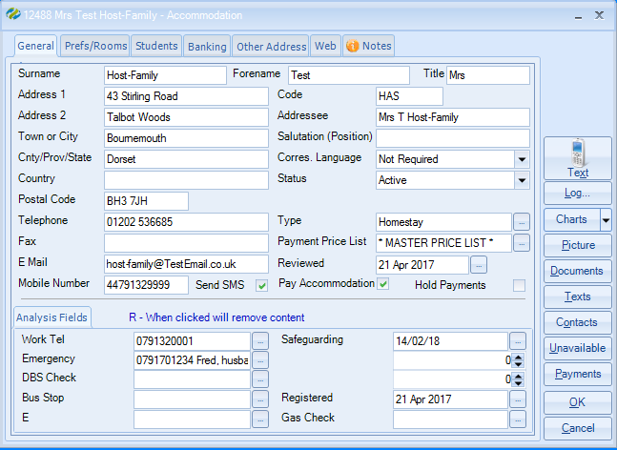

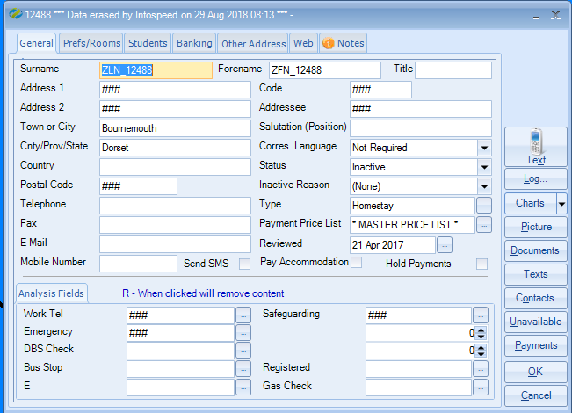
- Host Core Details
  - This option cannot be switched off. The core details of the host that will be erased are:
Data Field | New Value
Address1 | ###
Address2 | ###
Postal Code | ###
Telephone | Blank
Fax | Blank
Position | Blank
Bank Account Holder | Blank
Bank Account Number | Blank
Bank Name | Blank
Bank Sort Code | Blank
Bank Branch | Blank
Bank Reference 1 | Blank
Bank Reference 2 | Blank
Bank IBAN Number | Blank
Bank BIC Number | Blank
Tax Reference | Blank
Pay Host Option | Switched Off
Payment Method | Set to ‘Cheque’
Statement Addressee | Blank
Statement Address1 | Blank
Statement Address2 | Blank
Statement Postal Code | Blank
Statement Telephone | Blank
Statement Fax | Blank
Statement Email | Blank
Other Addressee | Blank
Other Address1 | Blank
Other Address2 | Blank
Other Town | Blank
Other Region | Blank
Other Country | Blank
Other Postal Code | Blank
Other Telephone | Blank
Other Fax | Blank
Other Email | Blank
Show Note 1 | Switched Off
Note 1 | Blank
Note 2 | Blank
Note 3 | Blank
Send SMS Messages Option | Switched Off
Mobile Number | Blank
Allow Host Web Access Option | Switched Off
Web Login Username | Blank
Web Login Password | Blank
Document Address | Set to ‘Main’
Invoice Address | Set to ‘Main’
Send By Option | Set to ‘Printer’
E-Mail Format | Set to ‘MS Word’
Host Status | Set to ‘Inactive’
Host Picture(s) | Deleted from the database

- Host Core - Name
  - If selected, the name details of the host that will be erased are:
Data Field | New Value
Title | Blank
Forename | ZFN_HostId
Surname | ZLN_HostId
Addressee | ###

- Host Core - Code
  - If selected, the code details of the host that will be erased are:
Data Field | New Value
Code | ###

- Host Core - Email
  - If selected, the code details of the host that will be erased are:
Data Field | New Value
Email | Blank

- Host Analysis Fields
  - Based on which options have been selected in system settings to blank out, the following updates will occur:
Data Field | New Value
Analysis 1 | ###
Analysis 2 | ###
Analysis 3 | ###
Analysis 4 | ###
Analysis 5 | ###
Analysis 6 | ###
Analysis 7 | 0
Analysis 8 | 0
Analysis 9 | Database Null Value
Analysis 10 | Database Null Value

- Host User Defined Fields
  - Based on which options have been selected in system settings, any host UDFs flagged for erasure will be updated from the host’s details.
Data Field | New Value
Note | ###
Content | ###

- Host Dated Notes
  - If selected, all host dated notes will be updated from the host’s details.
Data Field | New Value
Note Heading | ###
Note History | ###

- Host Room Notes and Pictures
  - If selected, the following host room note fields will be updated:
Data Field | New Value
Note 1 | Blank
Note 2 | Blank
Host Room Picture(s) | Deleted from the database

- Host SMS Messages
  - If selected, all host SMS messages will be updated from the host’s details.
Data Field | New Value
Message | ###
Mobile Number | ###

- Host Contact Details
  - If selected, the following fields will be updated on the host contact entries:
Data Field | New Value
Code | ###
Title | Blank
Forename | ZFN_ContactId
Surname | ZLN_ContactId
Company Name | ###
Addressee | ###
Address1 | ###
Address2 | ###
Postal Code | Blank
Telephone Number | Blank
Fax | Blank
Email | Blank
Position | Blank
Note | Blank
Mobile Number | Blank
Allow Contact Web Access Option | Switched Off
Allow Online Option | Switched Off
Web Login Username | Blank
Web Login Password | Blank
Active Status | Set to ‘Inactive’
Contact Picture | Deleted from the database

- Host Contact Analysis Fields
  - Based on which options have been selected in system settings to blank out, the following updates will occur:
Data Field | New Value
Analysis 1 | ###
Analysis 2 | ###
Analysis 3 | ###
Analysis 4 | ###
Analysis 5 | ###
Analysis 6 | ###
Analysis 7 | 0
Analysis 8 | 0
Analysis 9 | Database Null Value
Analysis 10 | Database Null Value

- Host Documents
  - If selected, then all the physical MS Word documents for the host will be deleted from the documents folder. The document entries will remain in Class but if anyone tries to view them, they will be recreated with blanked out details. In addition to this, the remaining document entries in Class will have the following details updated:
Data Field | New Value
Addressee | ###
Email | ###
Fax | Blank
Subject | ZDocument_DocumentId or ZHostPayment_DocumentId
Email Body Text | Blank
Send Method Option | Set to ‘Printer’
Email Format | Set to ‘MS Word’
Address Option | Set to ‘Main’

- Host External Documents
  - If selected, all the physical external documents for the host will be deleted from the documents folder. All entries for the host will also be removed from the database.

Teachers
Before a teacher’s details are removed from the system, schools should review the following areas in the system settings and select which UDF and analysis fields need to be addressed and removed from the system during the erase process:
Maintenance/Settings > General Settings > Academic
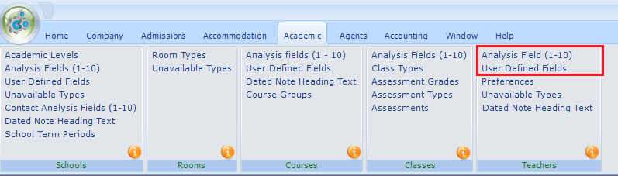
- Teacher analysis fields
- Teacher UDFs
From the main teacher browse screen, a new ‘ERASE’ option has been added to the top right of the screen; which is enabled when the user has been granted the ‘Teacher Data Erasure – GDPR’ permission or if they are an administrator. By selecting a teacher and clicking this option, a new screen will be displayed showing some basic details on the teacher and listing all the erase/delete options available. These are as follow:
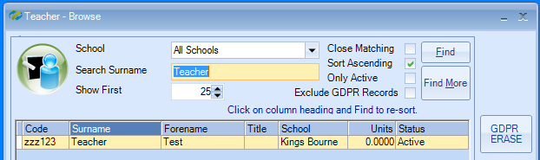
The “Exclude GDPR Records” checkbox is ticked any records that have been processed by the GDPR erase process will be excluded from the search results.
Untick this option if you require the GDPR erased record to be included in the search results.

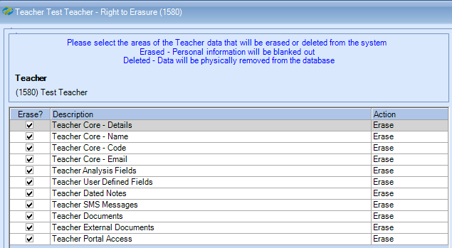
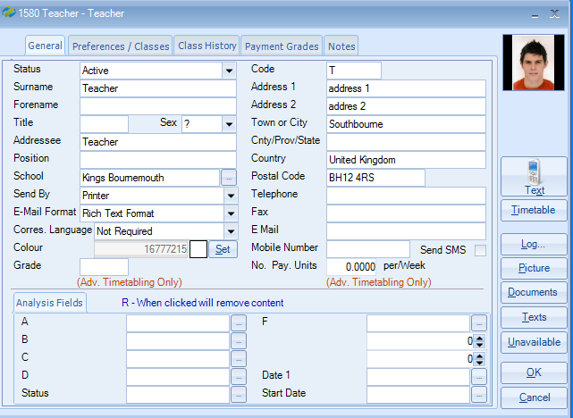
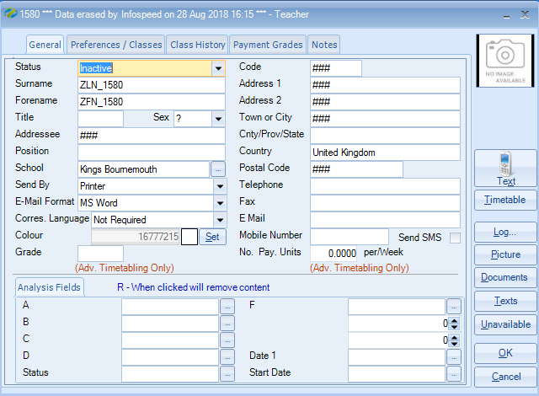

- Teacher Core Details
  - This option cannot be switched off. The core details of the teacher that will be erased are:
Data Field | New Value
Address1 | ###
Address2 | ###
Postal Code | Blank
Telephone | Blank
Fax | Blank
Position | Blank
Note 1 | Blank
Note 2 | Blank
Note 3 | Blank
Send SMS Messages Option | Switched Off
Mobile Number | Blank
Send By Option | Set to ‘Printer’
E-Mail Format | Set to ‘MS Word’
Teacher Status | Set to ‘Inactive’
Teacher Picture | Deleted from the database

- Teacher Core - Name
  - If selected, the name details of the teacher that will be erased are:
Data Field | New Value
Title | Blank
Forename | ZFN_TeacherId
Surname | ZLN_TeacherId
Addressee | ###

- Teacher Core - Code
- If selected, the code details of the teacher that will be erased are:
Data Field | New Value
Code | ###

- Teacher Core - Email
- If selected, the code details of the teacher that will be erased are:
Data Field | New Value
Email | Blank

- Teacher Analysis Fields
  - Based on which options have been selected in system settings to blank out, the following updates will occur:
Data Field | New Value
Analysis 1 | ###
Analysis 2 | ###
Analysis 3 | ###
Analysis 4 | ###
Analysis 5 | ###
Analysis 6 | ###
Analysis 7 | 0
Analysis 8 | 0
Analysis 9 | Database Null Value
Analysis 10 | Database Null Value

- Teacher User Defined Fields
  - Based on which options have been selected in system settings, any teacher UDFs flagged for erasure will be update from the teacher’s details.
Data Field | New Value
Note | ###
Content | ###

- Teacher Dated Notes
  - If selected, all teacher dated notes will be updated from the teacher’s details.
Data Field | New Value
Note Heading | ###
Note History | ###

- Teacher SMS Messages
  - If selected, all teacher SMS messages will be updated from the teacher’s details.
Data Field | New Value
Message | ###
Mobile | ###

- Teacher Documents
  - If selected, then all the physical MS Word documents for the teacher will be deleted from the documents folder. The document entries will remain in Class but if anyone tries to view them, they will be recreated with blanked out details. In addition to this, the remaining document entries in Class will have the following details updated:
Data Field | New Value
Addressee | ###
Email | ###
Fax | Blank
Subject | Zdocument_DocumentId
Email Body Text | Blank
Document Name | ###
Send Method Option | Set to ‘Printer’
Email Format | Set to ‘MS Word’
Address Option | Set to ‘Main’

- Teacher External Documents
  - If selected, all the physical external documents for the teacher will be deleted from the documents folder. All entries for the teacher will also be removed from the database.

- Teacher Portal Access
  - If selected, then the details of the Class ‘User’ that this teacher is assigned to will be deactivated. The teachers Class ‘User’ will have the following field updated:
Data Field | New Value
Active | Set to False

Class Users
From the main user browse screen, a new ‘ERASE’ option has been added to the top right of the screen; which is enabled when the user has been granted the ‘User Data Erasure – GDPR’ permission or if they are an administrator. By selecting a user and clicking this option, a new screen will be displayed showing some basic details on the user and listing all the erase/delete options available. These are as follow:
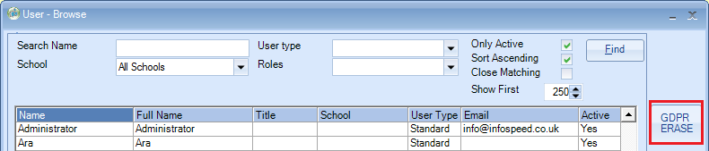
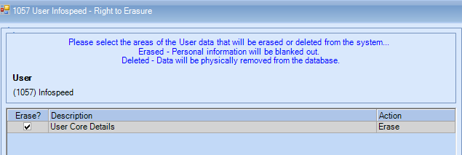
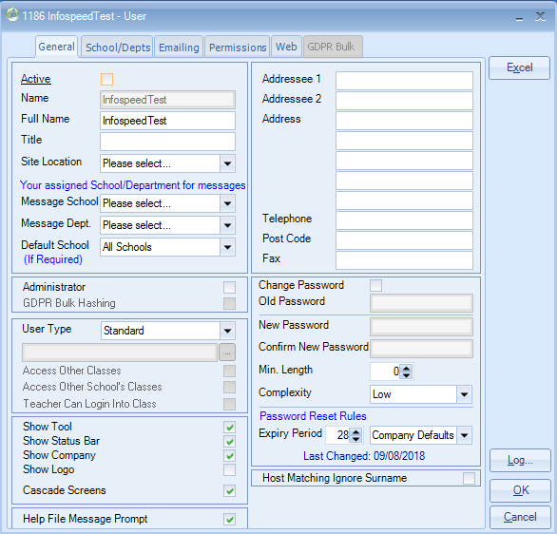
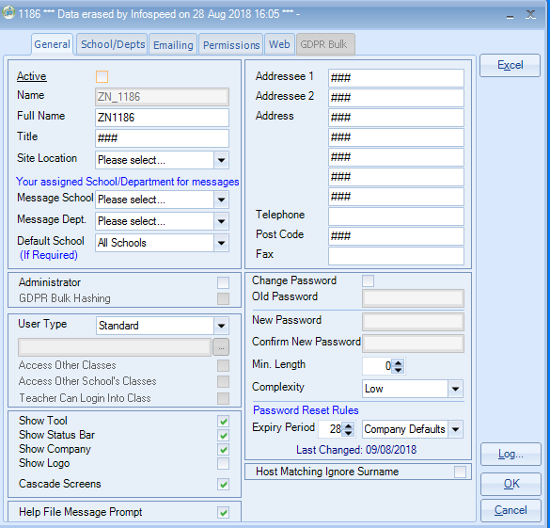
- User Core Details
  - This option cannot be switched off. The core details of the user that will be erased are:
Data Field | New Value
Title | ###
Name | ZN_UserID
Full Name | ZN_UserID
Addressee 1 | ###
Addressee 2 | ###
Address1 | ###
Address2 | ###
Town | ###
Region | ###
Country | ###
Postal Code | ###
Telephone | Blank
Fax | Blank
Email | Blank
Email Reply To | Blank
Email Display Name | Blank
MS Outlook Profile Name | Blank
Mobile Number | Blank
User Status | Set to ‘Inactive’

Note: Any GDPR Bulk Permissions will be deleted from the user as part of the “core” erase process

- User name stamp Entries
  - In some areas of the system, the users name is stamped on certain tables. If this option is selected the following fields will be reset where the user’s name is found:
Data Field | New Value
tblAudit.txtUserName | ZN_UserId
tblBatchEdit.txtCreatedBy | ZN_UserId
tblBatchEdit.txtChangedBy | ZN_UserId
tblCommissionBatch.txtUserName | ZN_UserId
tblDocument.txtUserName | ZN_UserId
tblDocumentExternal.txtUserName | ZN_UserId
tblDocumentMaster.txtCreatedUserName | ZN_UserId
tblDcoumentMaster.txtAmendedUserName | ZN_UserId
tblECourseAdjust.txtUserName | ZN_UserId
tblEHostAdjust.txtUserName | ZN_UserId
tblStatistic.txtCreatedBy | ZN_UserId
tblStatistic.txtChangedBy | ZN_UserId

Web booking
Note: You will not see this tab if you are not using the Class Online Toolkit module.
As a web booking could contain data for Student Analysis, Student UDF, Enrolment Analysis, Transfer Analysis fields, the erase process will adhere to the same setting for each of the areas set as previously detailed.
From the main web booking browse screen, a new ‘ERASE’ option has been added to the top right of the screen; which is enabled when the user has been granted the ‘Web Booking Data Erasure – GDPR’ permission or if they are an administrator. By selecting a web booking and clicking this option, a new screen will be displayed showing some basic details on the web Booking and listing all the erase/delete options available. These are as follow:
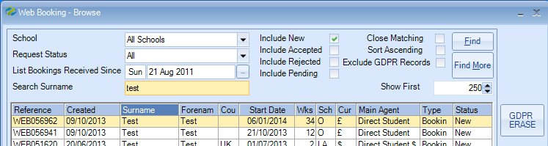
The “Exclude GDPR Records” checkbox is ticked any records that have been processed by the GDPR erase process will be excluded from the search results.
Untick this option if you require the GDPR erased record to be included in the search results.
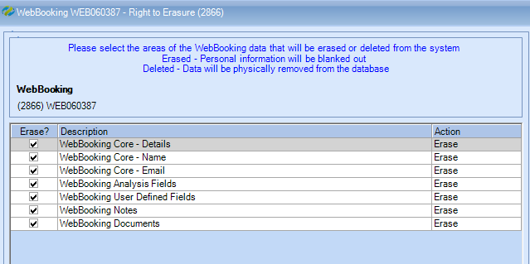

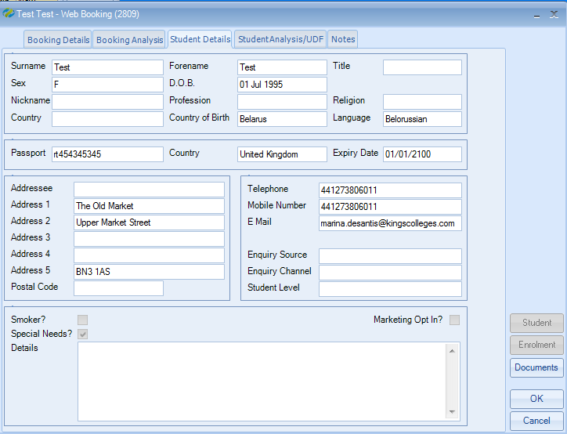
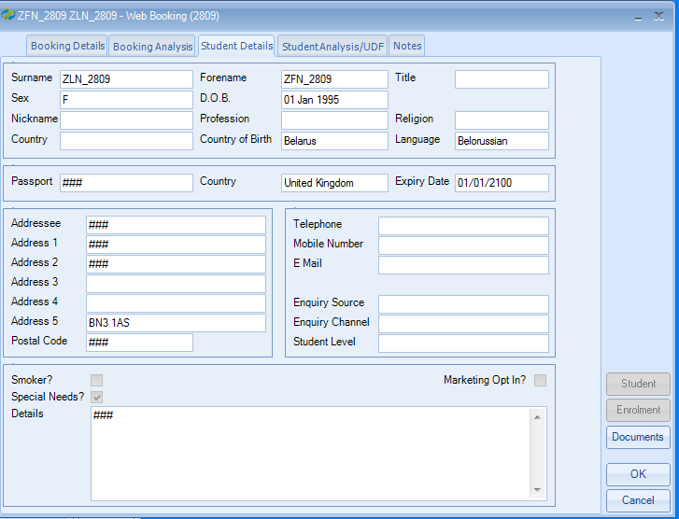

- Web booking Core Details
  - This option cannot be switched off. The core details of the web booking that will be erased are:
Data Field | New Value
Address1 | ###
Address2 | ###
Postal Code | Blank
Telephone | Blank
Mobile Number | Blank
Data of Birth | 01/01(Date Of Birth (Year))
Passport Number | ###
Marketing Option | No
Student Picture | Deleted from the database

- Web booking Core - Name
  - If selected, the name details of the web booking that will be erased are:
Data Field | New Value
Title | Blank
Forename | ZFN_WebBookingId
Surname | ZLN_WebBookingId
Addressee | ###

- Web booking Core - Email
- If selected, the email details of the web booking that will be erased are:
Data Field | New Value
Email | Blank

- Web booking Analysis Fields
Note. The erase process will only erase data within the web booking records and not any linked students, enrolments or transfers.
  - Based on which options have been selected in system settings to blank out, the following updates will occur:
Web booking - Student Analysis
Data Field | New Value
Analysis 1 | ###
Analysis 2 | ###
Analysis 3 | ###
Analysis 4 | ###
Analysis 5 | ###
Analysis 6 | ###
Analysis 7 | 0
Analysis 8 | 0
Analysis 9 | Database Null Value
Analysis 10 | Database Null Value

Web booking - Enrolment Analysis
Data Field | New Value
Analysis 1 | ###
Analysis 2 | ###
Analysis 3 | ###
Analysis 4 | ###
Analysis 5 | ###
Analysis 6 | ###
Analysis 7 | 0
Analysis 8 | 0
Analysis 9 | Database Null Value
Analysis 10 | Database Null Value

Web booking – Transfer Analysis (Arrival & Departure
Data Field | New Value
Analysis 1 | ###
Analysis 2 | ###
Analysis 3 | ###
Analysis 4 | ###
Analysis 5 | ###
Analysis 6 | ###

Web booking – Student UDF
  - If selected, all web booking UDF will be updated from the web booking details.
Data Field | New Value
Note | ###
Content | ###

Web booking Notes
  - If selected, all web booking notes will be updated from the webbooking details.
Data Field | New Value
Note Heading | ###

Web booking External Documents
  - If selected, all the physical external documents for the web booking will be deleted from the documents folder. All document entries for the web booking will also be updated as below.
Data Field | New Value
Addressee | ###
Email | ###
Fax | Blank
Subject | Zdocument_DocumentId
Email Body Text | Blank
Document Name | ###

Summary
Once the erasure process is completed, the individual’s profile details are updated with the user who carried out the erase function along with the current date and time. When the individual’s profile is viewed, these details can be seen in the title bar of the appropriate forms.

GDPR – Opt In for Marketing Purposes

A new field has been added to the student and agent screens to enable users to specify that they have opted into any marketing. This is NOT currently linked to COT (Class Online Toolkit Version 1).
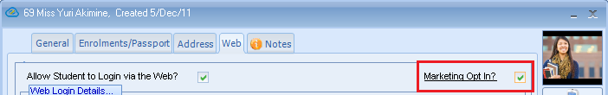

The above is available in COT (Class Online Toolkit Version 1).

Documents
Any attached General or Official document records will still show against a student etc but they will not be viewable as the physical document has been deleted as part of the GDPR Process. The record of the document will be hashed as below
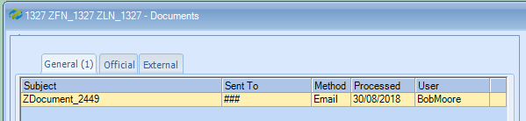
If the user clicks on the document to view the follow error message will be displayed and the user will need to click “OK” to continue.
For any Financial documents these can be regenerated but the details of the addressee will be hashed out as below.
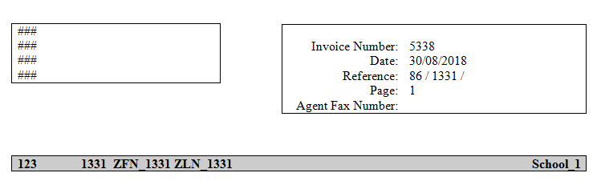

Quick Reports
If a student, agent, host family or teacher asks for details that you hold for them, we would suggest running a quick report.
For the Class users there is no quick report available. However, within the user settings (Maintenance/Settings > User Settings) go in to the users record and click the Excel button to produce the details in a spreadsheet.
If you would like assistance creating the report(s) please contact the support desk - support@infospeed.co.uk

