 Class.Net – Help Document

Problem
If you do not allocate the receipt at the time of entry how do you allocate it later.

Solution
Go into Receipts.
Highlight the receipt that you want to allocate and click on edit or double click.

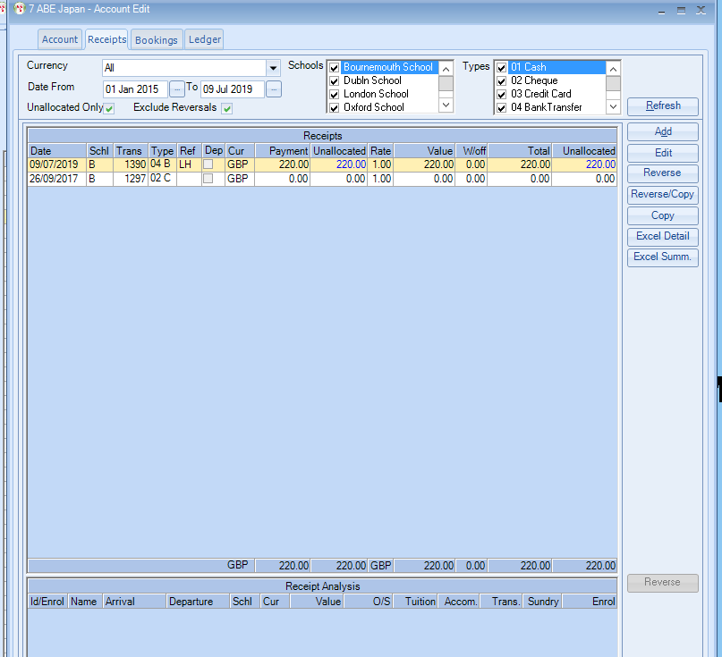

You can now allocate this Receipt to a transaction(s) with an outstanding value.

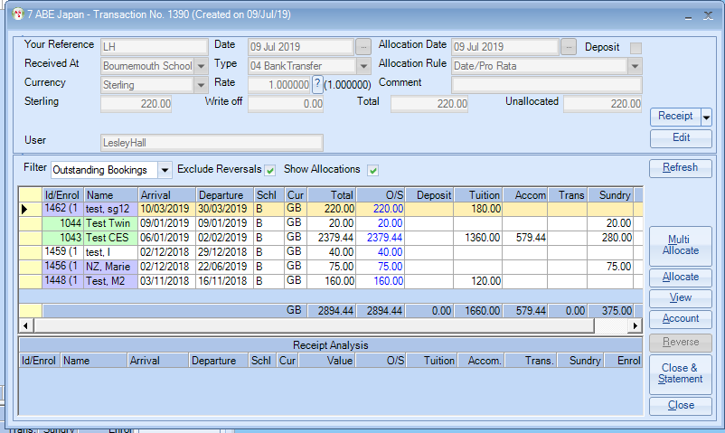

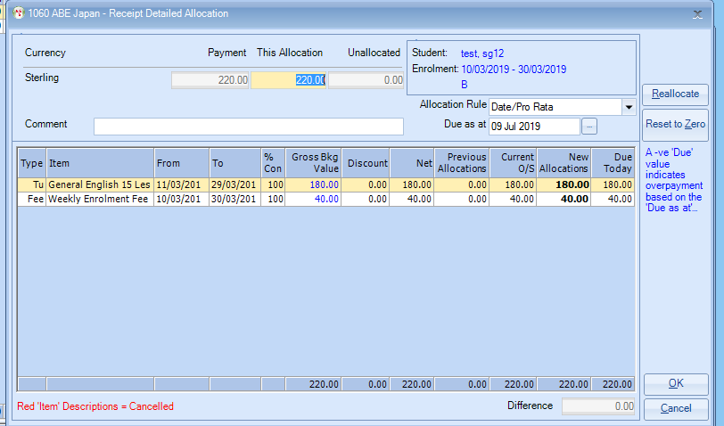

Click OK

