Class – Help Document


Period End Reports

Issue
How do I get a report that gives me the figures to post to our accounting system?

Solution
The report you require can be obtained by doing the following:

- Class Ledger
- Reporting
- Period End Accounting Analysis
- Invoice Accounting (Nominal Analysis)

- Report of all Class accounting transactions within the date range.
- The report may be produced in detailed or summary format.

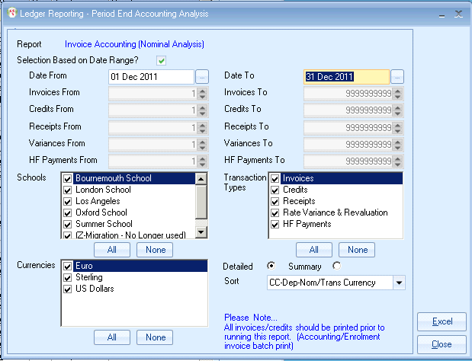

Summary

One line per nominal code

Nominal + Values
This report will give you the figures that you need to manually post via journal(s) into your accounting ledger. Use the far right column (Convert to Base Currency) unless your accountant advises differently.

Detail

Breakdown of each nominal

