Class – Help Document


How to add Nominal Codes

Go into Class and then do the following:
- Maintenance/Settings
- General Settings

Select Accounting / Nominal Codes

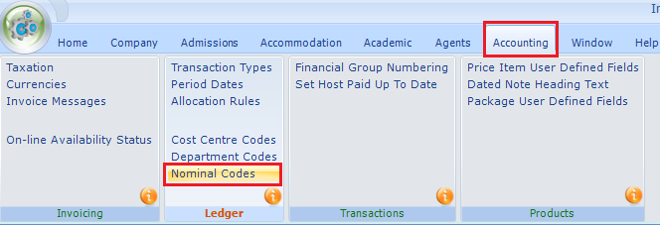

Set up as required
These codes can be set up to match those in your accounting package.

Example:
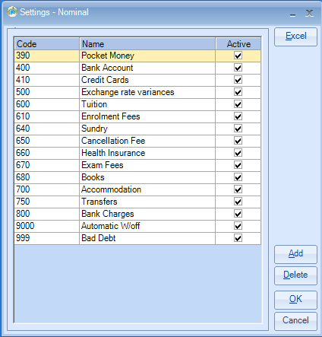

Cost Centres and Departments can also be set up if a further breakdown is required.

Firstly, you need to set them in use.

This is done within Maintenance/Settings > General Settings.
Company > Company.
Finance / Ledger.

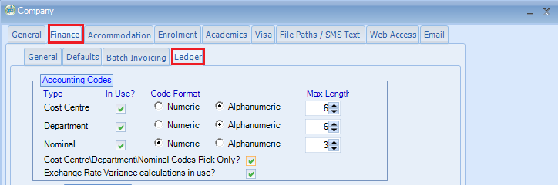

Once done go to Maintenance/Settings > General Settings.
Accounting > Cost Centre Codes / Department Codes

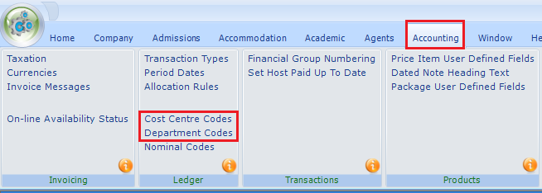

These can be set to your required specifications.

Some clients just use the cost centres to split their schools.
Some clients use both cost centres and departments.

An example:

Cost Centres could be set for difference schools

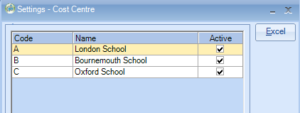

Departments could be the different departments within the school

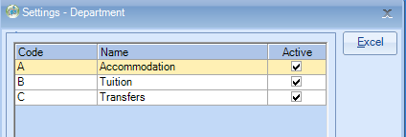

IMPORTANT:
Maintenance/Settings > Maintenance
Your Price items will need to be assigned to the correct Nominal Code and if in use the Cost Centres and/or Departments.

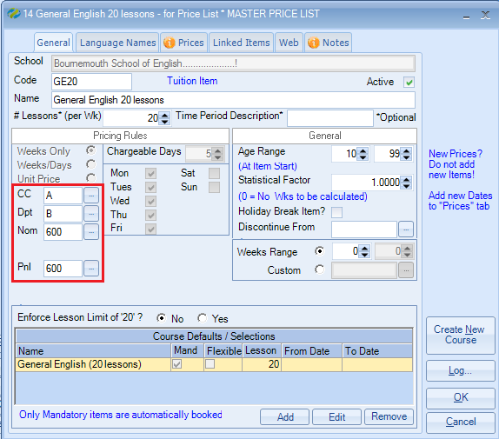

NOTE:
The Period End report within the Ledger: Invoice Accounting (Nominal Analysis) will break down your accounting figures based on the above settings.

Last Updated: Aug 2015/JA

