 Class.Net – Help Document

Question: How do I post receipts to the Class Ledger?

Solution

Go to the Class Ledger. 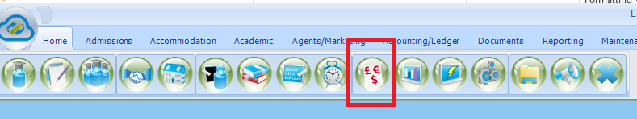

To get into the ledger select the above icon within Class.
Or
Within the student’s enrolment, go to the Invoicing screen and select the ‘Agent Account’ or ‘Student Account’ button. This will take you directly to the account for this enrolment.
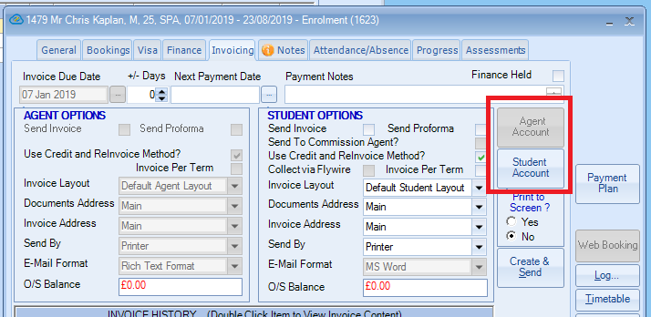

If you select the first option, you will need to search for the account in the Account Browse screen

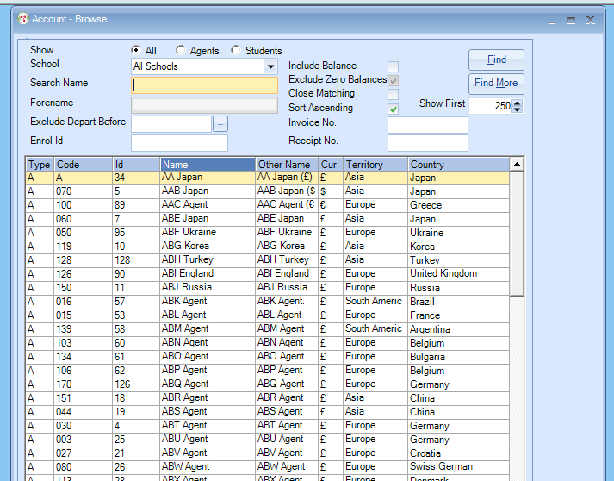

If you select the second option, then this will take you directly into the account and into the Receipts tab.
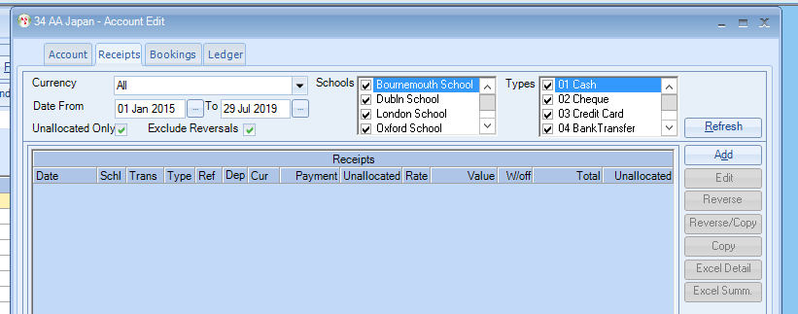

If you untick the Unallocated Only box, you will see a list of all the receipts that have been added to this account.

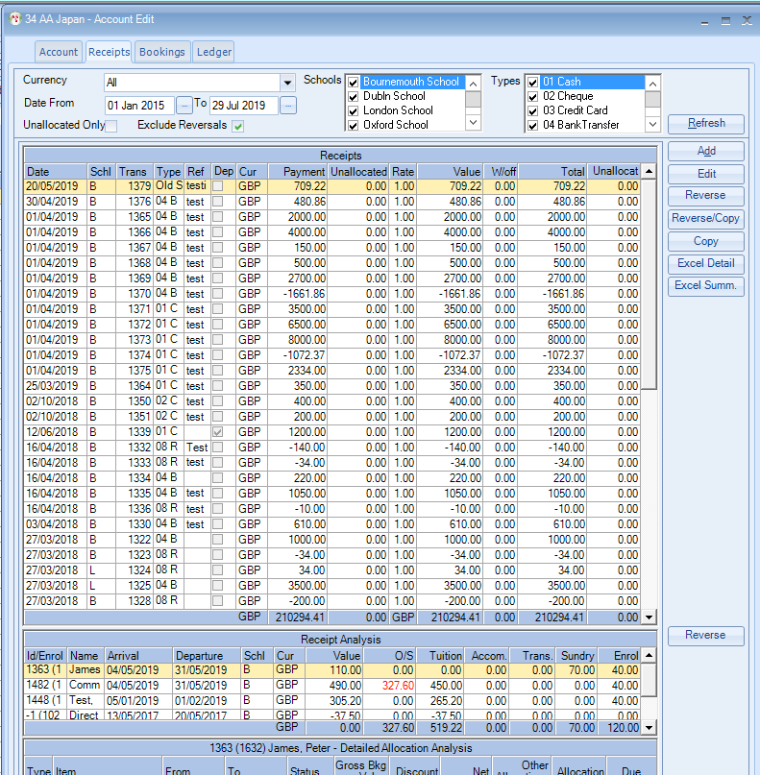
The receipts screen shows any unallocated cash (top section), and any allocations of that receipt (bottom section).

From this screen unallocated receipts can be further allocated. See Help Sheet LED026 for further information on Unallocated Cash.
Other actions may also take place e.g. reverse a receipt transaction.

Add a ‘New’ Receipt - Click on Add.
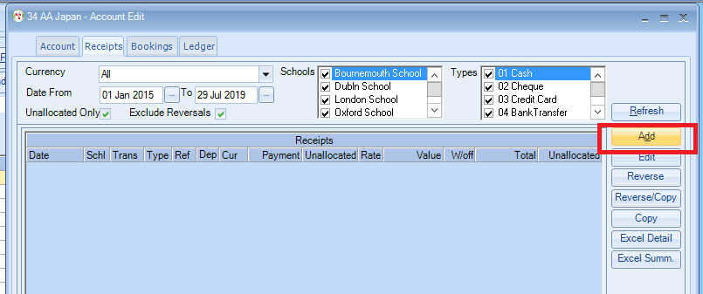

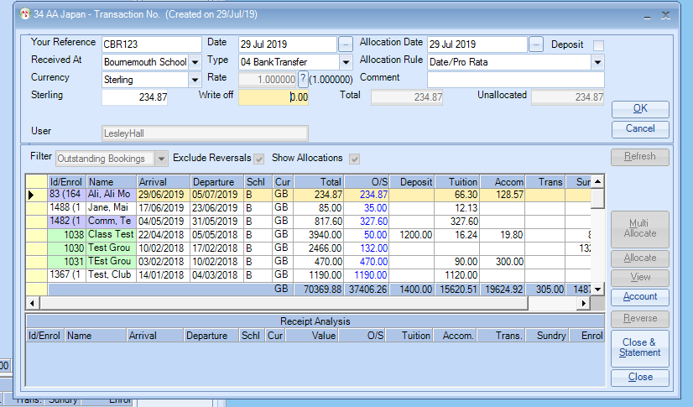

Your Reference
30 character Customer or Bank reference.

Deposit
Set if a deposit. This is purely for information. Deposit cash is still allocated in the same way as any other cash.

Date
Transaction (Receipt) date. (Must be within “open” accounting periods).

School
School receiving the money, not the enrolment school. You can enter a School that has received the money even though the enrolment was for another school.

Type
Type of receipt.
Cash, Credit Transfer, Visa etc. (Can be found in Maintenance/Settings/General Settings – see below)
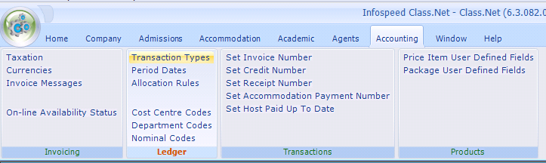
See Help Sheet LED025 for further information on Transaction Types

Allocation Rule
Defines (Only Used for clients using “Cash” Accounting), the allocation rules.

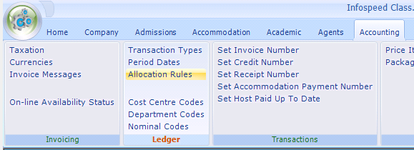

These are set up to establish the order with which the allocations are made for example, if the school wants the receipt to be allocated firstly to Accommodation then the Enrolment, then Tuition, then Transfers, then Sundry, then they would create an allocation rule as below.
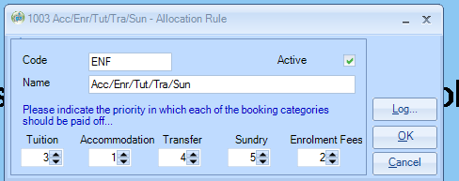

Non Cash Accounting Users will normally use the Date Pro Rata, which will allocate the receipt by pro rata date.
Select as appropriate.

Currency
Select the currency. (Default is base currency), if the receipt has come in another currency this can be changed for example the booking was in sterling the receipt has come in as Euros.
If the account currency is sterling and the receipt is entered as Euro, the system will convert to the account currency value.

Rate
If base currency has not been selected, then the rate of exchange from Settings (Settings/Invoicing/Currencies) is displayed. If a User’s rights allow, the rate may be changed.

Foreign Currency Receipts
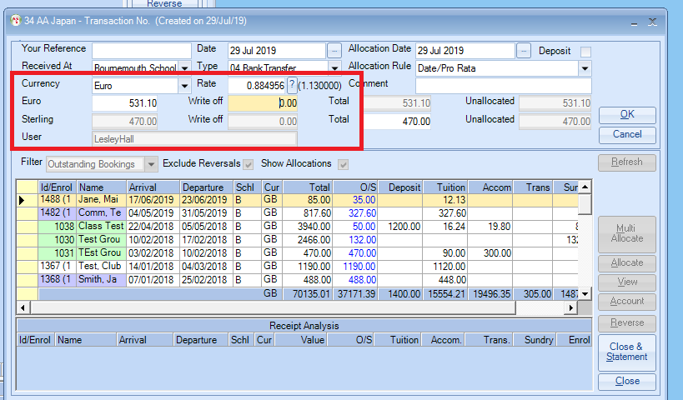
In the above example the receipt is in Euro (the account is sterling). Receipts are always converted into the “account currency.”
The user (if permissions allow) can provide the system with the resulting account value, and the system will work out the exchange rate.
You can see we have selected Euros and the system has given us the rate to sterling.

If you go into General Settings/Accounting/Invoicing/Currencies.
You can see where this information is picked up from below:
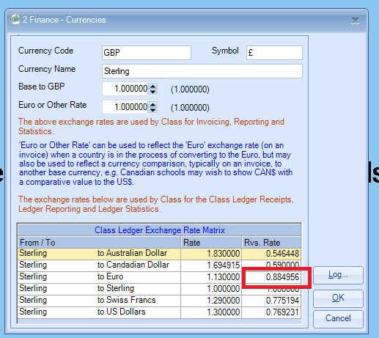

Comment
50 character comment, this could be the name of a student or a booking reference

Base Currency (e.g. UK sterling) This sequence changes if the enrolment currency e.g.UK sterling, is not the receipt currency, as detailed above.
Amount received (less any bank charges)

Write Off
Value of any charges or write off value to be absorbed as part of the receipt. If charges are not to be absorbed, then the account is only credited with the actual receipt value.
For example, the total amount to be paid is £500.00 but within this there is a bank charge of £10.00. enter the value of £490.00 into the sterling value allocate this amount, then add the £10 as another receipt but with a transaction type of Bank Charges, this keeps the two amounts separate but will clear the total amount to be paid.

The receipt must be OK’d before it can be allocated or accepted.
Once OK’d, enrolments can be allocated from the list.

Note: the grid defaults to only showing outstanding enrolments, but can be changed to show all enrolments, or the grid can be extended to show more students, deselecting “show allocations.”

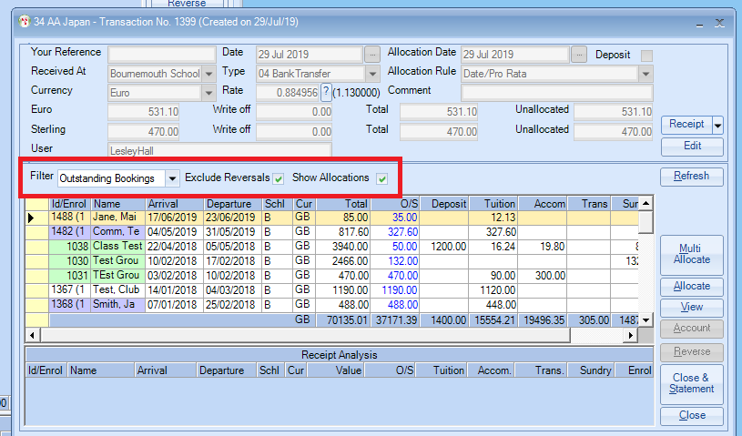

Allocations

There are 2 methods depending on the system settings

(General Settings/Company/Finance/Ledger – Use Detailed Allocations?

Method 1

““Use Detailed” allocations set:

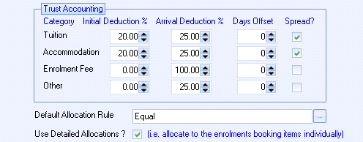

Receipts can be allocated down to enrolment booking level, e.g. a specific course, accommodation, booking fee, etc.

Receipts are entered as per method 2, but once “Allocation” is selected the screen below will show
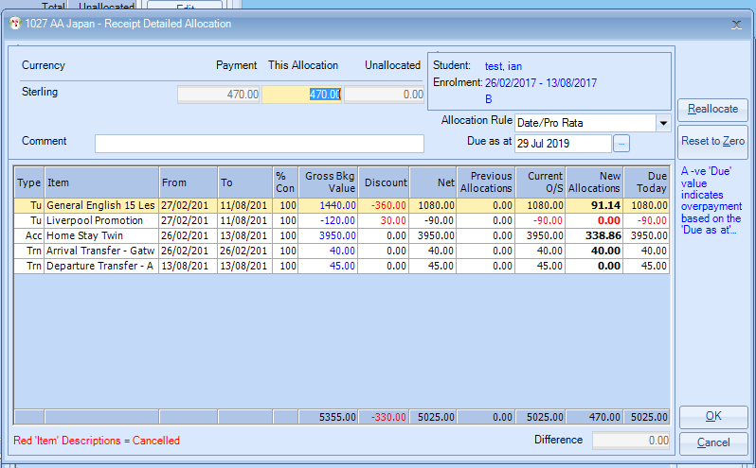

The screen layout has been designed to give maximum information, including previous allocations.

The amount to be allocated is shown at the top of the screen and is auto allocated according to the “Allocation Rule” shown.

The Allocation Rule may be changed e.g. Equal

By changing to Date/Pro Rata, Class will allocate using date first, so in the example above everything has been allocated apart from the departure transfer which is dated 13/8.

Entries may be changed by hand to reflect special situations, e.g. a student paying only the accommodation part of the booking.

The “Due as at” date may be changed to reflect monies due up to a specific date, e.g. a student wants to pay for accommodation up to the end of August.

(Please bear in mind Class is calculating the values based on the From/To dates (7 days a week), so in some cases (e.g. 5 day a week course) may only be an indicative.

A “Comment” may be added.

“Reallocate” will allow the values to be reset according to the Allocation Rule.

“Reset to Zero,” will set New Allocations to zero, perhaps to allow manual entry.

Enrolments can be over allocated, see Help sheet LED007 for more information on overpayments and fully allocated enrolments can be further allocated……….just in case you are paid twice for the same student! Names shown in blue have a “student” account which can be selected by pressing the Account button. Green names are groups.

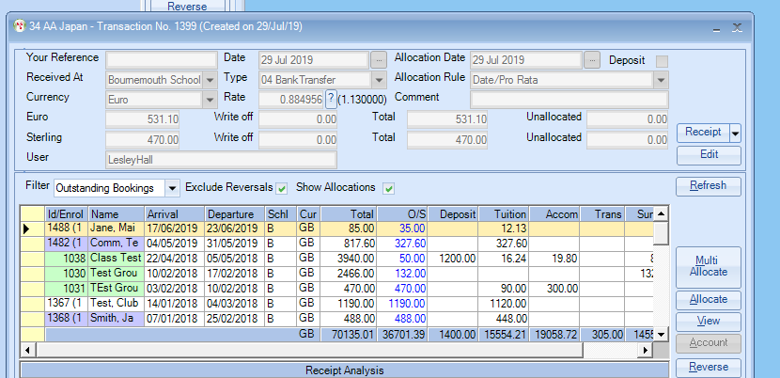

Method 2

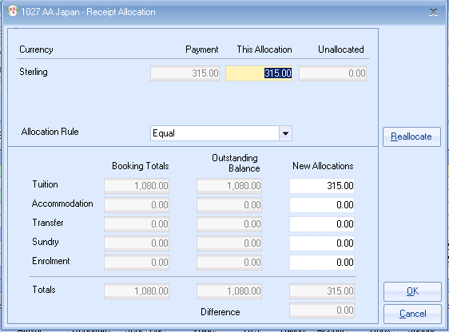

The system defaults to allocating the outstanding amount. This can be changed (increased or decreased). At the same time, for the benefit of users using “cash accounting” (as above) the receipt is allocated across the enrolment elements (tuition, accomm etc). The allocation is made according to the allocation rule selected when entering the receipt.
It can be manually changed, but the system will force it to balance to the allocated value. Allocated values can be reset by pressing the Reallocate button.
If the item selected is fully allocated, when accepted, it will be removed automatically from the grid showing “outstanding bookings.”…….it is therefore no longer outstanding!
It is not necessary to fully allocate the receipt, but on exit from the allocation process the user is warned that the transaction has not been fully allocated.

Correcting wrongly entered receipts/allocations See Help Sheet LED003 for further information
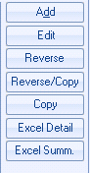

Edit
Once a transaction has been accepted only the Reference & Comment fields may be changed.

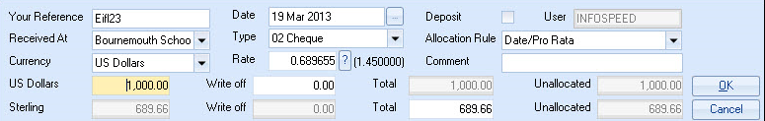

Reverse
Typically used for wrongly entered transactions or where the transaction has been entered against the wrong Agent.
A transaction together with its allocations can be reversed.
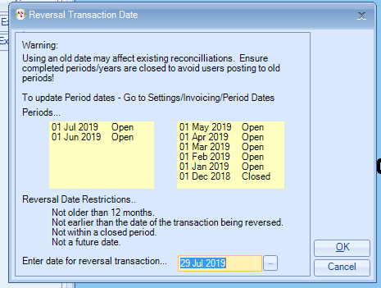
The above screen will appear when the reverse button is selected.
The restrictions are:
Not Older than 12 months
Not earlier than the date of the transaction being reversed
Not within a closed Period, if periods are closed within the system settings then the receipt date cannot be changed.
Not a future date.

Reverse/Copy
Two transactions are created.
1. Reversing out the original transaction
2. Creating a new “open” transaction for reprocessing.

Copy
Duplicates the highlighted transaction.

Reverse
Individual allocation items can be reversed at any stage. The value can then be re-entered and re-allocated to another student/enrolment if required.

