
Class.Net – Help Document

Overpayments.

I have an amount that is more than the total due.
How do I deal with this?

Enter the receipt as normal. ‘In this example, we have received £180.00 but only £160.00 is outstanding.’

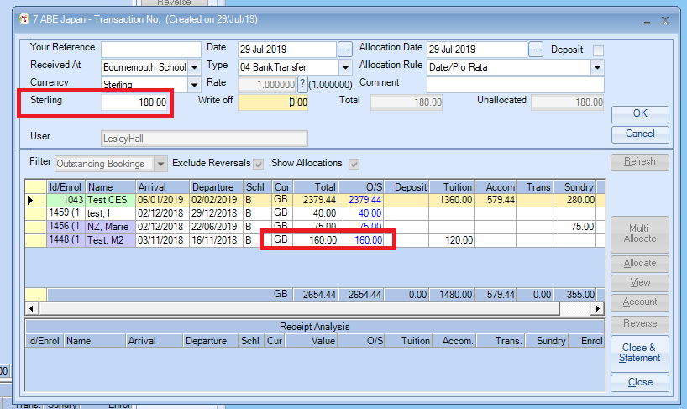

When you get to the allocation do the following.
Change “This Allocation” to the full amount of the payment. In this example £180.00. Check that there is a zero value in the difference at the bottom of the screen. If there is an amount in the difference box, then in the New allocation column amend these figures to reflect the amount being paid then check to make sure the difference is zero.
Click OK.

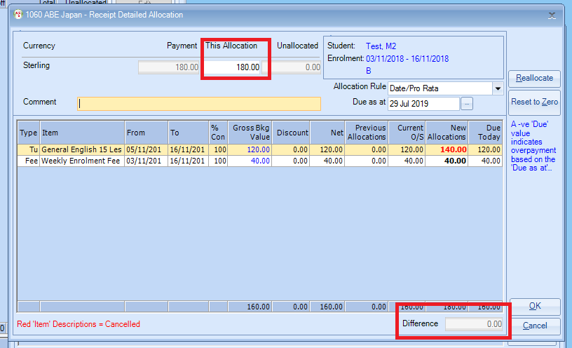

You now have a negative outstanding amount.

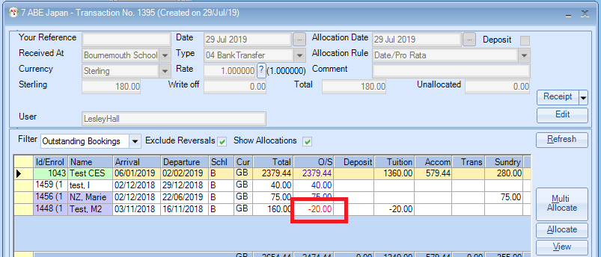

You will now need to add a negative receipt (a minus value) to clear this out.
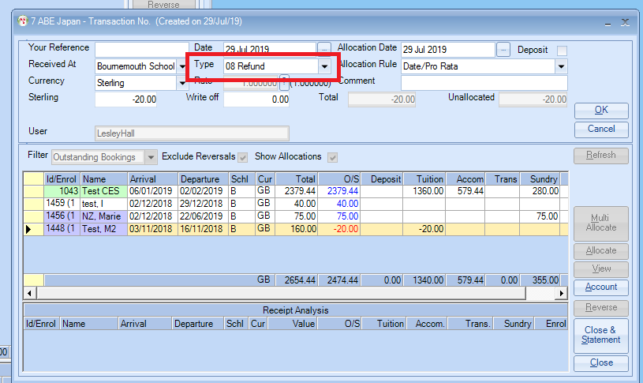
We suggest you use a “Type” of Refund. Click OK
Then allocate in the normal way.
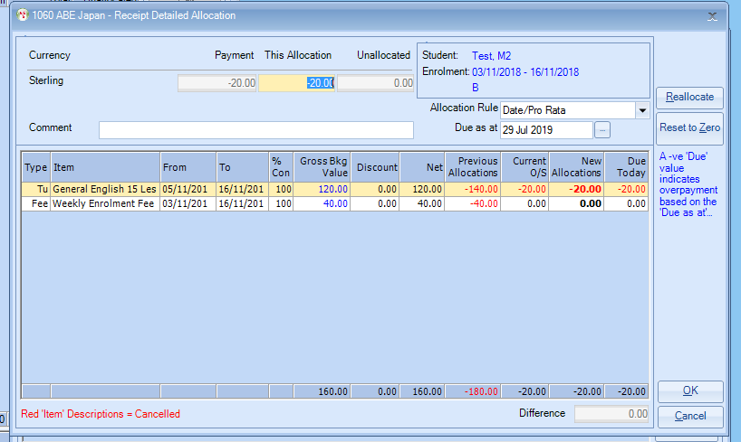
Click OK

