 Class.Net – Help Document

Class - Period End (with Ledger)

Summary Check list

Print all invoices/credits

- Input all Receipts (payments received)

- Run Ledger Verification

- Balance the Ledger

- Run End of Period reports

- Close the month

- Run other reports as required

Detailed Processes Pages 2-11

Class - Period End (with Ledger)

Detailed
General

These notes are intended as a guide only and only represent one view. Your financial advisers may suggest/require a different process

For the following example we are producing documentation and closing the month of April 2019.

Print all invoices/credits – See Help document SQL182 for further information on Batch Invoicing.
- Class
- Accounting/Ledger
- Invoicing
- Batch Print

Ensure the date of the invoices/credits is for the month in question.

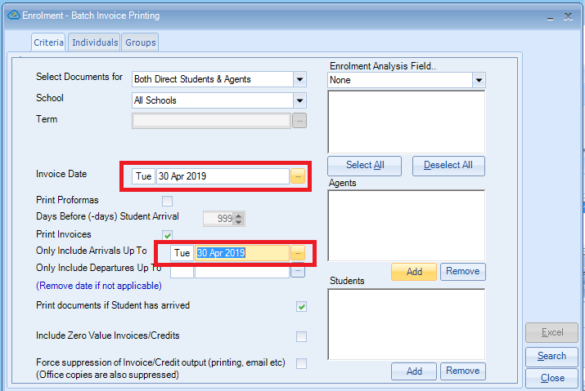

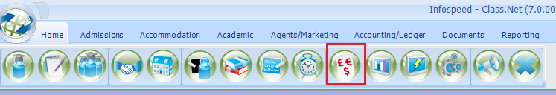

- Ensure all receipts received before the end of the month you are reporting on are entered into the Class Ledger

To post a Receipt

- Class Ledger
- Select the Accounts button (if the list of accounts is not automatically displayed)

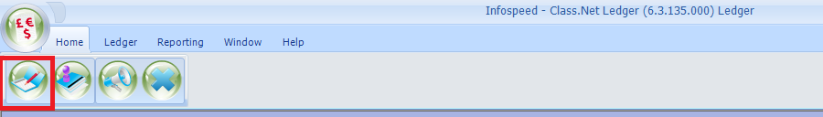

- Select the correct account
- Select the “Receipts” tab
- Click on the “Add” button

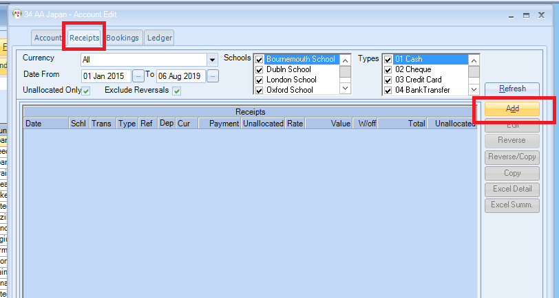

See Help document LED006 for further information on posting receipts.

Balancing the Ledger

Important
The following two reports need to be completed without adding invoices/credits/receipts to the system for the period in question. If transactions are entered after the reports have been run, (for the period in question) then the reports will not balance to each other.

Ensure that no enrolments are being added/amended or Receipts being processed while you carry out this process.

Control Totals
- Class
- Accounting/Ledger
- Reporting
- Control Totals

The date should be the month that you are closing.
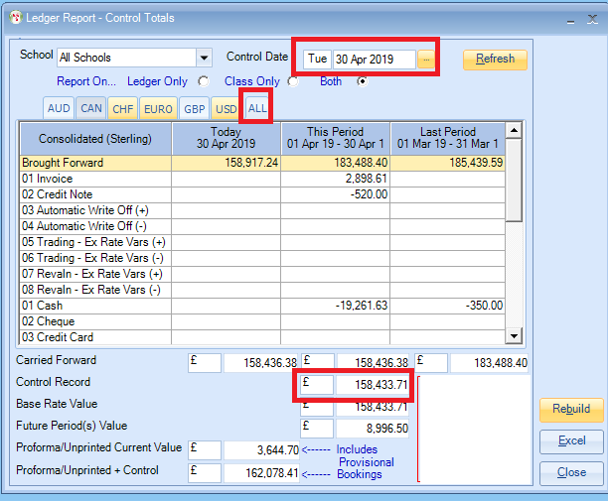

Note the value highlighted (Control Record) as this is the figure you will be balancing to.
This is the total of all invoices, credits and receipts added to the Class Ledger up until the date you have input (in this case 30.04.19)

Ledger Reconciliation
- Class
- Accounting/Ledger
- Reporting
- Ledger/Balance reconciliation

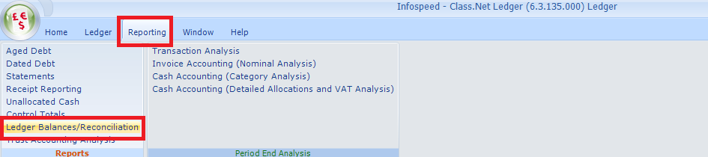

- Ensure that the date is for the month you are closing.
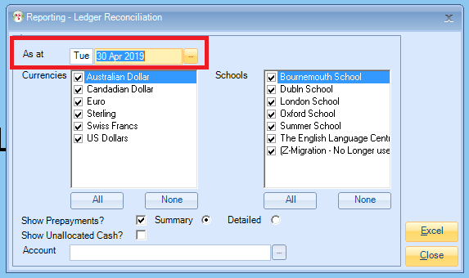

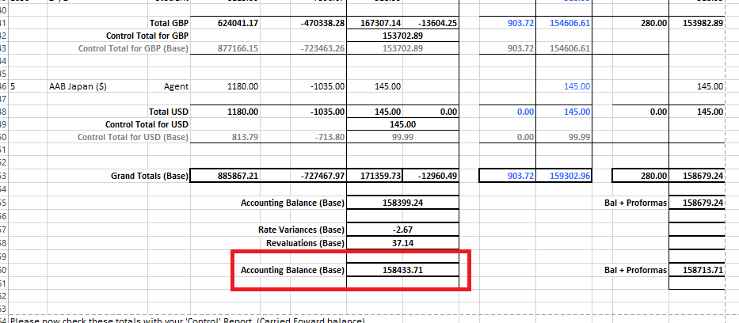

The two figures should balance if they do not please contact the Class Support Desk
Totals
(in Base Currency)
Control Total  Taken from the Control Totals screen on page 6 |  | £158433.71
Ledger Reconciliation  (Taken from the Ledger Balances/Reconciliation report above) | Base | £158433.71

NB Base Currency is your main currency
i.e. in the UK it would be pounds (£) but you may also invoice in Euro’s (€). This would mean your euro transaction values would be converted into pounds.

You have now completed the balancing of the Class Ledger.
End of Period Reports

If values are required from Class for input into your accounting package (Sage/Quick Books/Dream etc.). The Nominal Analysis will give you these figures.

There is an additional Class module available you may wish to use - the Accounting Export module which can transfer these via export/import routines for you. Please ask sales@infospeed.co.uk for more information.

Nominal Analysis
- Class
- Accounting/Ledger
- Ledger
- Reporting
- Menu Item - Period End Analysis
- Invoice accounting (Nominal Analysis)

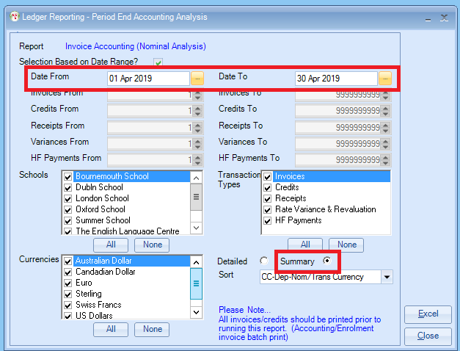

The report details, by Nominal/General Ledger code, all the invoices, credits, payments received and accommodation payments to accommodation providers.

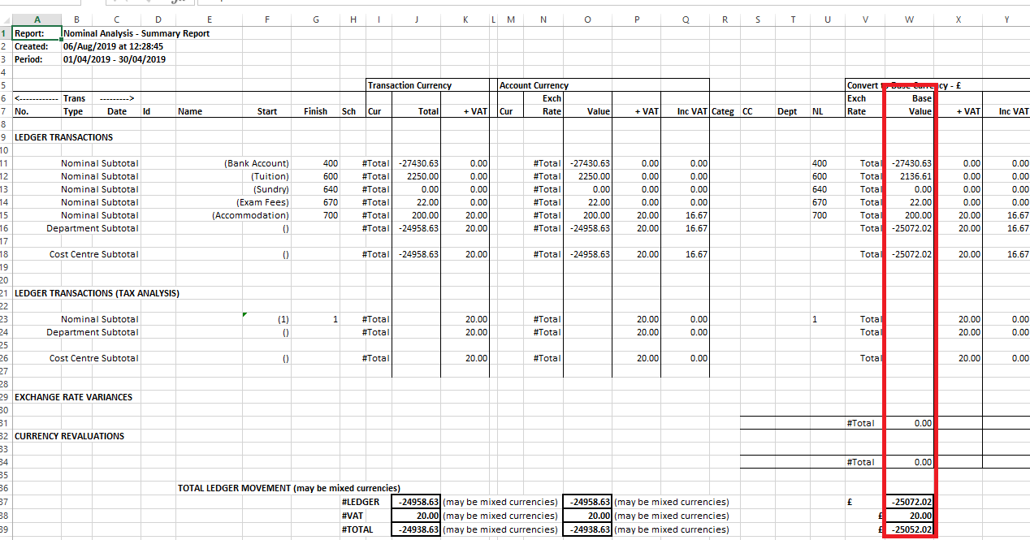

The values highlighted in red should be what are required for your management accounts but your accountant may request more detail or for VAT/Tax to be recorded. Many schools do not have to charge VAT/Tax so the VAT columns will often be 0.00.

Accommodation payments made during the accounting period will be listed on the last page of this report.

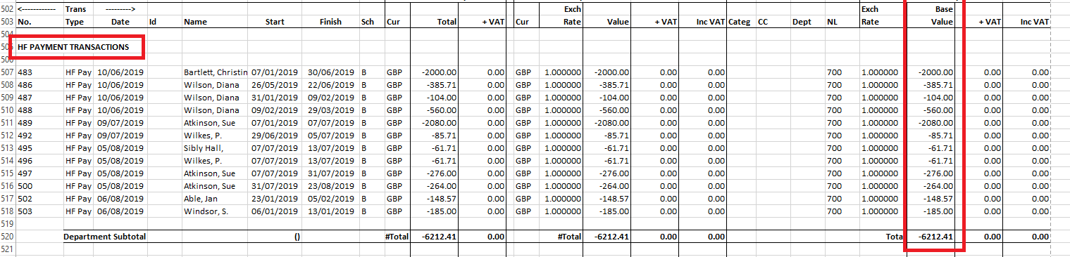
Closing the Month

Once the End of Period processing has been carried out then the accounting period should be closed. This will stop any Receipts being added with a date of an accounting period that is closed/finalised.

- Class
- Maintenance/Settings
- General Settings
- Accounting
- Period Dates

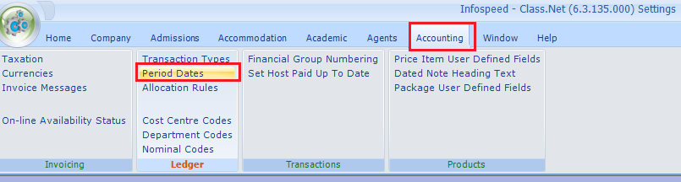

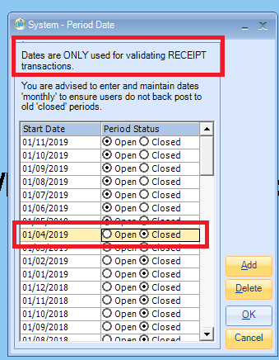
To add further dates, click on the add button. The first day of the month is always used when creating new period dates.

Other Reports

Although not essential the following reports will be useful.

- Aged Debts – See Help Document LED020
- Statements – See Help Document LED023
- Unallocated Cash –See Help Document LED026

