 Class.Net – Help Document

Writing Off Outstanding Values in the Class Ledger

On the “Bookings” tab within the ledger there is £20.00 that is outstanding that you wish to write-off.

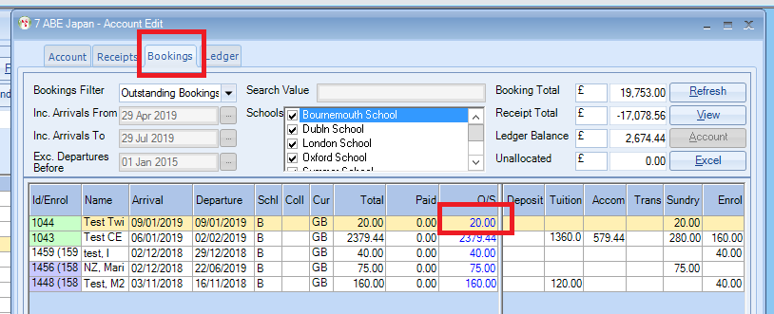

Add a receipt for £20 in the normal way, selecting Write Off in Type. (if you need to create a new transaction type you can do this in the System Settings).
See Help sheet LED025 for creating new Transaction Types.

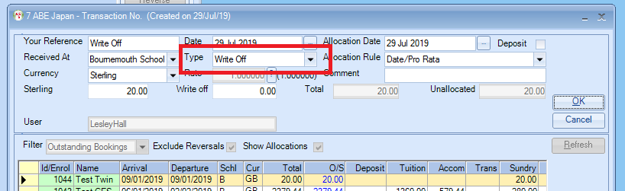

You can then report on just ‘Write Offs’ by selecting ‘Transaction Type’ of Write Off when running your month end reports. See Help sheet LED008 for more information on Period End Reporting.

