
Class.Net – Help Document

Question: How do I post a refund to a student or agent on the Class Ledger?

Solution

Receipts

There is a value overpaid that you want to refund to the student/agent.
See Help sheet LED007 for information on overpayments and overallocations

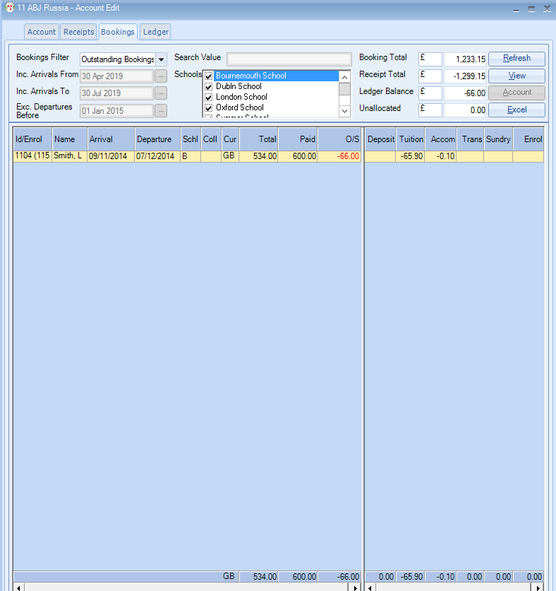
Add a New Receipt

Ensure that the value that you want to refund is input as a negative amount.

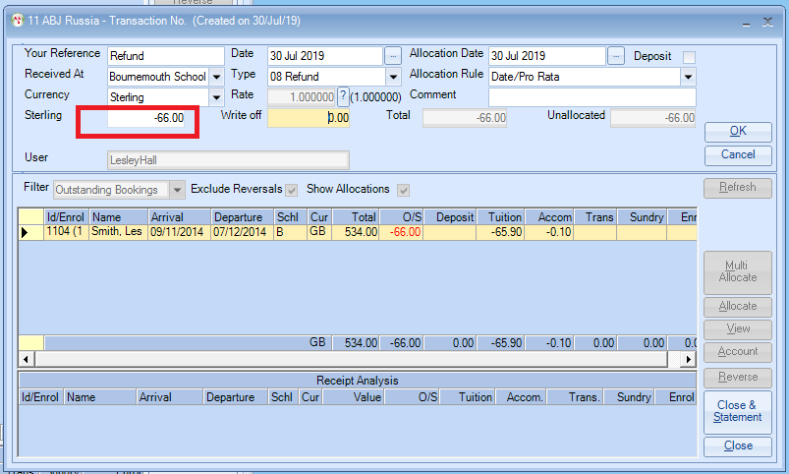

Allocate - 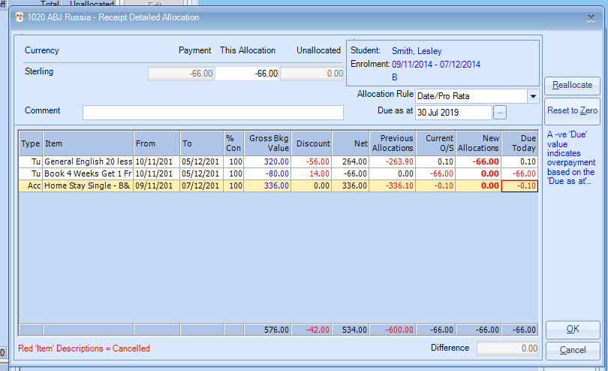

The refund has now been entered and allocated.

