
Class.Net – Help Document

Inputting Opening Balances

Ensure you have an up to date backup.

- Ensure all users are out of Class and the Class Ledger.

- Select Ledger
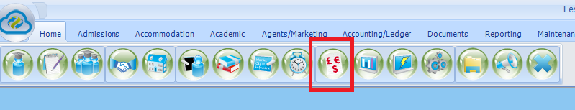

- Ledger Verification…

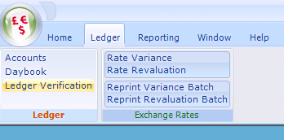

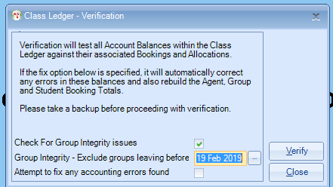

- Ensure that the “Attempt to fix any errors found” box is ticked.
- Click on “Verify”
- You will get the following message

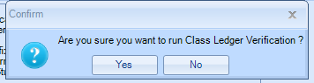

- Answer Yes

- Results Example:

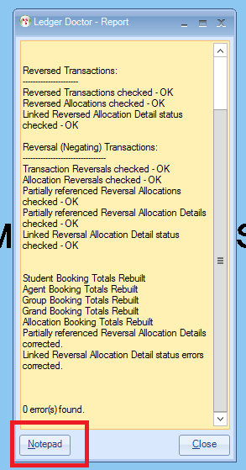

- Report any errors to Infospeed, (Click on the Notepad tab and this will create a document that can be sent to Infospeed for investigation).

- Go To File -
- Special Functions
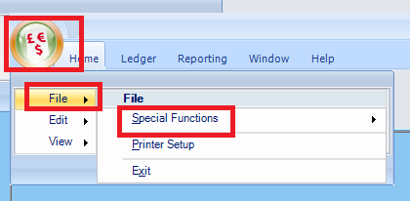

- Create/Adjust Account Balances

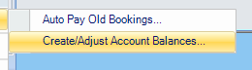

- The password = letmein

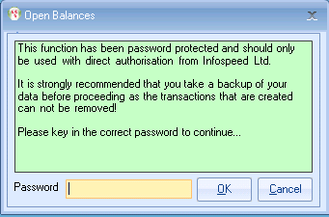

- The next screen allows you to input the new balances.

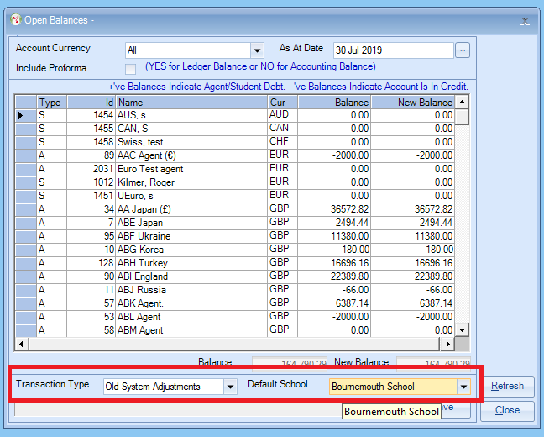

Transaction Type – Set up in the System Settings, Old System Adjustments, is an example of a transaction type you can use. When running reports, this transaction type can be left unticked or if included easily identified in the reports.

Enter each balance individually or leave if the correct value is the same.

- Once all the balances have been entered click on Save.

Once completed:
- Ledger
- Ledger Verification

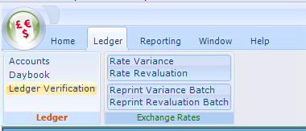

- Ensure that the “Attempt to fix any errors found” box is ticked.
- Click on “Verify”

Once this is completed, we would suggest that you run the Aged Debt and check that you are happy with the balances that are left on the ledger.

If you have any problems, please contact the Support Desk.

