

Class.Net – Help Document

How to zeroise Accounts in Class Ledger

Run the Special Function to “Auto Pay Old Bookings.

Ensure you have an up to date backup.

Ensure all users are out of Class and the Class Ledger

Select Ledger
Ledger Verification…

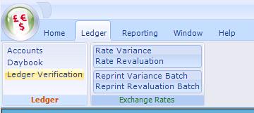

Ensure that the “Attempt to fix any errors found” box is ticked.
Click on “Verify”
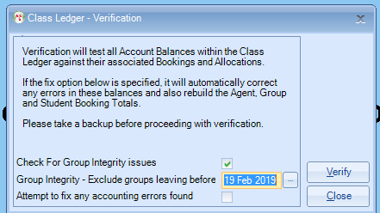

Report any errors to Infospeed

File
Special Functions
AutoPay Old Bookings

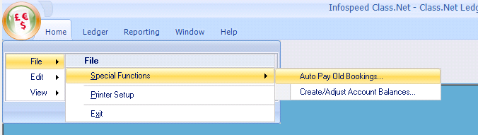
You will then be given the following login screen:
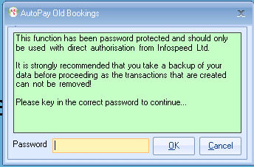

The password is: letmein (in lower case).

You will then get the following selection screen:

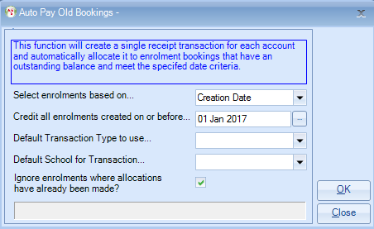

Select enrolments based on… - choose Creation Date, Arrival or Departure Date

Credit all enrolments created on or before… select the required date.

Default Transaction Type to use… select ‘Old System Balance’ or ‘Opening Balance Adjustment’ or similar.

If you do not have a transaction type similar to the above please ask support@infospeed.co.uk for assistance.

Click on “OK”
Once completed run the ledger verification once more:

Ledger
Ledger Verification

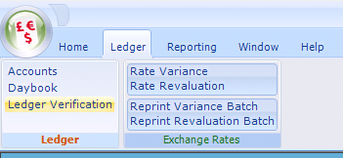

Ensure that the “Attempt to fix any errors found” box is ticked.
Click on “Verify”

Once this is done, we would suggest that you run the Aged Debt and check that you are happy with the balances that are left on the ledger.

If you have any problems please contact the Support Desk. – support@infospeed.co.uk

