Class – Help Document


Year End – Currency Exchange Rate

This is something that is not used by schools.

Problem: It is our Year End and we need to:

Provide for any exchange profit/loss at the end of the year.

Revise exchange rates for the start of the year.

Solution:

Class Ledger

- Run the Ledger Balance/Reconciliation report

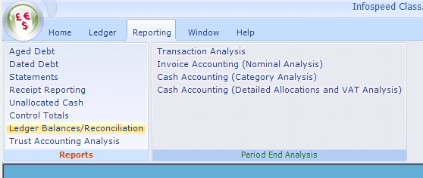

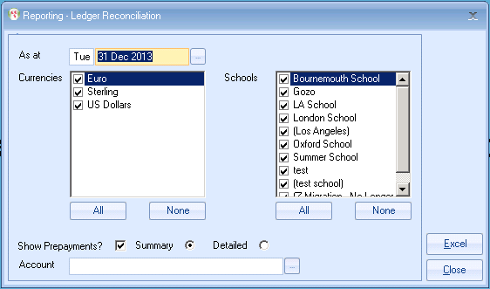

This will give totals for all outstanding invoices/credits/receipts for each currency that you deal with.

Below is an example of the manual calculation required for each of the currencies.

Base £
Currency for calculation US$
Total invoices outstanding = $1000

Old exchange rate $1 = £0.5263
Year End exchange rate $1 = £0.5128

Balance (US Dollars) at old rate
$1000 x 0.5263 = £526.30

Balance (US Dollars) at new rate
$1000 x 0.5128 = £512.80

The difference between the calculation done at the old and new rates:
£526.30 less £512.80 = £13.50 (loss)

A provision should be made in your accounting system (Profit/Loss on Exchange Rates) for the £13.50 (loss).

- Amend the “Settings” within Class to reflect your view on exchange rates for the start of the year e.g.

