
Class.Net – Help Document

Agent Account
Allocating money to a different student

Example:
An agent has paid for a student booking in full, £1490.00, then the student cancels part of the booking, in this case a transfer and this will then give an overpayment of £40.
The agent wants to offset this against an existing outstanding booking.

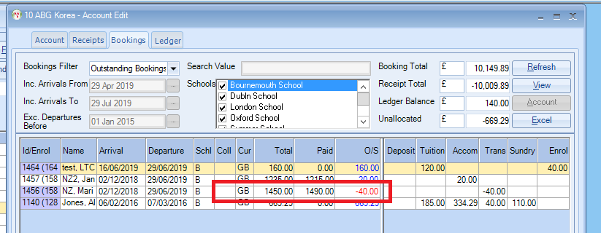

Receipt Tab
Remove the tick for “Unallocated only” and find the receipt that the agent originally sent. (if you cannot find it check that you have the correct “Date From and “Date To” to include it in the list.
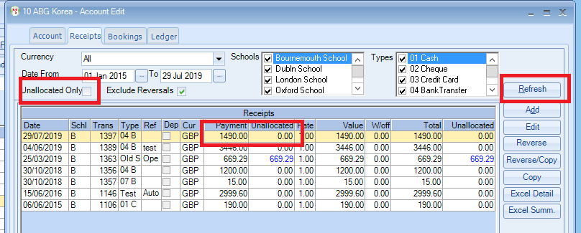

Highlight the relevant receipt

Click “Reverse” in the bottom part of the screen, this will unallocate the original allocation.

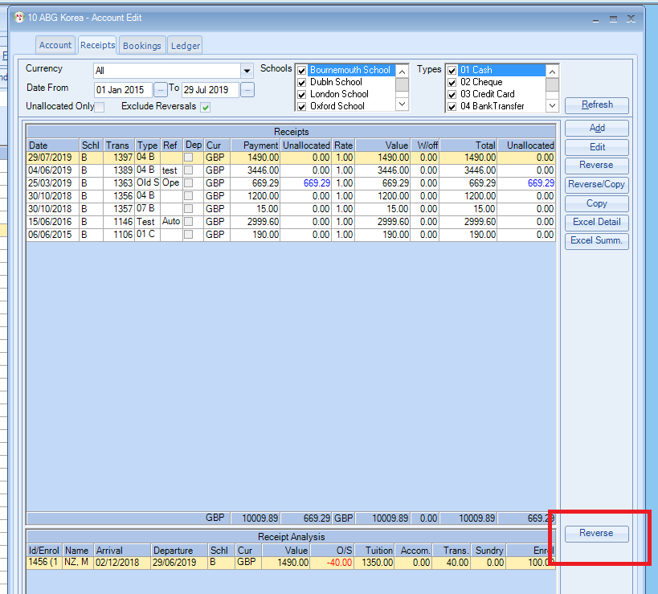

As the receipt is now unallocated you can re-allocate it against the original booking and the extra amount that is outstanding against another booking.

