

Class.Net – Help Document

Aged Debt Report

This report is used to chase for outstanding payments.
It can be produced based on all debts for both students and agents or just agents / just students. It can also be run for a specific agent/student.

Accounting/Ledger > Ledger
Reporting > Aged Debt

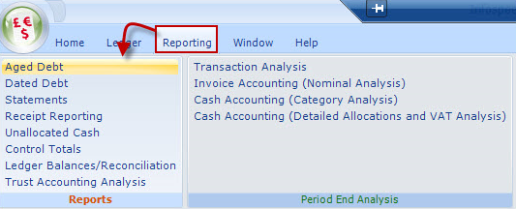

Selection criteria:
An Aged debt report can be produced based on a selection of students or agents.

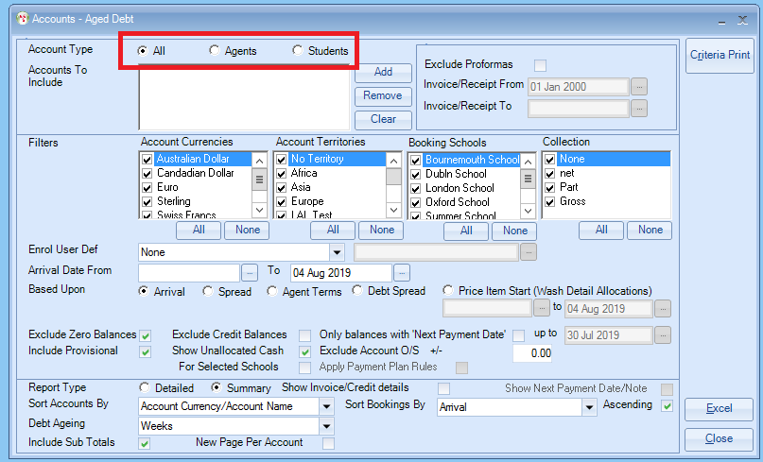
Account Type
Agent or Student Accounts may be separately selected, or individual accounts selected for inclusion, click on the Add button to select a specific agent or student.

Exclude Proformas
If Proformas are excluded by ticking the Exclude Proformas box, an “Invoice Date To” may be added, which restricts invoices/credits/receipts to within the date range shown.
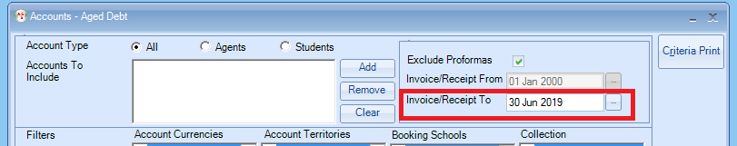

Excluding Proformas allows the Aged debt to be balanced to other reports e.g. Ledger Balances/Reconciliation, and Control Balances. It also allows the Aged Debt to be reproduced “as at” a specific date. This is useful for period or year ends and allows you to back date the report.
If you are using multi currencies, and you have a difference check each report by currency, to identify which currency has an imbalance.

Filters
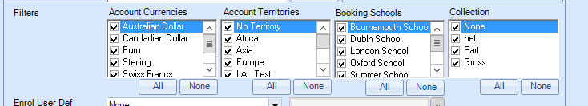
Specific, currencies, territories, schools and collections can be selected, by selecting none this will untick all the options and you can then select the specific item.

Enrol User Defined
You only need to use these if you wish to base this report on one of the “Enrolment Analysis Fields”.
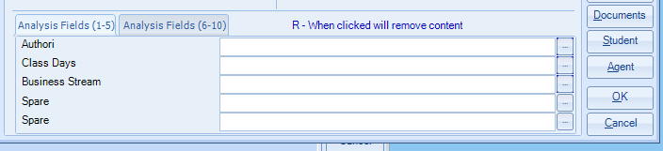

Arrival Date Range
Select the required arrival date range.

If you only want to see the debt of students arriving up to a certain date, then enter the Arrival to date in here. If you are running the aged debt for the end of month and want to see all owed balances, then clear this date out and run the report without a date in.

Based Upon
- Arrival Date – Whole debt will be shown in the column relating to the students arrival date ( Most popular one used)
- Spread – System will spread the value of the booking over the duration based on arrival and departure dates
- Agent Terms – Date Due based on the Agent terms as set within the Agent Record.
- Finance Details/General screen. (“0” = on arrival)
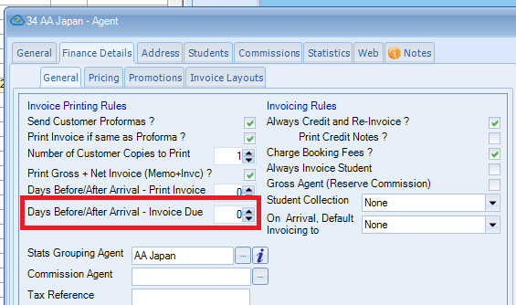)
- Debt Spread – Receipts are spread pro rata to duration broken down by each booking price item. useful for detailed debt collecting
This is useful for checking to see if student has paid sufficient money to cover existing study at the school.
Debtor Analysis
In the debt spread the system has spread what is owed by the student over their complete stay.

- Enrolment Price Item Start – This can be used if you use academic terms and only want to debt chase on a specific date range.

If you select to Exclude Proformas then the Include Provisional box will be greyed out as it is assumed provisional bookings will not have been invoiced.

Only balances with Next Payment Date
The “next payment date” is available in the enrolment (invoicing tab).
This allows, typically direct students, who are paying by instalments to be monitored

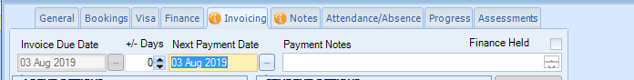

Report Type:

A detailed or summary report can be run, it is suggested a summary report is run firstly and if there are any problems with an account you can run a detailed one for the specific account.

Sort Accounts By options:

Sort Bookings By:

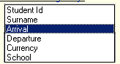

The aged debt only goes up to 6 weeks in advance so the last column will include the balance for the remainder of the stay.

Summary Report:

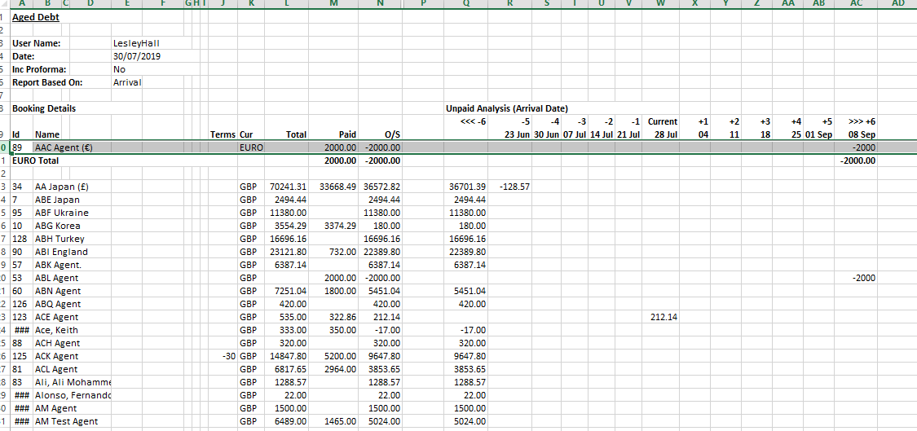

Detailed Report:

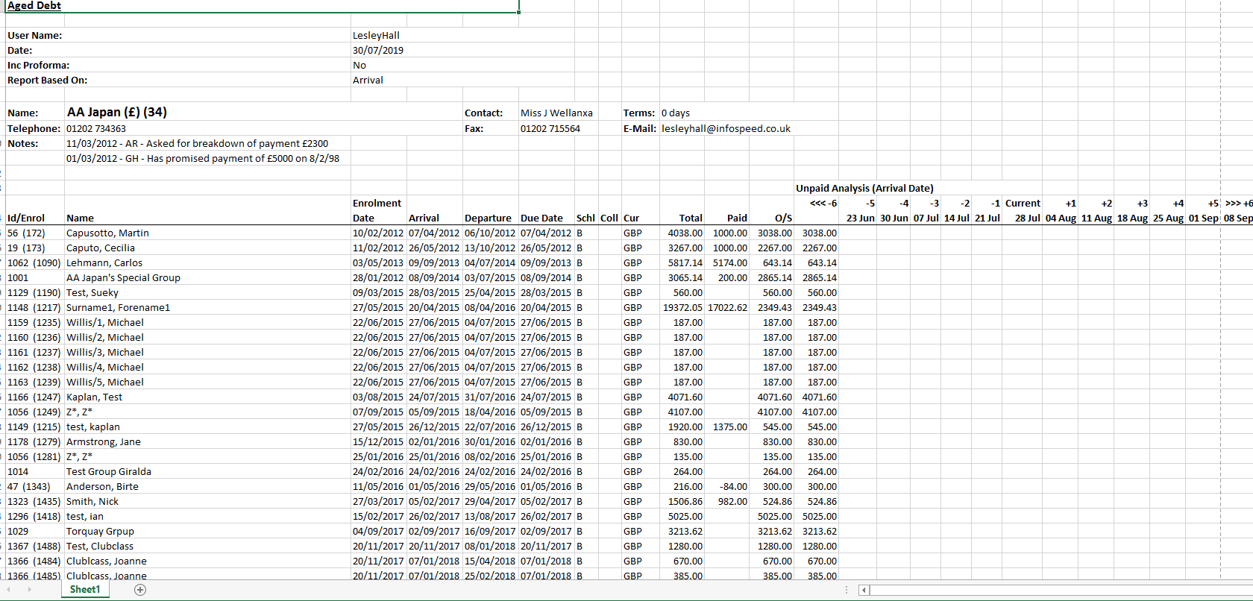

Coll = “Student Collection” as set up within the agents record (Finance Details / General)
Blank = None (nothing selected) CG = Collect Gross. CN = Collect Net. CP = Collect Part

