
Class Ledger

Aged Debt Report (with pre-payment details)

This report differs from the main Aged Debt report in that it adjusts the outstanding balance to exclude any pre-payments or unallocated receipts.

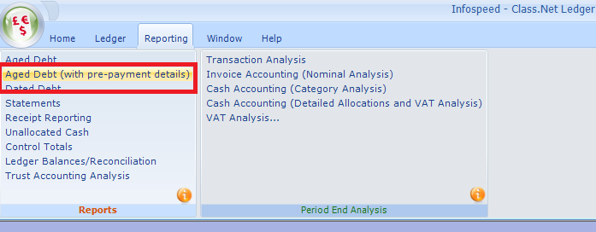

The selection screen is similar to the existing Aged Debt report. The differences being that “Based Upon” options have been reduced and the “Aged Debt Date” has been added.

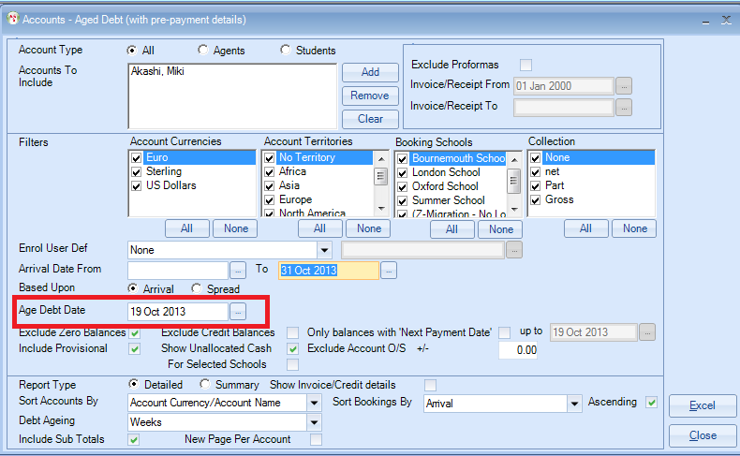

Selection criteria:

Account Type
Agent or Student Accounts may be separately selected, or individual accounts selected for inclusion

Exclude Proformas
If Proformas are excluded an “Invoice Date To” may be added, which restricts invoices/credits/receipts to within the date range shown.

Excluding Proformas allows the Aged debt to be balanced to other reports e.g. Ledger Balances/Reconciliation, and Control Balances. It also allows the Aged Debt to be reproduced “as at” a specific date. This is useful for period or year ends.

Filters
Apply as required

Enrol User Defined
You only need to use these if you wish to based this report on one of the “Enrolment User Defined fields”.

Arrival Date Range
Select if the arrival date range that you require.

Based Upon
- Arrival Date – Whole debt will be shown in the column relating the students arrival date
- Spread – System will spread the value of the booking over the duration based on arrival and departure dates

Sort Accounts By options

Sort Bookings By
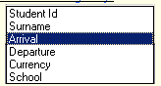

In this example:
- The report is being run as at the 19th October 2013
- The student is arriving on the 4th November 2013
- A Receipt for £200 has been added and allocated
- A Receipt for £100 has been added and NOT allocated

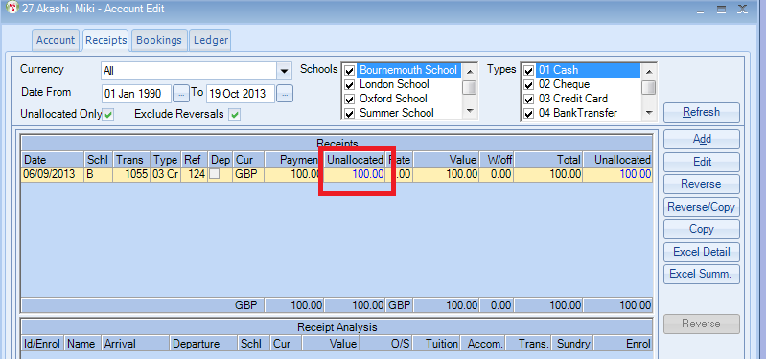

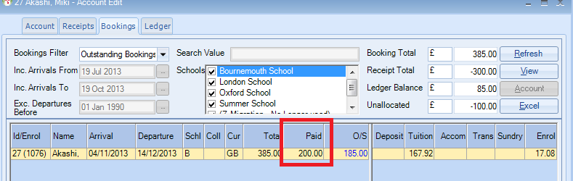

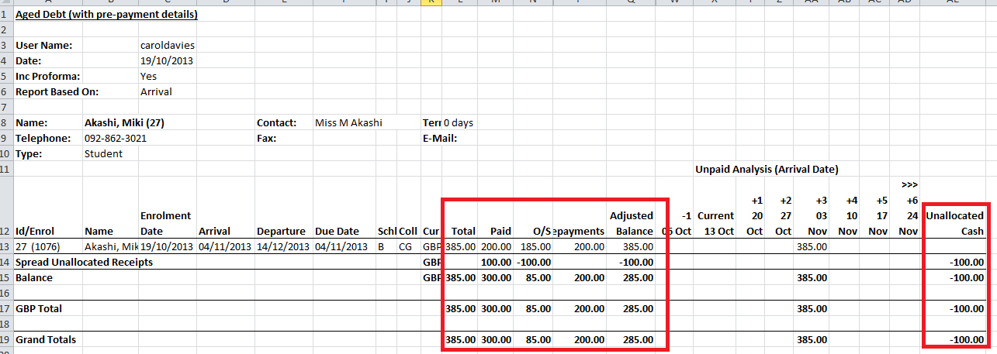

If you run the report with the Aged Debt Date as the 04.11.13 which is the students arrival date the report will look as follows:

