

Class.Net – Help Document

DATED DEBT
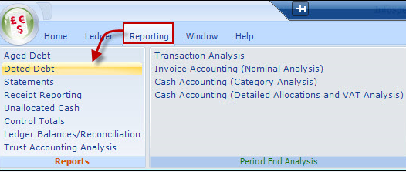

General

An accounting report, aimed at those schools where it is a requirement to only show debt for services provided up to a specific date (typically an accounting period). Invoices/Credits may cover a longer period of time, but Class calculates (on a daily basis) the amount due (called ‘Dated Debt’) on each element of the booking based on the From/To in the booking.

Against the ‘Dated Debt’, receipts (up to the ‘Invoices/Receipts to Date) are allocated against the booking debt, regardless of how the receipt may have been allocated during receipt entry process. Receipts are listed as individual lines and not against the booking items.
Receipts in excess of the dated debt are shown as Prepayments.

Only Invoices/Credits and Receipts are included (no Proformas). It is therefore critical that invoices/credits have been produced up to the date for the report to be meaningful.

Selection Screen- Only Invoices/Receipts will appear in this report.

The report is totaled by currency and the sequence is by Agent/Student/Student enrolments. This sequence is necessary in order to be able to allocate any Agents unallocated receipts correctly against student enrolments.

Summary Report
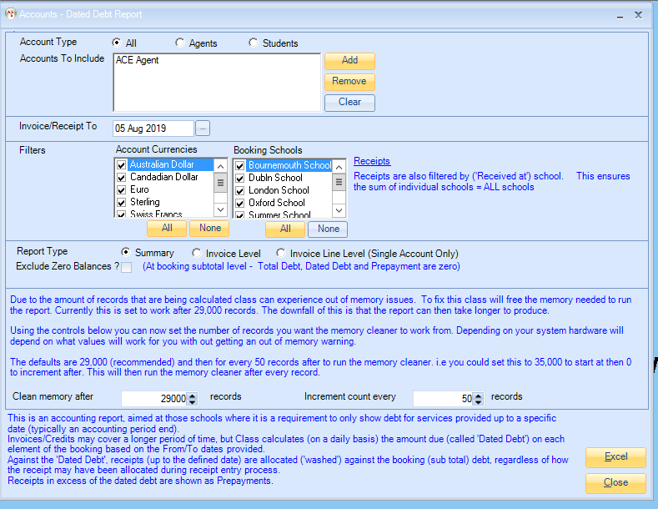

Will give you just the totals and not individual items.

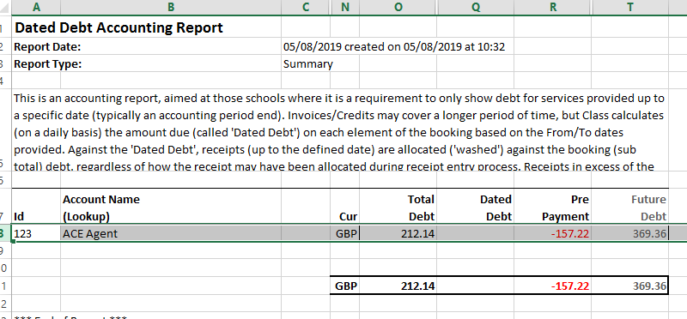

Invoice Level

Detail is provided at Invoice level and not against the individual booking lines, see Invoice Line Level (Single Account Only) for more detailed report.
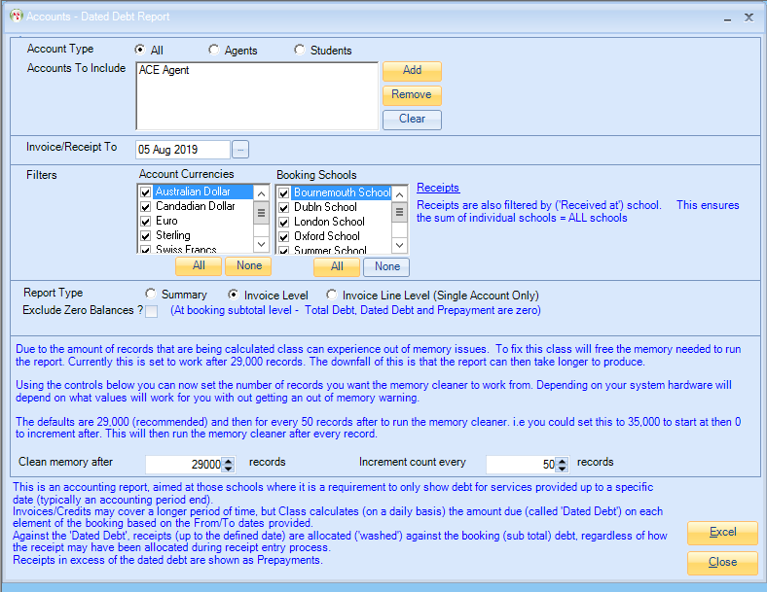

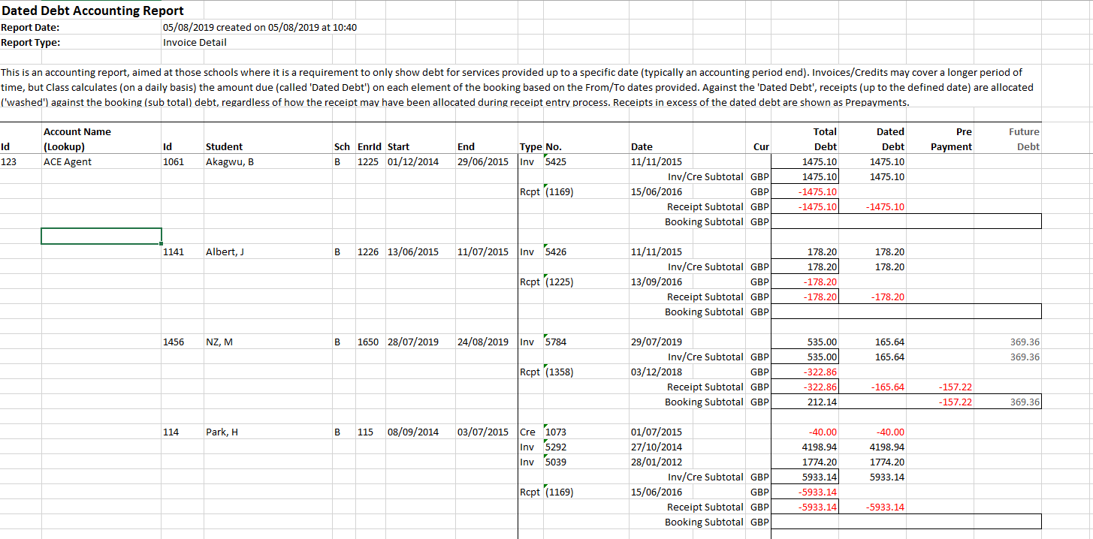

Invoice Line Level (Single Account Only)
Detailed Report.
Detail is provided at booking level in order to validate calculations. The report can only be selected on a single Agent or Student basis.
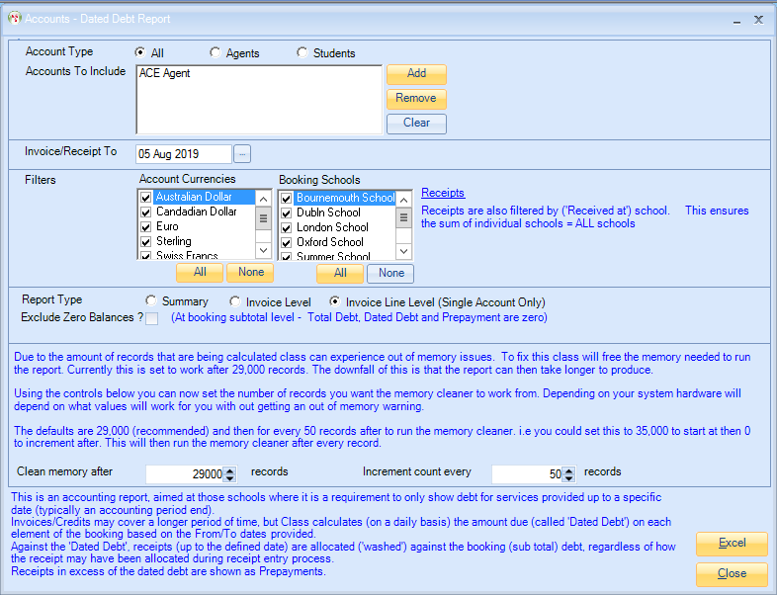

Each Element of a booking is shown.
The Dated Debt is calculated on a line by line basis, by taking the number of days in the booking and apportioning the value between the Dated Debt and the Future Debt in relation to the “Invoice/Receipt to” date.

Receipts are totaled and allocated to the Dated Debt, with any excess showing as a Prepayment. If an Agent has unallocated Receipts these are allocated to the total remaining Dated Debt, with any excess showing as a Prepayment.

See below for example and detailed explanation.

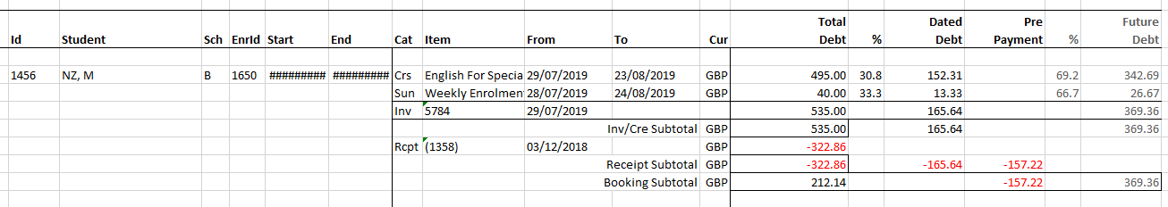

If we look at the Tuition Line the student is booked from 29.07.19 to 23.08.19
This is 26 days, the total value for the tuition is £495.00. we divide the total value for the tuition £495.00 by the number of days 26. £495.00 divided by 26 = £19.04 which is the daily value. The report was run on 5.08.19, from 29.07.19 (the start of the course) to 5.08.19 it is 8 days. To get the dated debt figure, times the number of days up to the date of the report by the daily value 8 x £19.04 = £152.31 this is the dated debt.
The future debt is the total value of the tuition £495.00 less the dated debt value £152.31. (£495.00 - £152.31 = £342.69)

If we now look at the sundry item, the dates are not the same and so the calculation will be worked out differently.
Booking dates 28.07.19 to 24.08.19 = 27 days, total value for the booking is £40.00
£40.00 divided by 27 = £1.48. (Value divided by total number of days).
Number of days up to the date of the report = 9 days x by £1.48 = £13.33. This is the dated debt.
The future debt is £40.00 -£13.33 = £26.67.

Receipt Received on 3.12.18 for £322.86
Total in dated debt column is £165.64 (up to the date of the report todays date).
Prepayment is Total paid £322.86 minus dated debt £165.64 = £157.22.

NOTE: The information highlighted below is explaining that this report has to look through every single line of every booking and so will take some time to produce and can cause out of memory issues.
With this in mind, Class will free up memory needed to run the report. The default is set to 29000 (which is recommended) then for every 50 records after it will run a memory cleaner. You could set the Clear memory after to 35000 and then set the Increment count to every to 0, this will run the memory cleaner after each record.

By using these controls, you can set the number of records you want the memory cleaner to work. This will of course depend on your hardware system on what values will work for you, before getting out of memory warning.

This does not run the report any quicker it will only stop out of memory issues.

