

Class.Net – Help Document

Manual Bank Reconcilliation in Class

When entering receipts into Class Ledger you enter a transaction type( these can be created and added to in the System Settings see below) for each receipt. Each transaction type can have a different Nominal Code (see system settings ), which will then enable you to run a receipt report at the end of each month to check against the bank statement. (see Help sheet LED005 for further information on setting up Nominal Codes)

Transaction Types

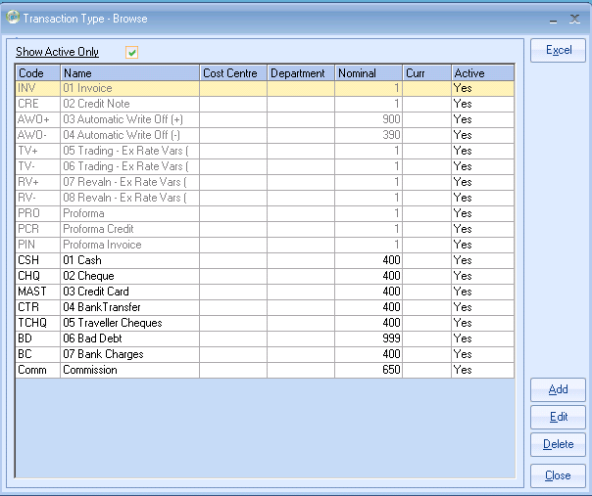

Nominal Codes

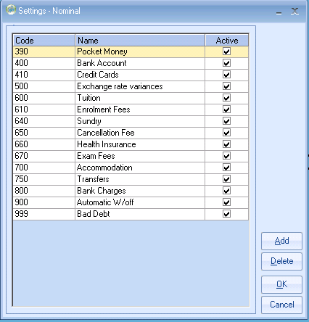

Receipt Reporting:

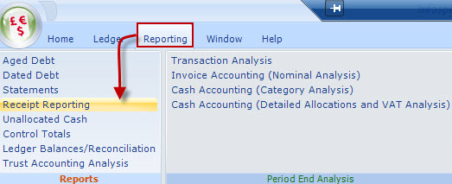

In the selection screen you can report on individual schools, currencies or a specific transaction type. Make your selection by ticking the required box.

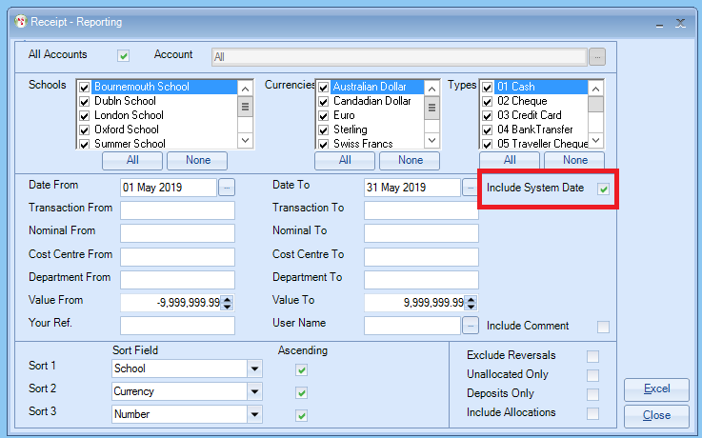

The report has several selections.
- Date From and Date To: as we are running a bank reconcilliation we would suggest you run this for the whole month.
- Transaction From and Transaction To. this is the receipt transaction number
- Nominal From and Nominal To: If you want to select on a specific nominal code .
- Cost Centre and Departments: only applicable if you are using cost centres and departments.
- Value From and Value To: if you are trying to find a receipt for a specific amount then you can add a value in here.
- Your Ref: This is the Reference you enter manually into the receipt.
- You can also include the System Date, this is useful if the receipt was added later then the actual date of the receipt, and can be identified in the results, if the actual date of the receipt is different to the date it was entered onto the system the system date will show in Blue.

In this example the report has been run by Date from and To.

Results:

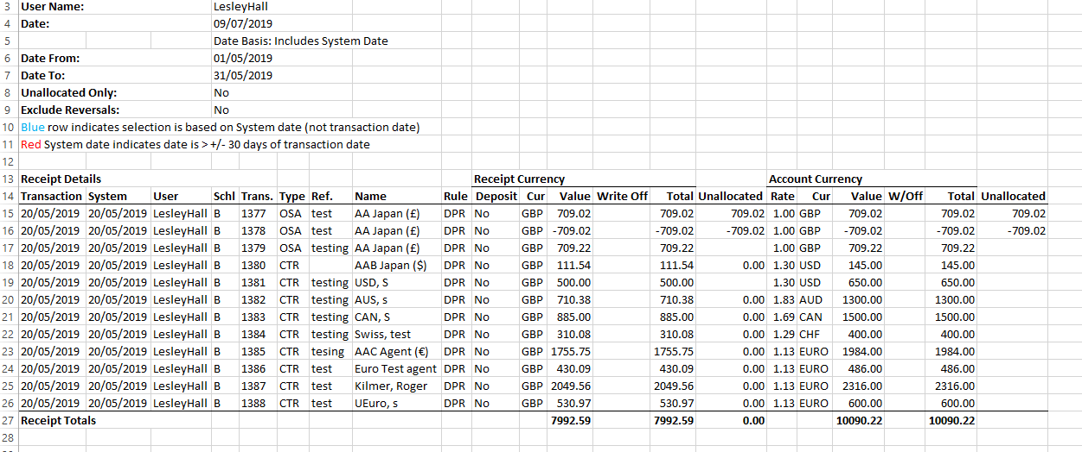

- You can now check this report against your bank statement.

- Nominal Analysis report for receipts can also be run fom the Period end Reports.
- Invoice Accounting (Nominal Analysis)

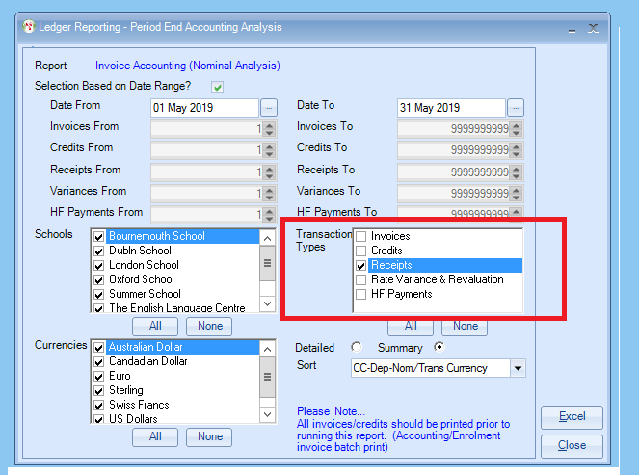

- In this report you can select a specific date.
- If you just want to run this report just for receipts, under Transaction Types tick the box for Receipts.

Results: Summary:
This Summary report will give you the totals for each Nominal Code and these total values can be entered into your accounting system.
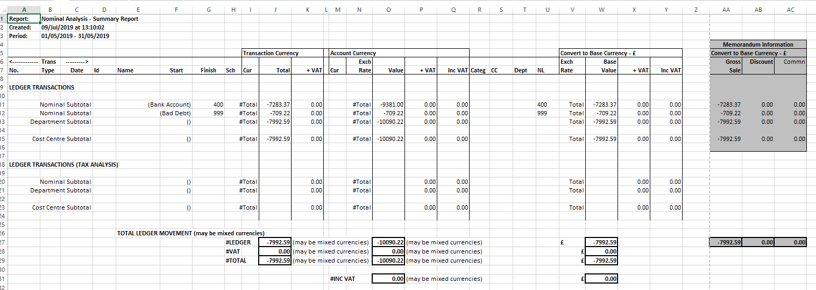

Results Detailed:
The detailed report gives you a breakdown of each transaction.

