

Class.Net – Help Document

Ledger - VAT Analysis Report

Ledger – Reporting – VAT Analysis

This report will give you details of all the tax entries in the date range selected and will include invoiced items only (no proforma or unprinted invoices will be included).

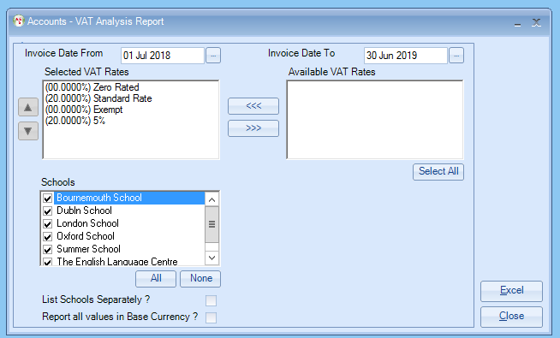

- Invoice Date From and Invoice Date To
This report will only give you VAT totals for invoiced items.
- Select the VAT Rate(s)
Highlight the rates on the right hand side and then click on the arrows.
- Select the school(s) required
You can report on individual schools or selected schools.
- Tick the box if you want to list the schools listed separately

- Report all Values in Base Currecncy? – If this is left unticked the report will pick up the value from ther invoice, if ticked then the you will get the results only in your Base Currency.

Results:

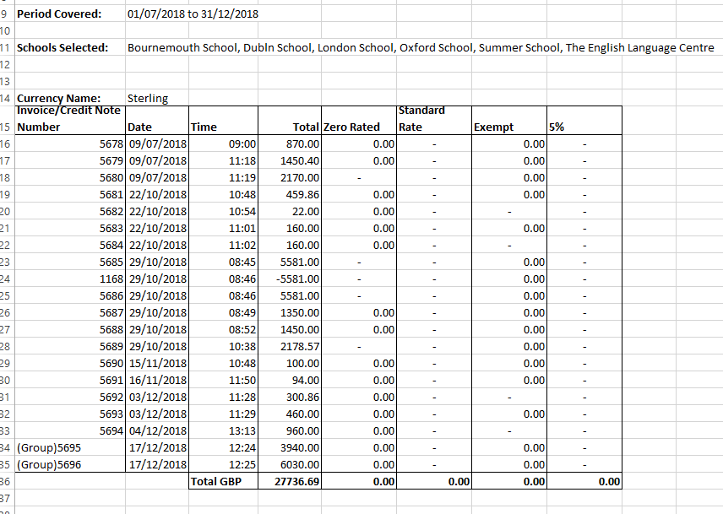

The Total column is the value inclusive of all tax.

All other columns will give you the value and totals of any VAT.

