Class – Help Document


Amending Invoice Layouts

Problem

How do I change the layout of an invoice/credit note?

If you want to change the layout of a particular invoice/credit note i.e. change the position of the address, do the following:

Class
- Click on Documents
- Finance Documents
- Click on either Invoice, Proforma, Memo or Credit
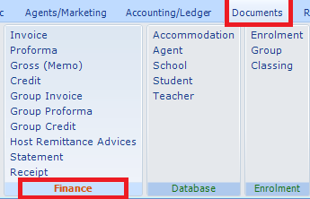
- Select the document you want to amend
- Click on Word
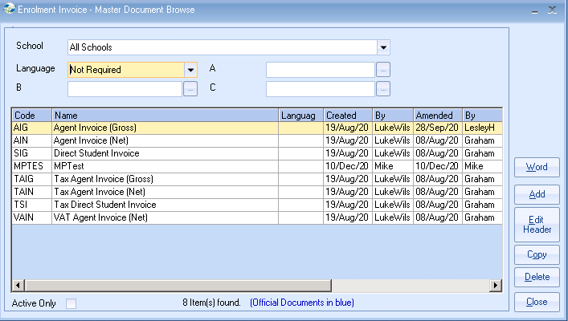
- You are now in the document and can make any amendments necessary.

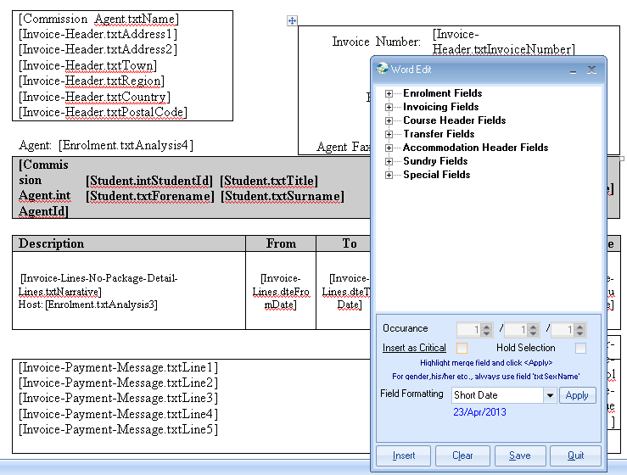
Once you have made your amendments click on Save.

