Class – Help Document


Print Labels for Students with Accommodation

Problem
I need to produce Labels for all students staying in accommodation.

Solution:
- Click on Reporting (top of the screen). Select Quick Reports
- Report Type: select ‘Enrolment Accommodation Booking’
- Click on ADD to create a new report.

Date Filter: Input the required “Present” date range.

Now add the fields to be printed on the label by using ‘Add Item’, together with any other fields needed for use with selection criteria.

See example below:
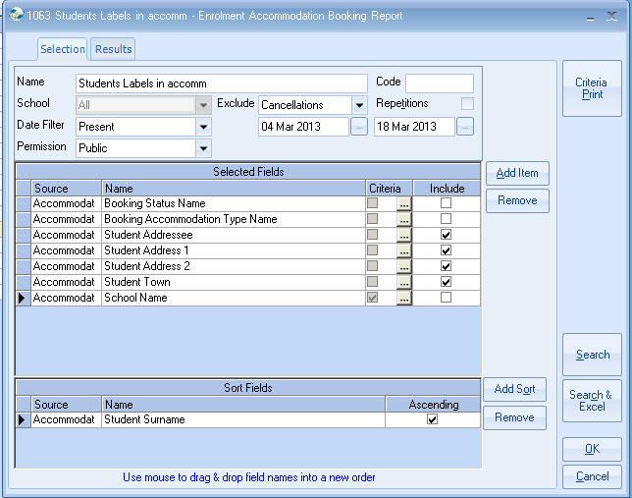

School:

If the labels are to be produced for a specific school add the field and criteria as shown below:

Example of Criteria to select one school:
Highlight school from list and select Set.

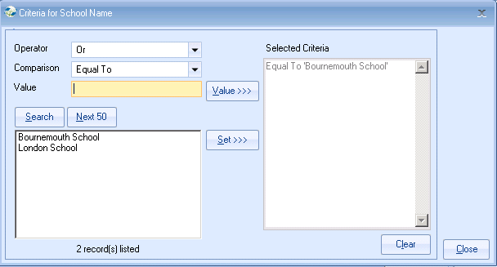

Booking Status Name
- Add this field to the report so that criteria can be added to include only Booked and Changed accommodation bookings.
- Untick the box under Include so this item is not printed on the label.

Booking Accommodation Type Name
- Add this field to the report so that criteria can be added to include only Host Families or Host Families and Halls of Residence. etc.
- Untick the box under Include so this item is not printed on the label.

Sort Fields:
At least one Sort field must be added

Click on Search

Click on Send as Labels

Label Format Choose your required label size from the list given.

If your label size is not listed, select User Defined and type the code in the Label Code field.

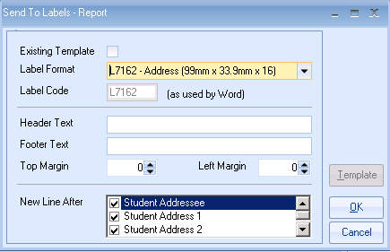

Click OK

This will go through a process of creating an Excel Spreadsheet listing the selected records and then create a Word label document with the merged names and addresses ready for printing.

This document can be saved for future use.

